Topic Name | 1.2: PBCS Navigation-Change Password
Department
File Name
Date Modified
Last Changed by
Status
Owner

Test Procedure

Step | Action | Author Notes
Open web browser and Sign in to My Services URL
https://myservices.us2.oraclecloud.com/mycloud/a419537/faces/dashboard.jspx

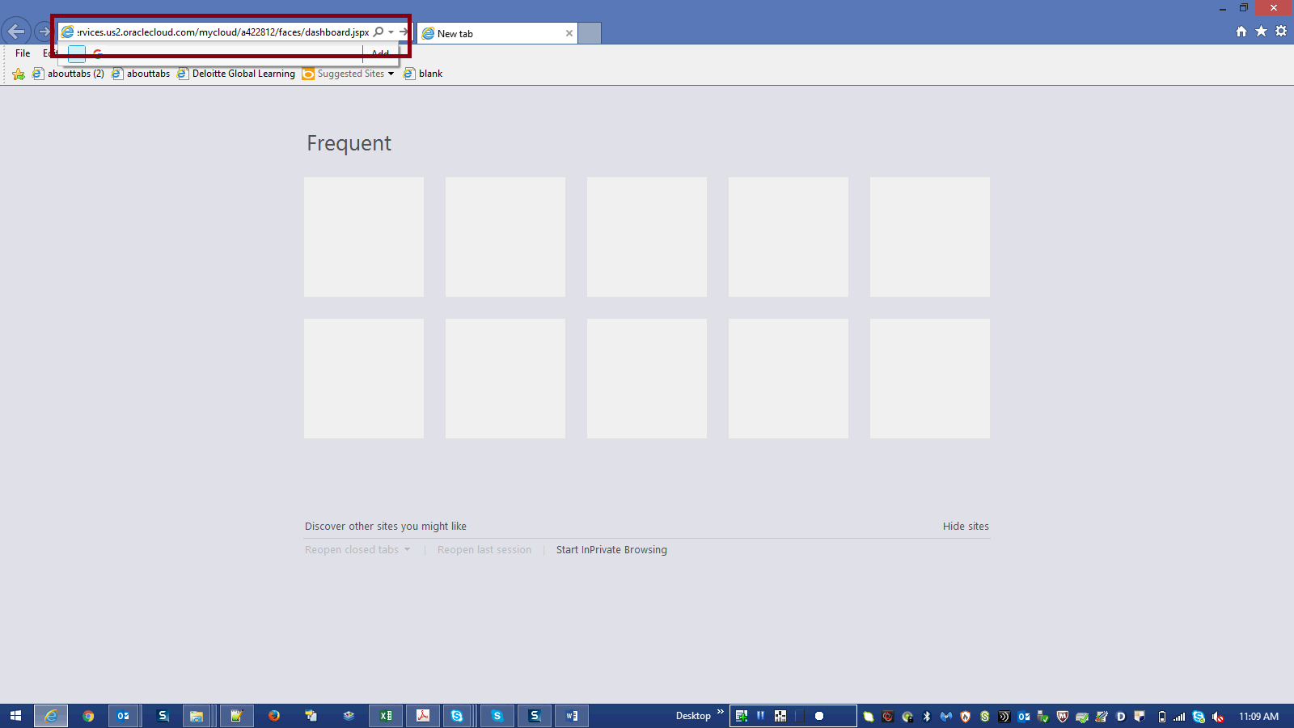

Step | Action | Author Notes
 | Press [Enter].
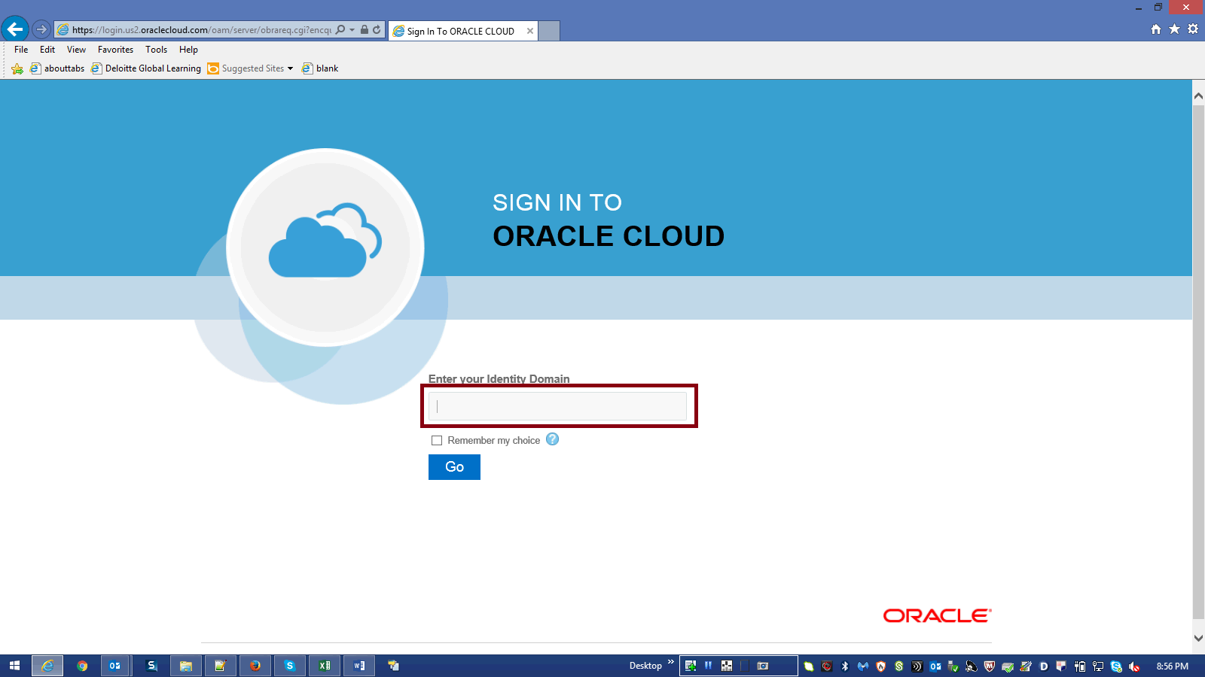

Step | Action | Author Notes
 | Enter your Identity Domain in the box
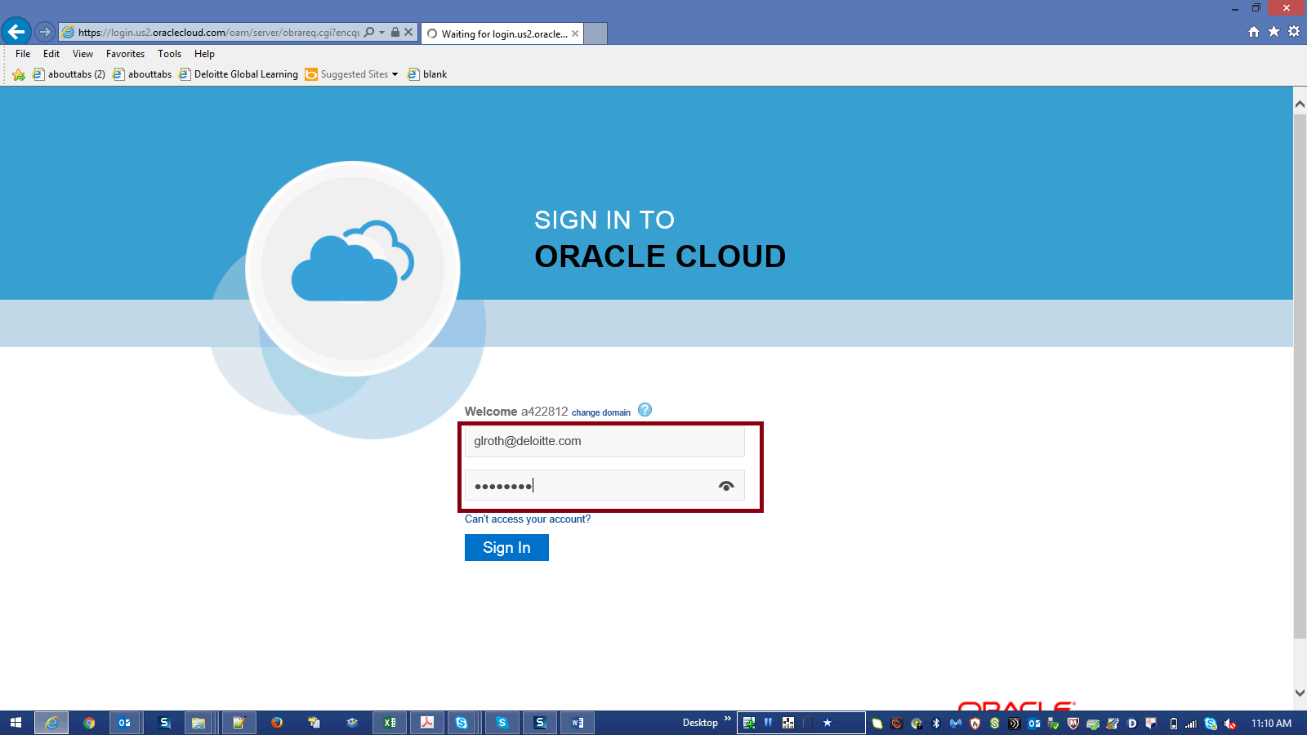

Step | Action | Author Notes
Enter Your UserName and Password then Click SignIn.
Enter a valid value
E.g.Username "xxxxx@xxxx.com".
Password : xxxxxx

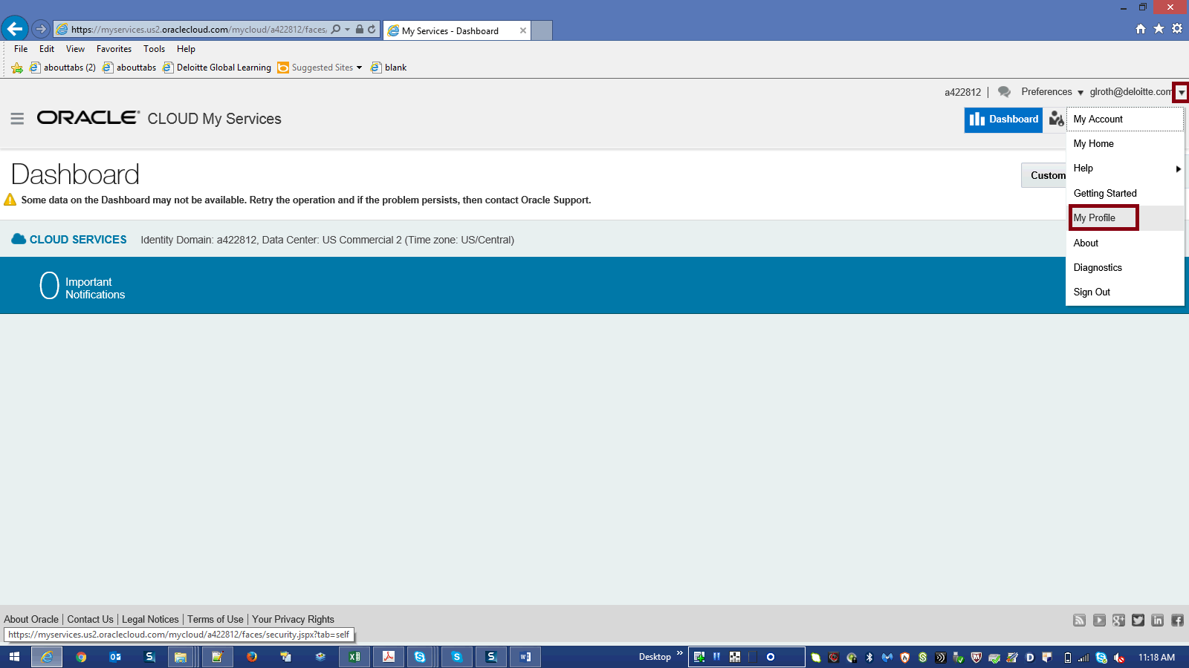

Step | Action | Author Notes
Click on Arrow next to "xxxxx@xxxx.com".
then click on My Profile
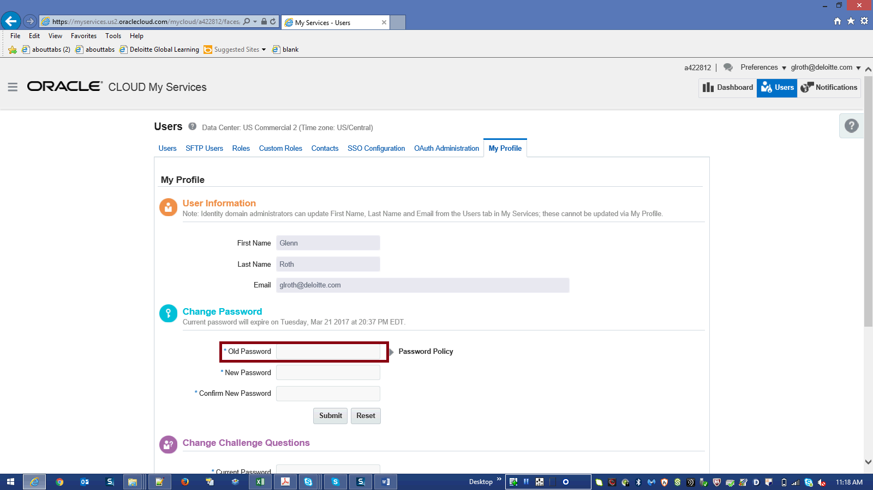

Step | Action | Author Notes
 | Enter your Old Password
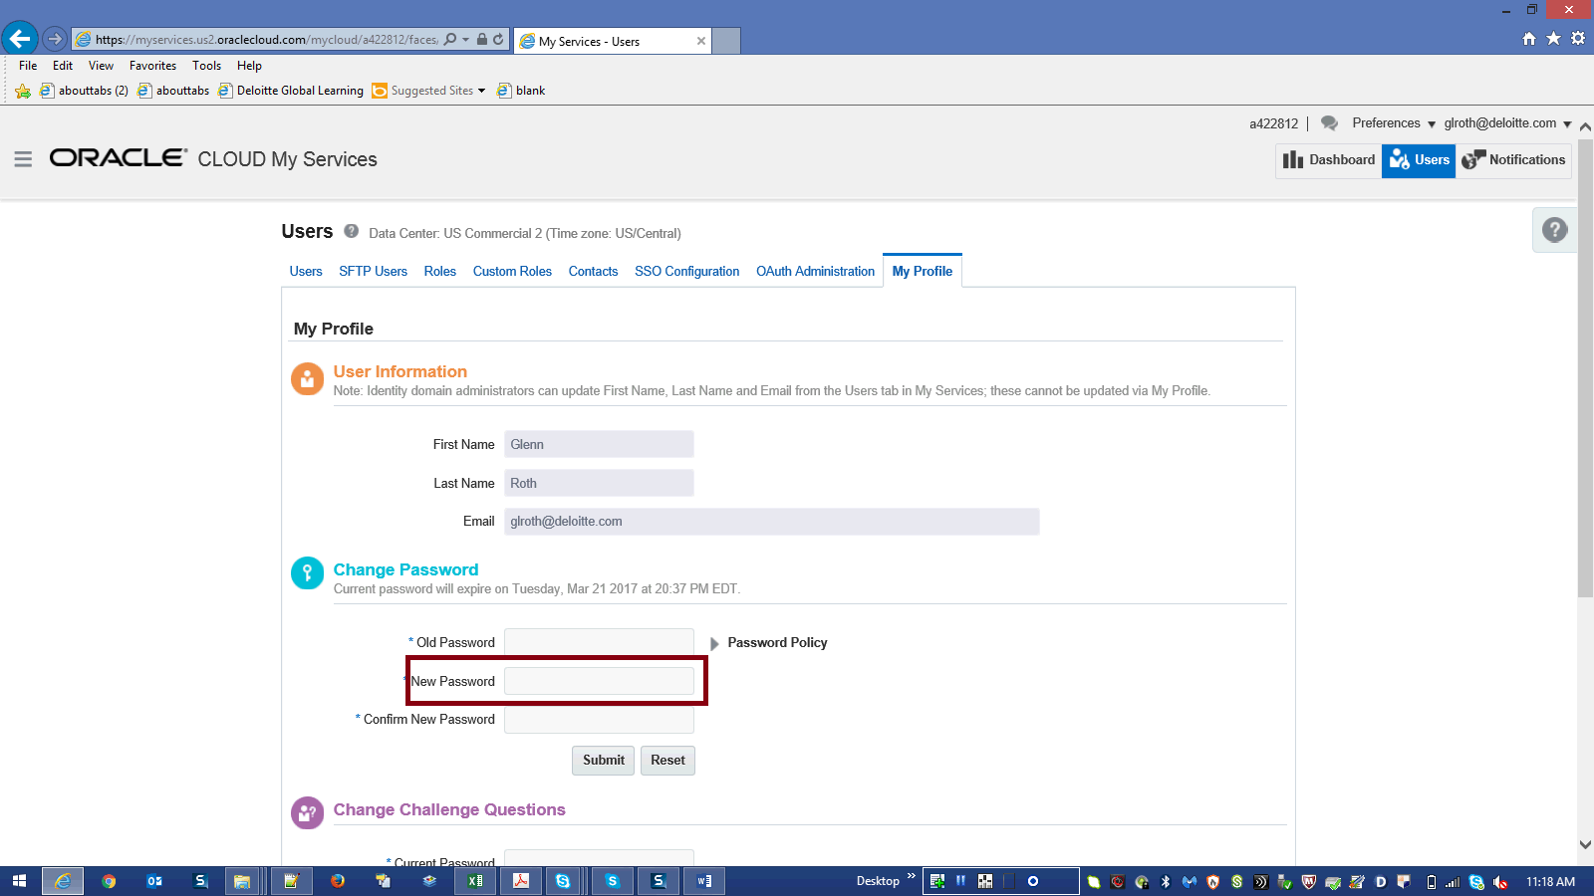

Step | Action | Author Notes
Enter your new password.
Note : Please consider the password policy details below while setting up new password:
•Password must be atleast 8 character(s) long
•Password must contain atleast 1 lowercase letter(s)
•Password must contain atleast 1 numeric charater(s)
•Password must contain atleast 1 uppercase letter(s)

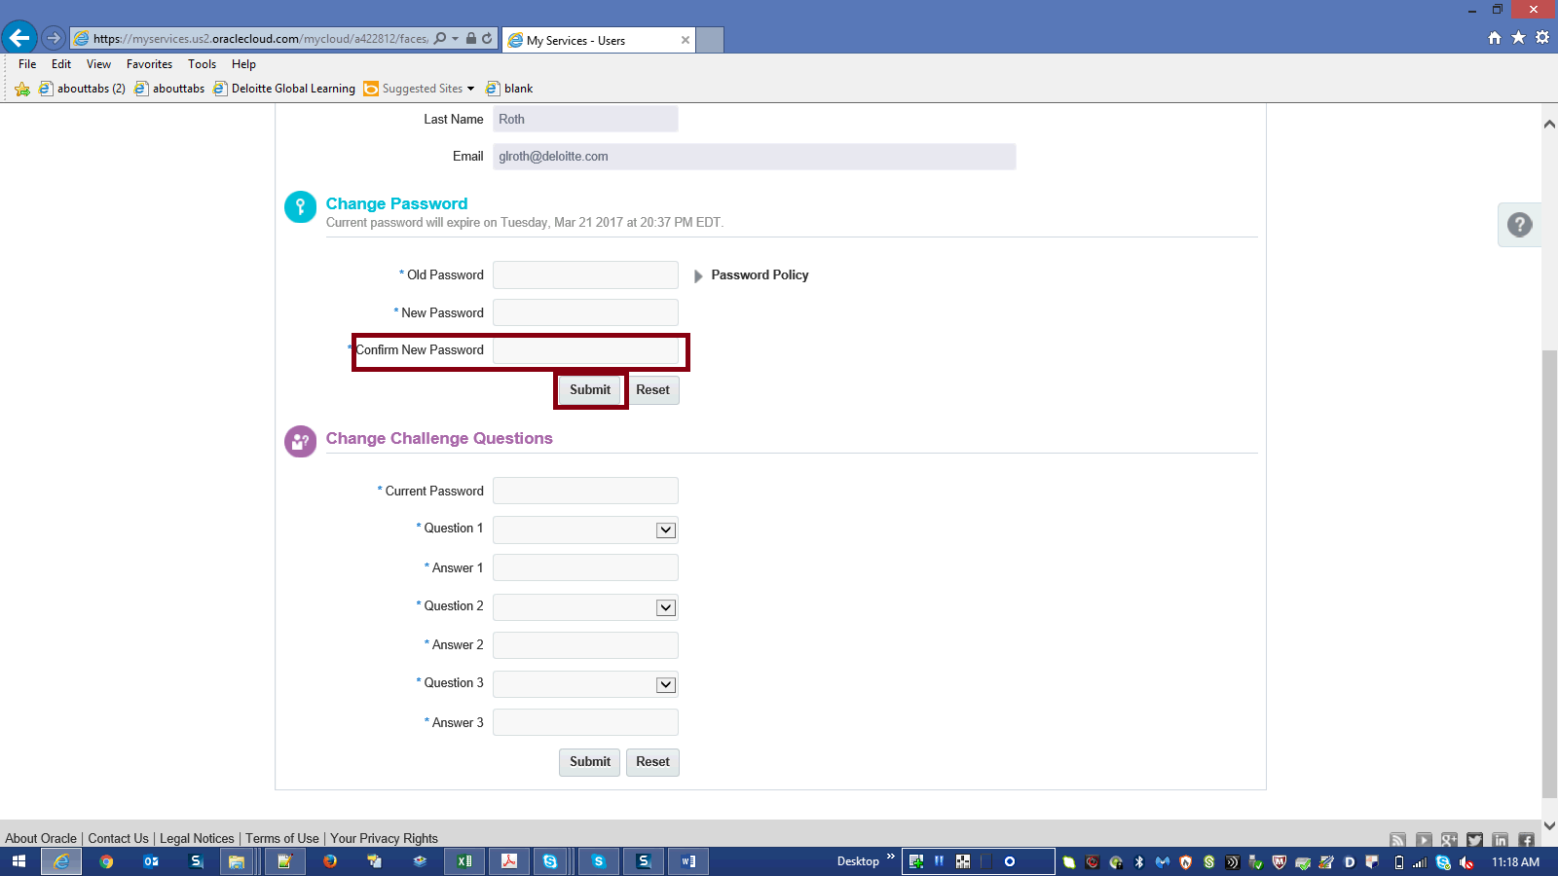

Step | Action | Author Notes
 | Enter new Password then click Submit
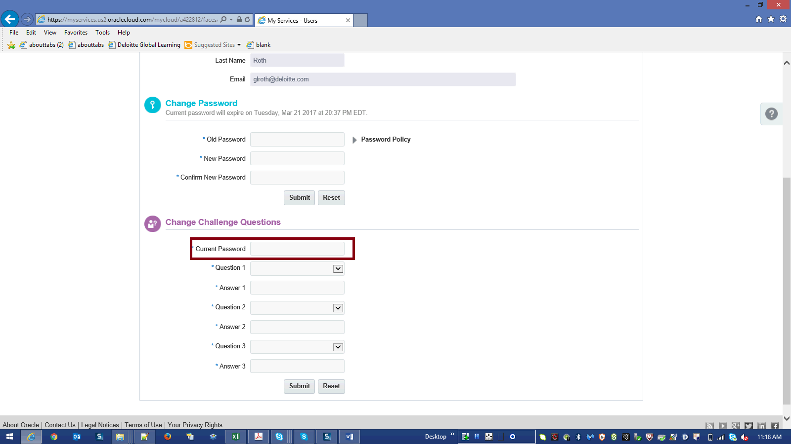

Step | Action | Author Notes
 | Enter Current Password
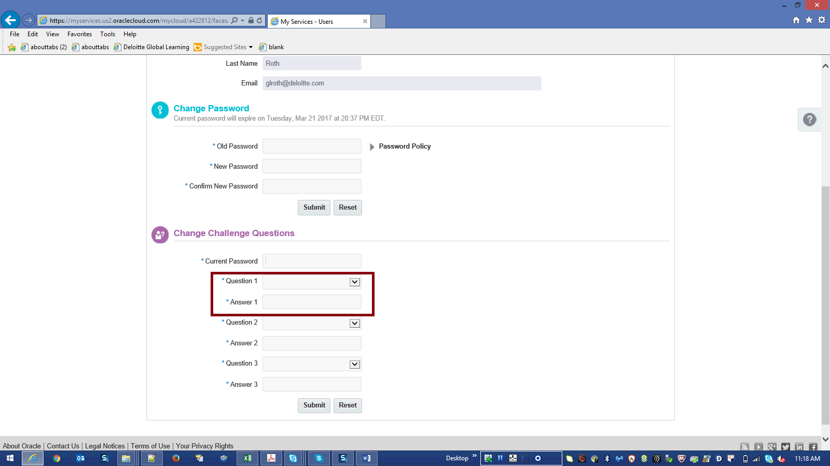

Step | Action | Author Notes
 | Select your desired question from the Question1 list and then enter appropriate your Answer in Answer1 field
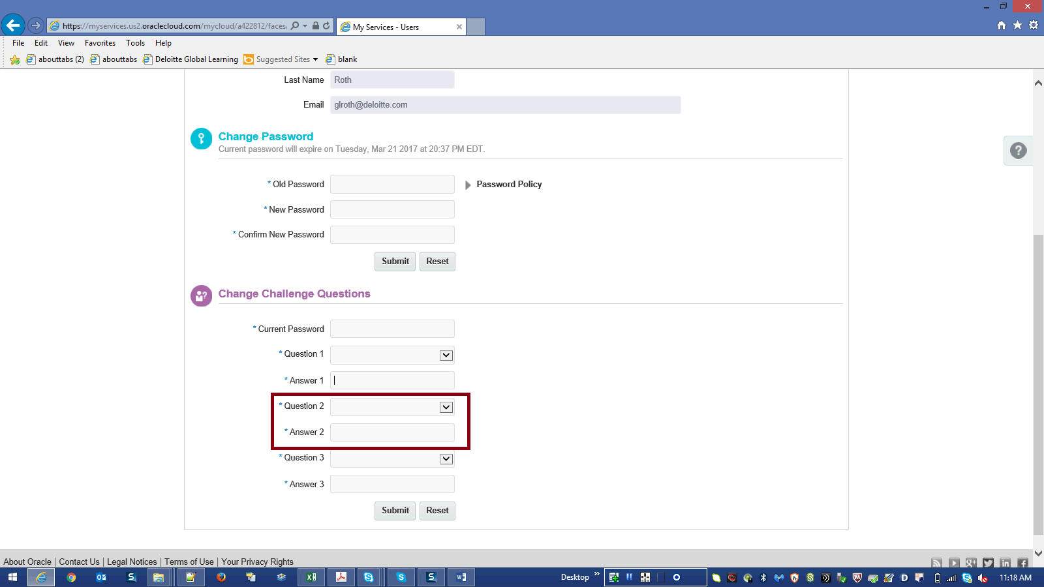

Step | Action | Author Notes
 | Select your desired question from the Question2 list and then enter appropriate your Answer in Answer2 field
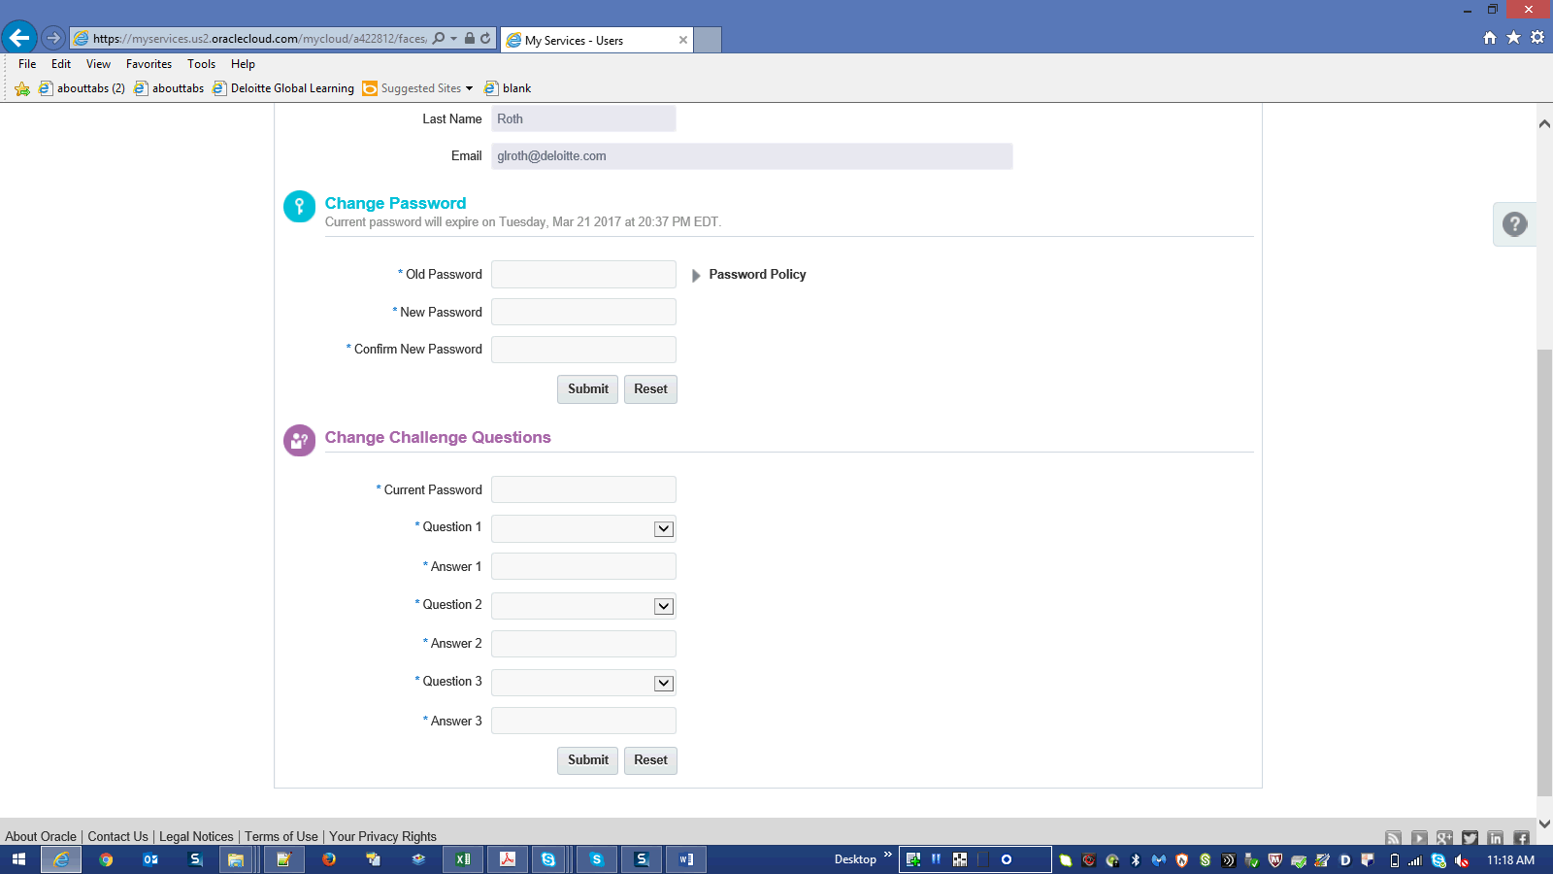

Step | Action | Author Notes
Select your desired question from the Question3 list and then enter appropriate your Answer in Answer3 field
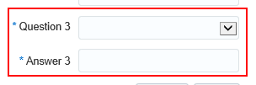
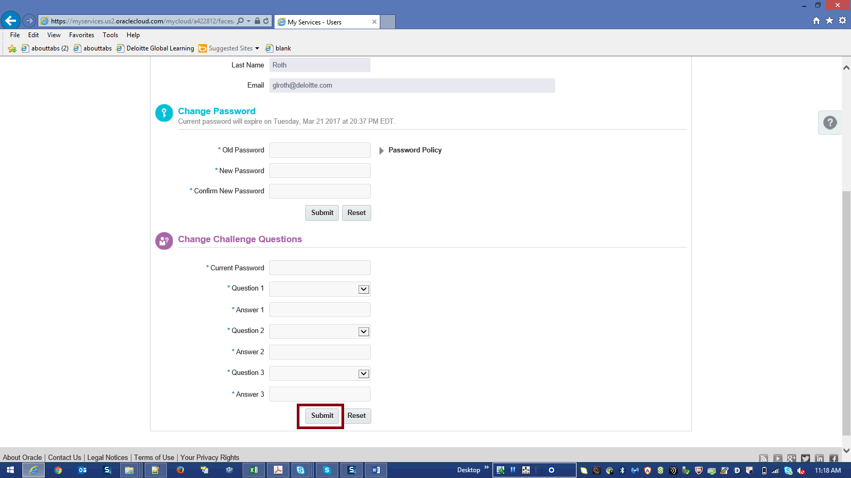

Step | Action | Author Notes
 | Click Submit
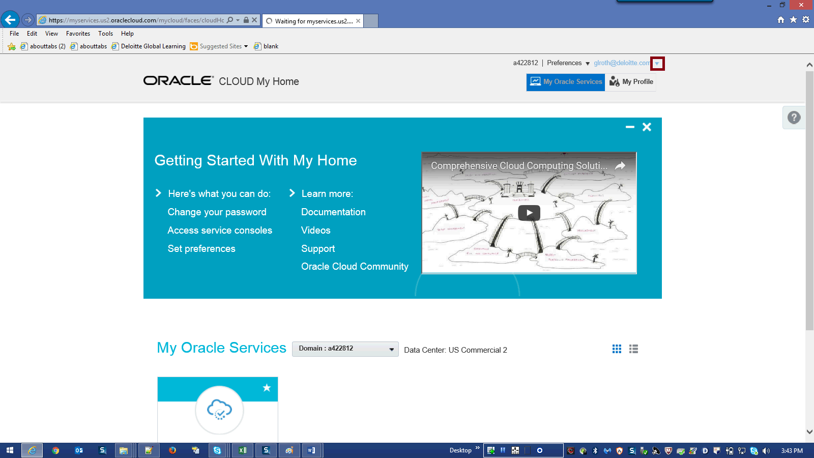

Step | Action | Author Notes
 | Click on Arrow next to glroth@deloitte.com
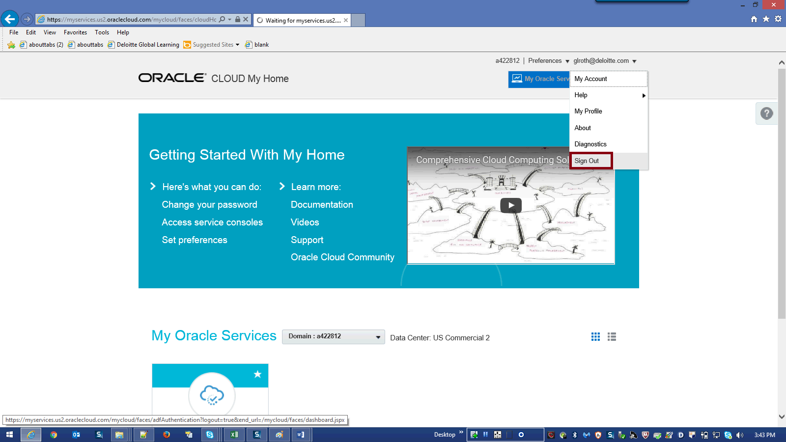

Step | Action | Author Notes
 | Click the Sign Out link.
Step | Action | Author Notes
 | End of Procedure.

