Topic Name | 1.1 PBCS Navigation-Login to PBCS Application
Department
File Name
Date Modified
Last Changed by
Status
Owner

Test Procedure

Step | Action | Author Notes
 | Click New tab tab. (Launch web browser Firefox or Google Chrome)

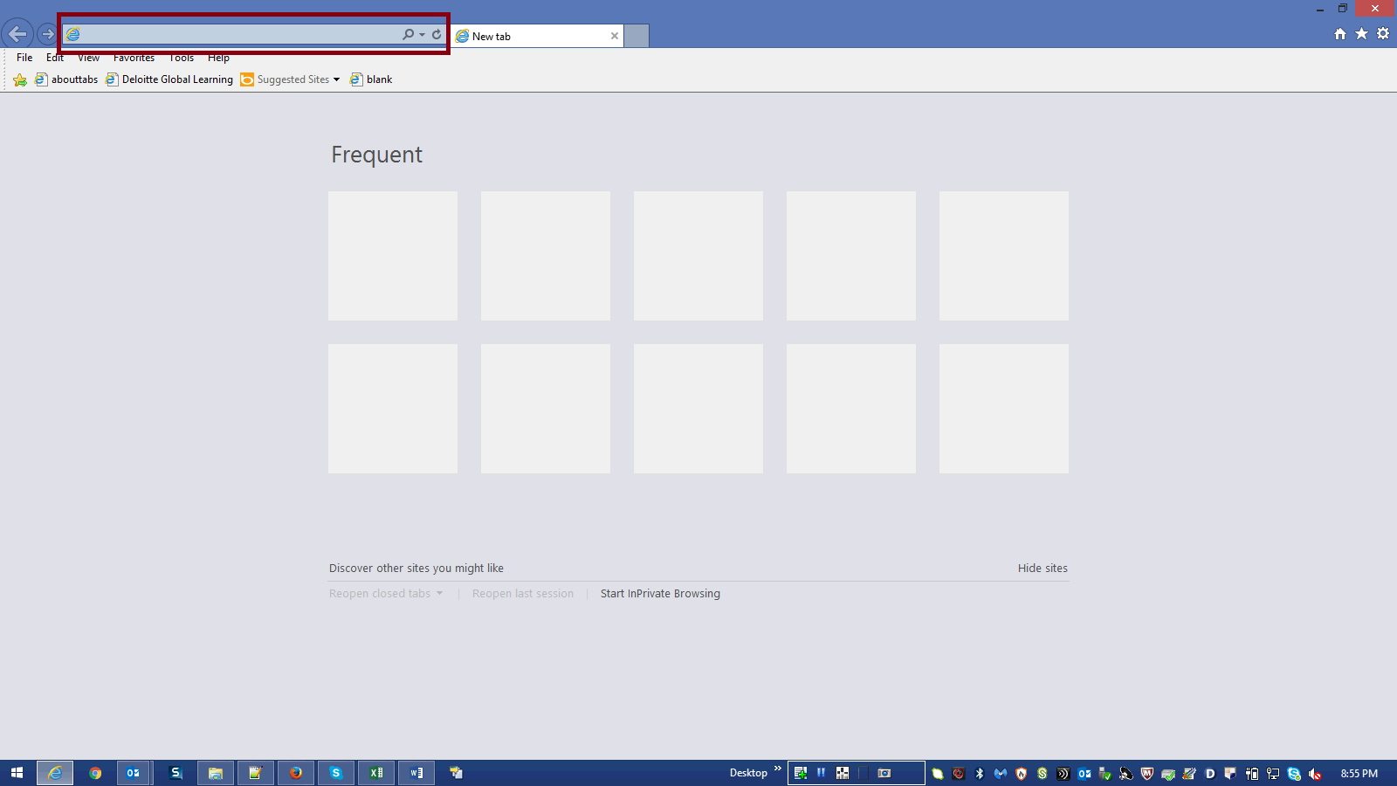

Step | Action | Author Notes
Copy application URL :
https://planning-a419537.pbcs.us2.oraclecloud.com/HyperionPlanning
 | Paste URL in browser and hit enter
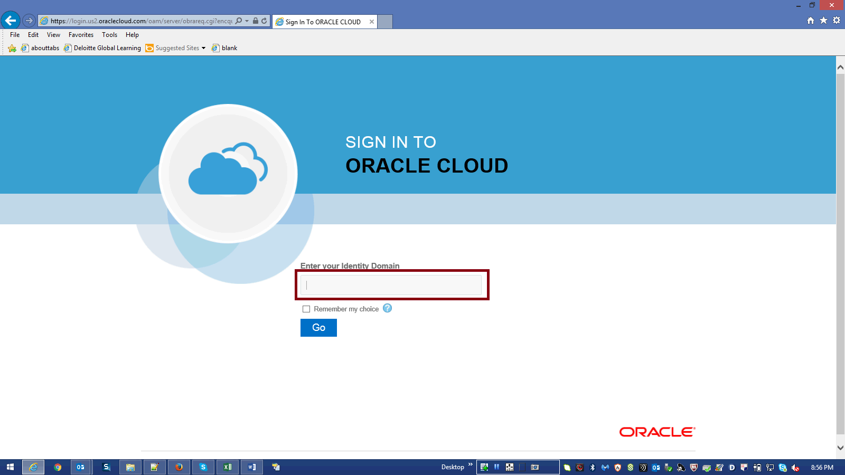

Step | Action | Author Notes
 | Enter your Identity Domain in the highlighted box.
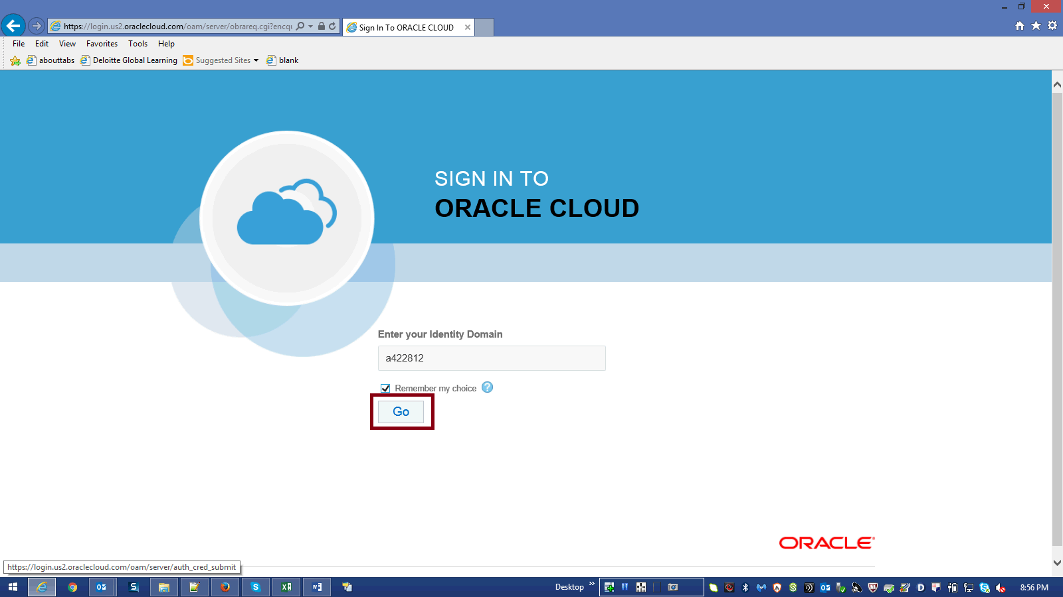

Step | Action | Author Notes
 | Click Go button.
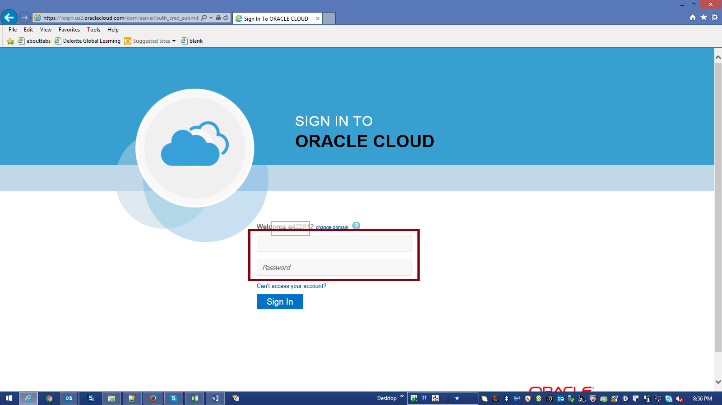

Step | Action | Author Notes
Enter Your UserName n Password.
Enter a valid value
E.g.Username "xxxxx@xxxx.com".
Password : xxxxxx
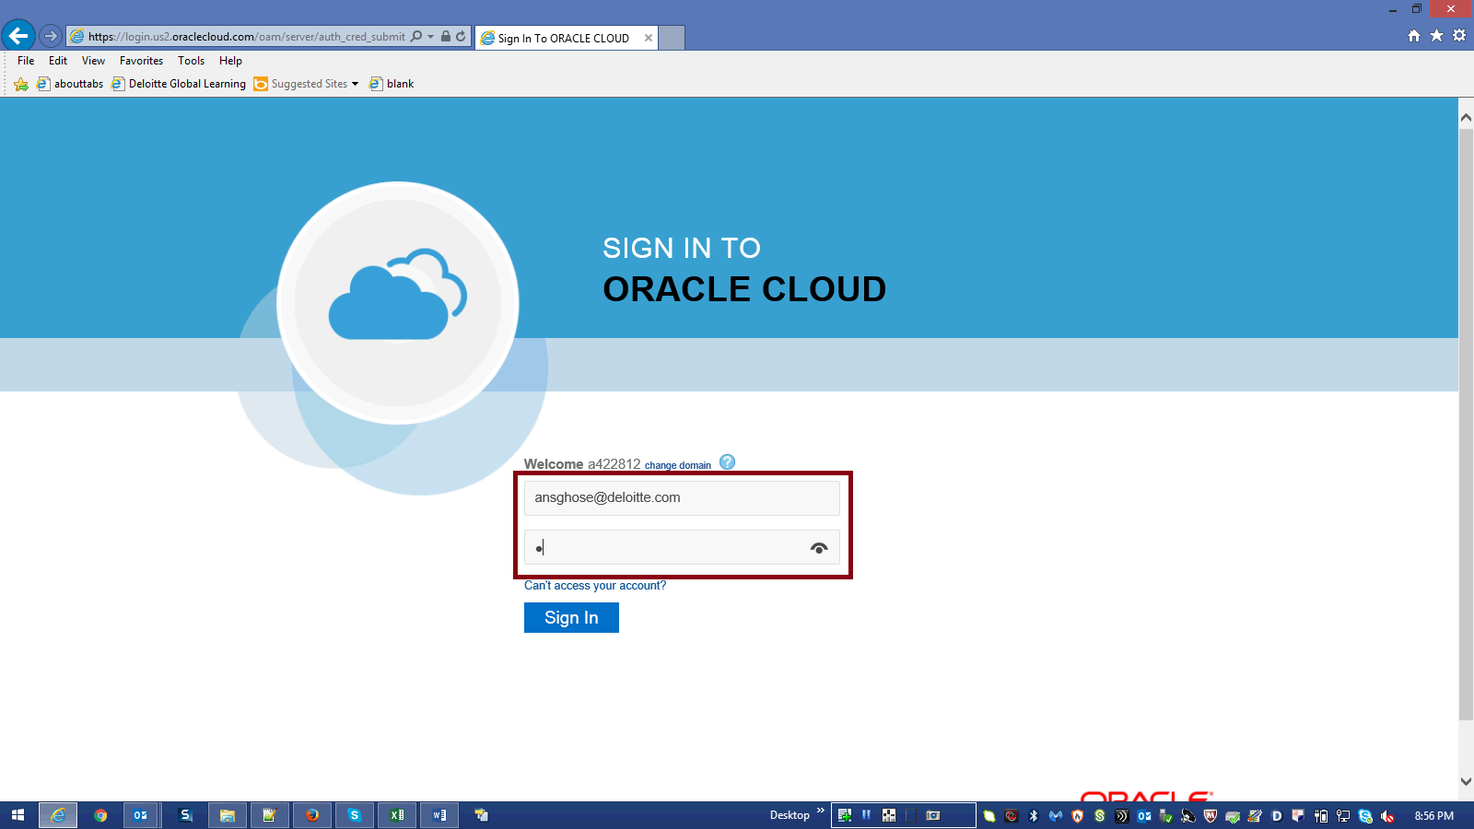

Step | Action | Author Notes
 | Click Sign in.
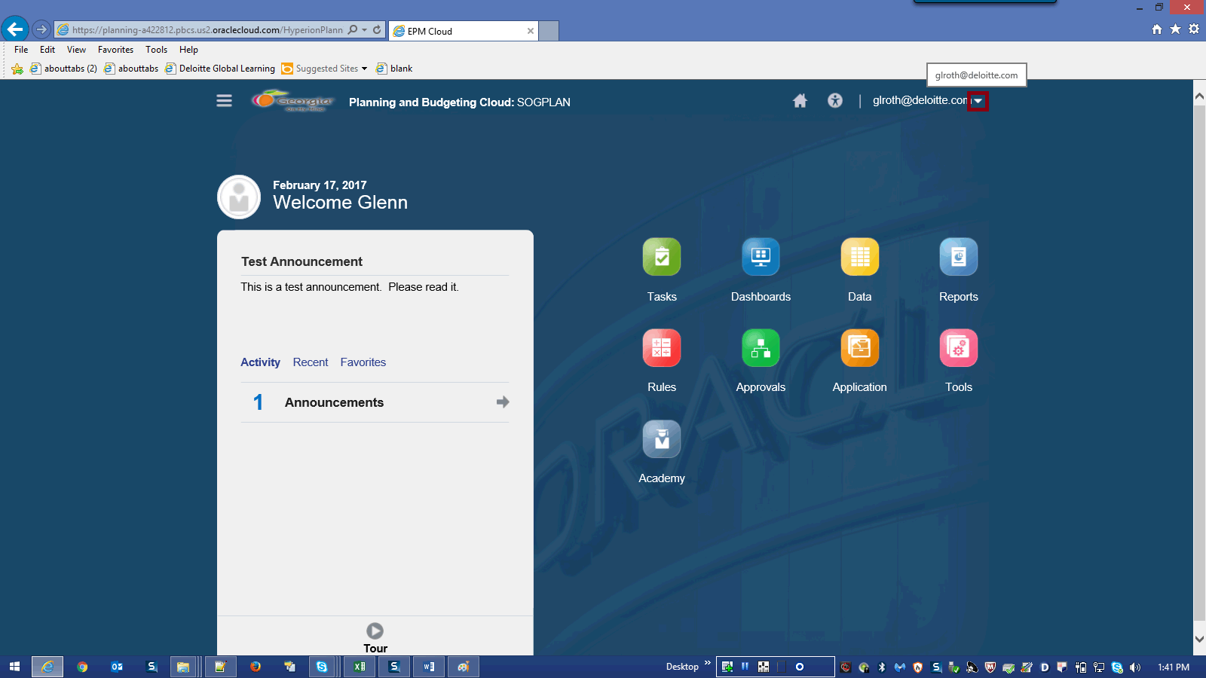

Step | Action | Author Notes
 | Click arrow next to user name xxxx@xxxx.xxx.
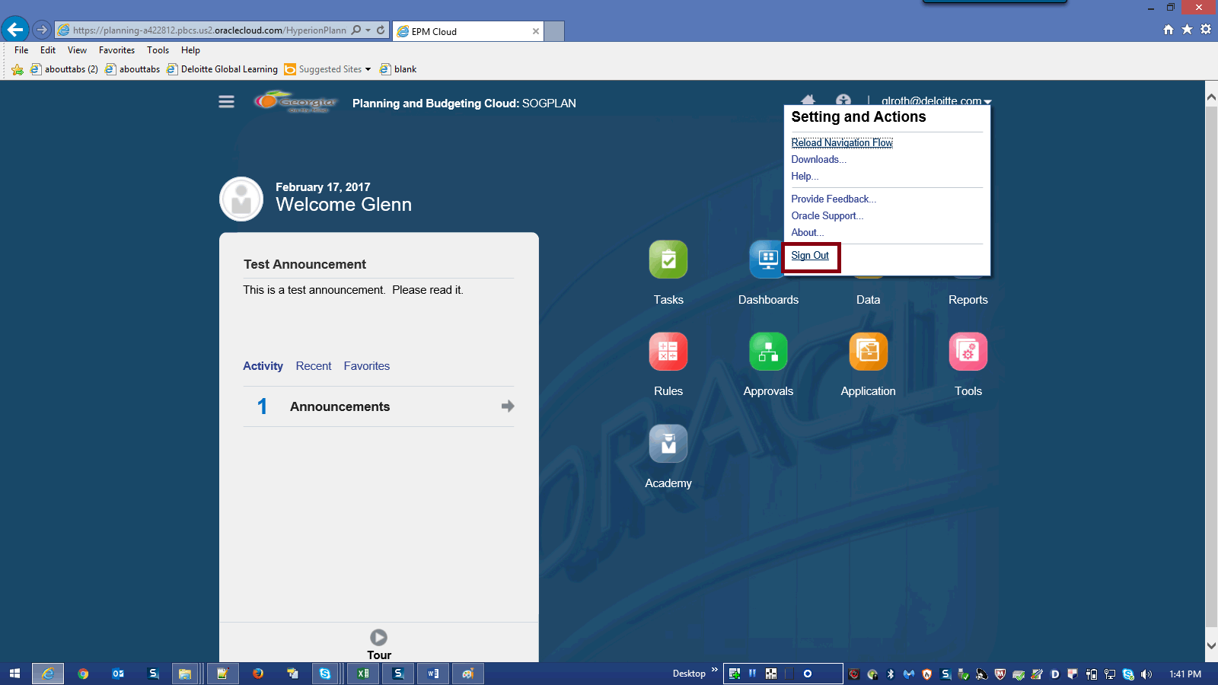

Step | Action | Author Notes
 | Click Sign Out link.
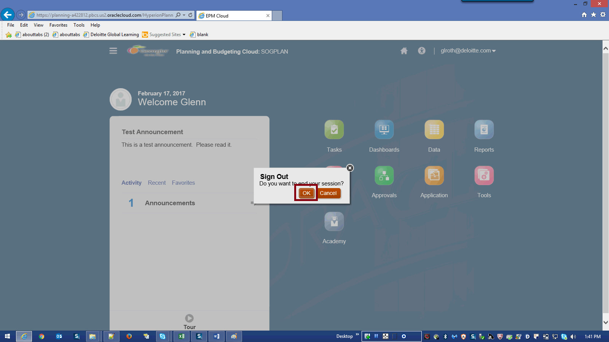

Step | Action | Author Notes
 | Click OK button.
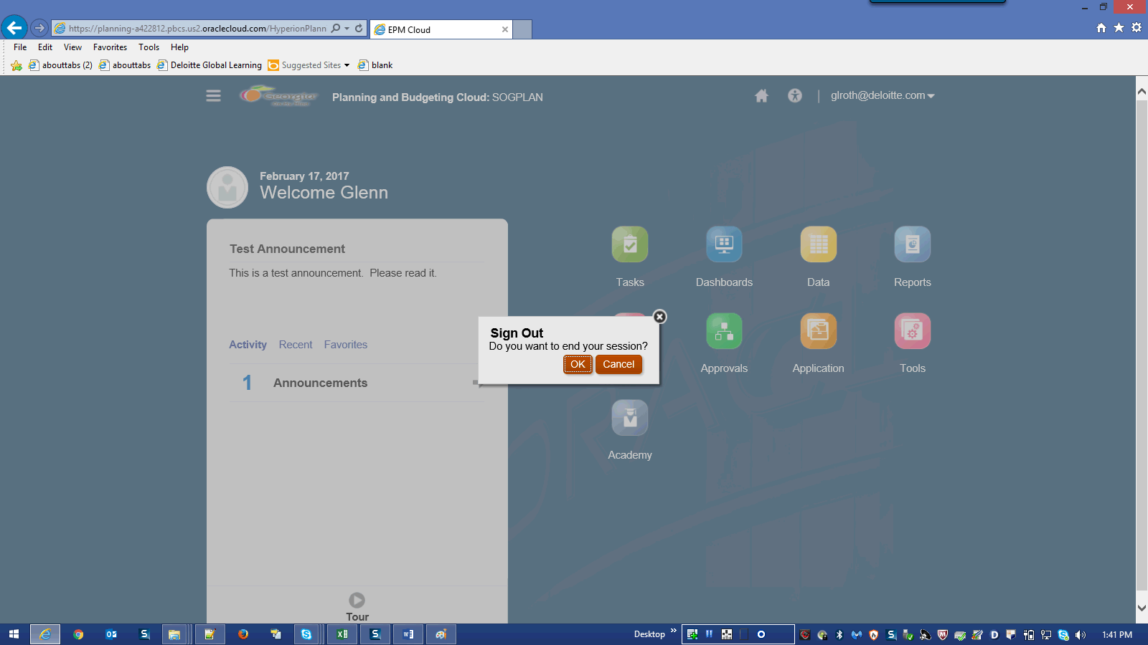

Step | Action | Author Notes
 | End of Procedure.

