Topic Name | 1.3 PBCS Navigation-Setting up User Preferences
Department
File Name
Date Modified
Last Changed by
Status
Owner

Test Procedure

Click the New tab tab. (Launch the web browser Firefox or Google Chrome)

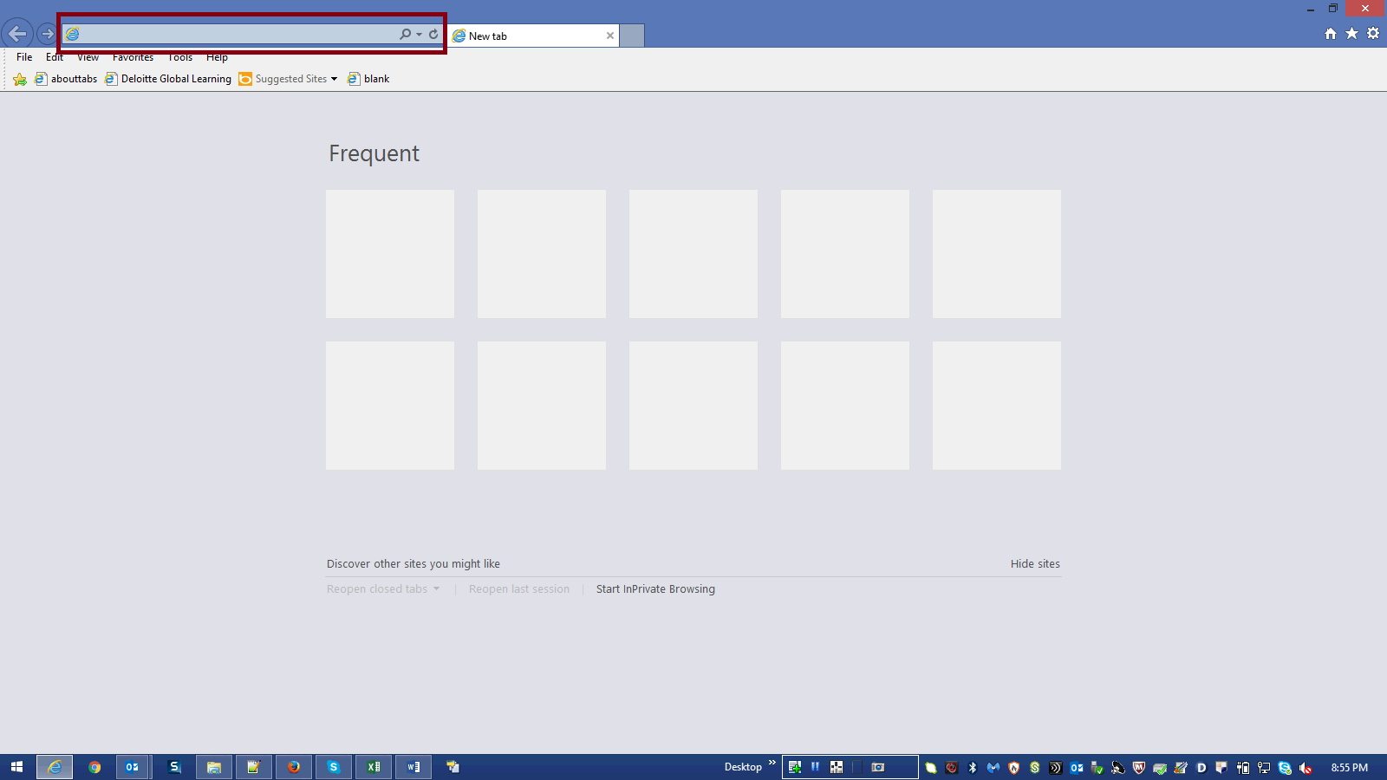

Step | Action | Author Notes
Copy application URL :
https://planning- a419537.pbcs.us2.oraclecloud.com/HyperionPlanning
 | Paste the URL in the browser and hit enter
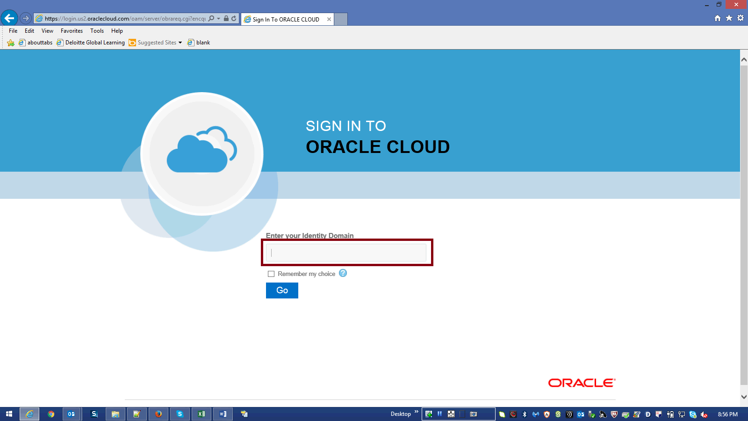

Step | Action | Author Notes
 | Enter your Identity Domain in the highlighted box.
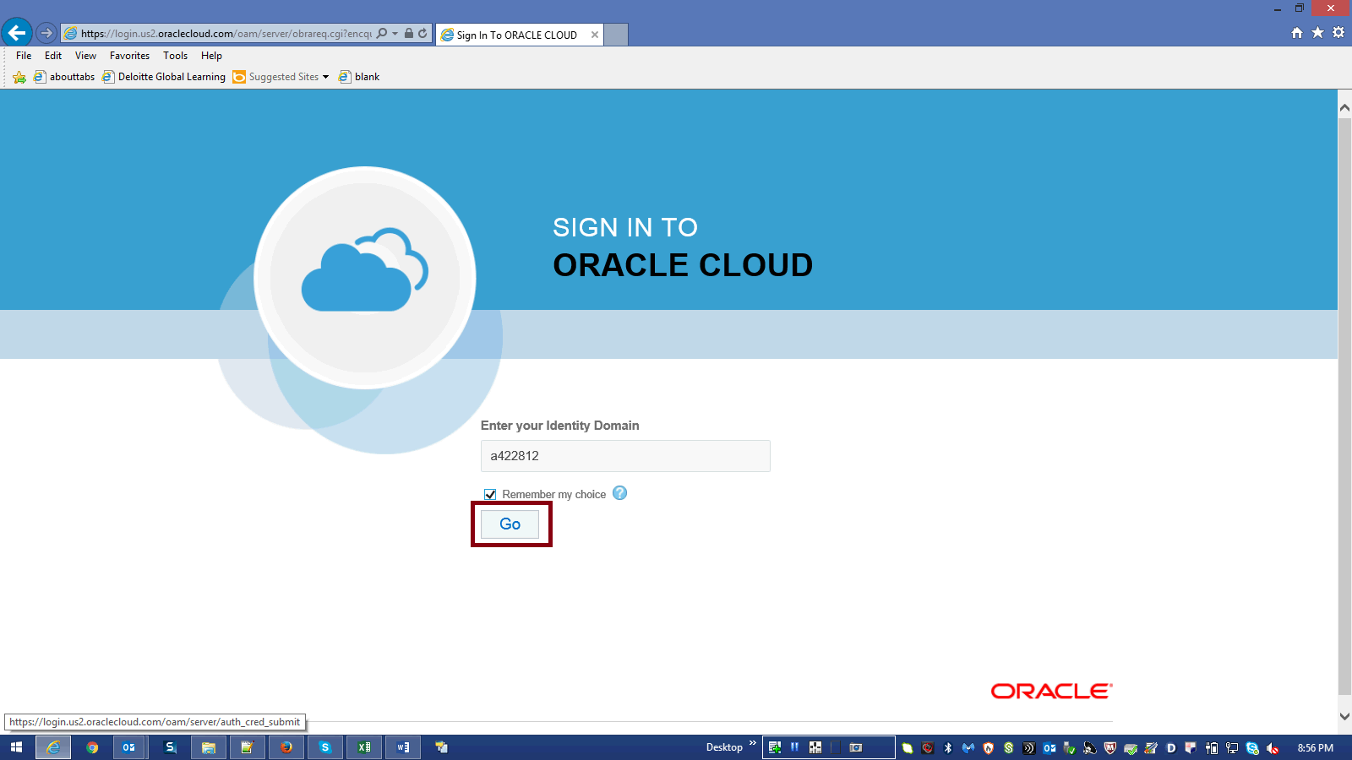

Step | Action | Author Notes
 | Click Go button.
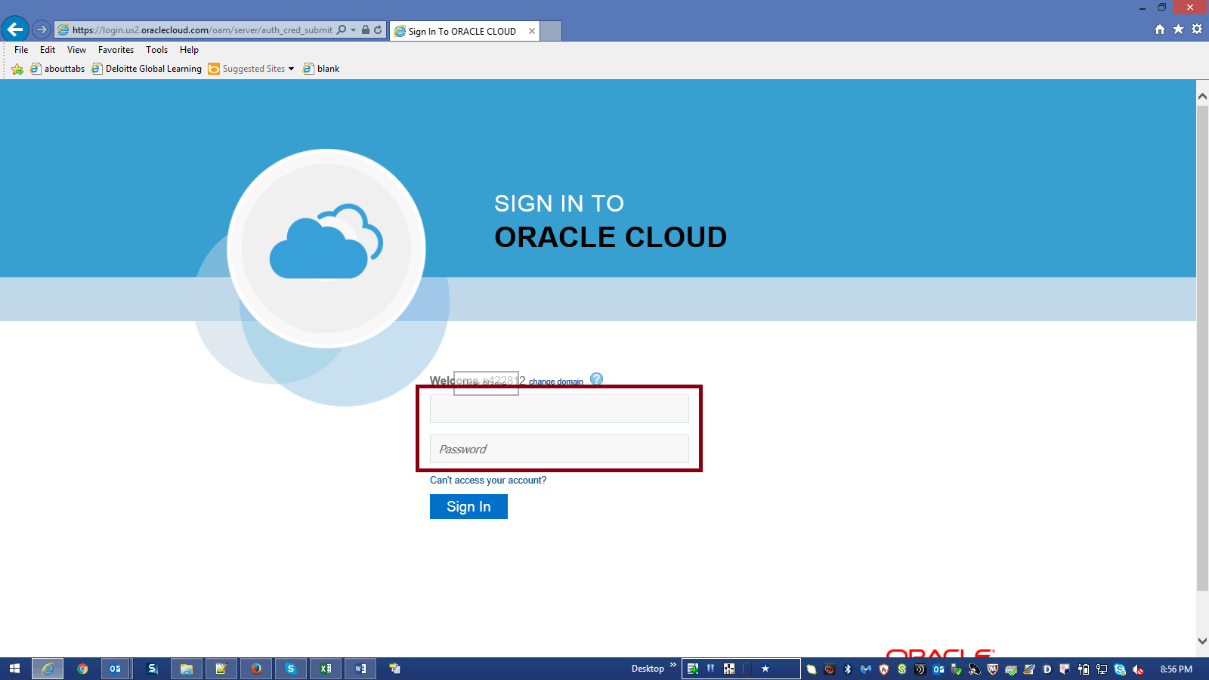

Step | Action | Author Notes
Enter Your UserName and Password then Click SignIn.
E.g.Username "xxxxx@xxxx.com".
Password : xxxxxx
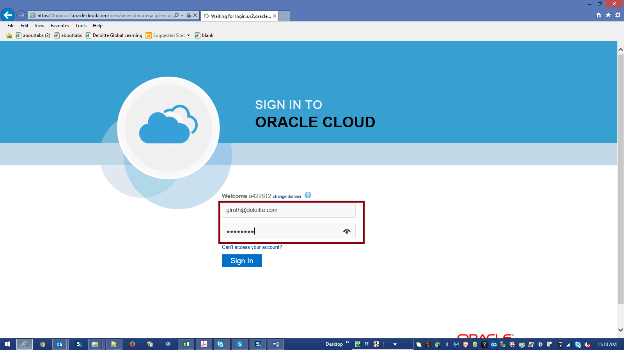

Step | Action | Author Notes
 | Click Sign in.

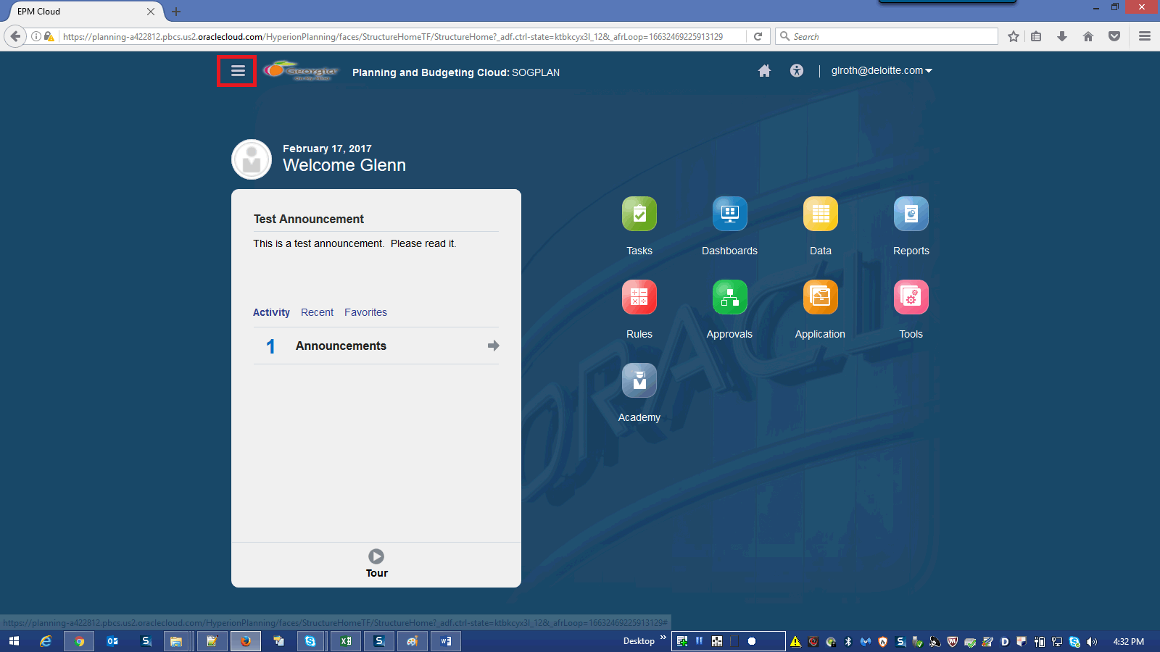

Step | Action | Author Notes
 | Click the Navigator graphic.
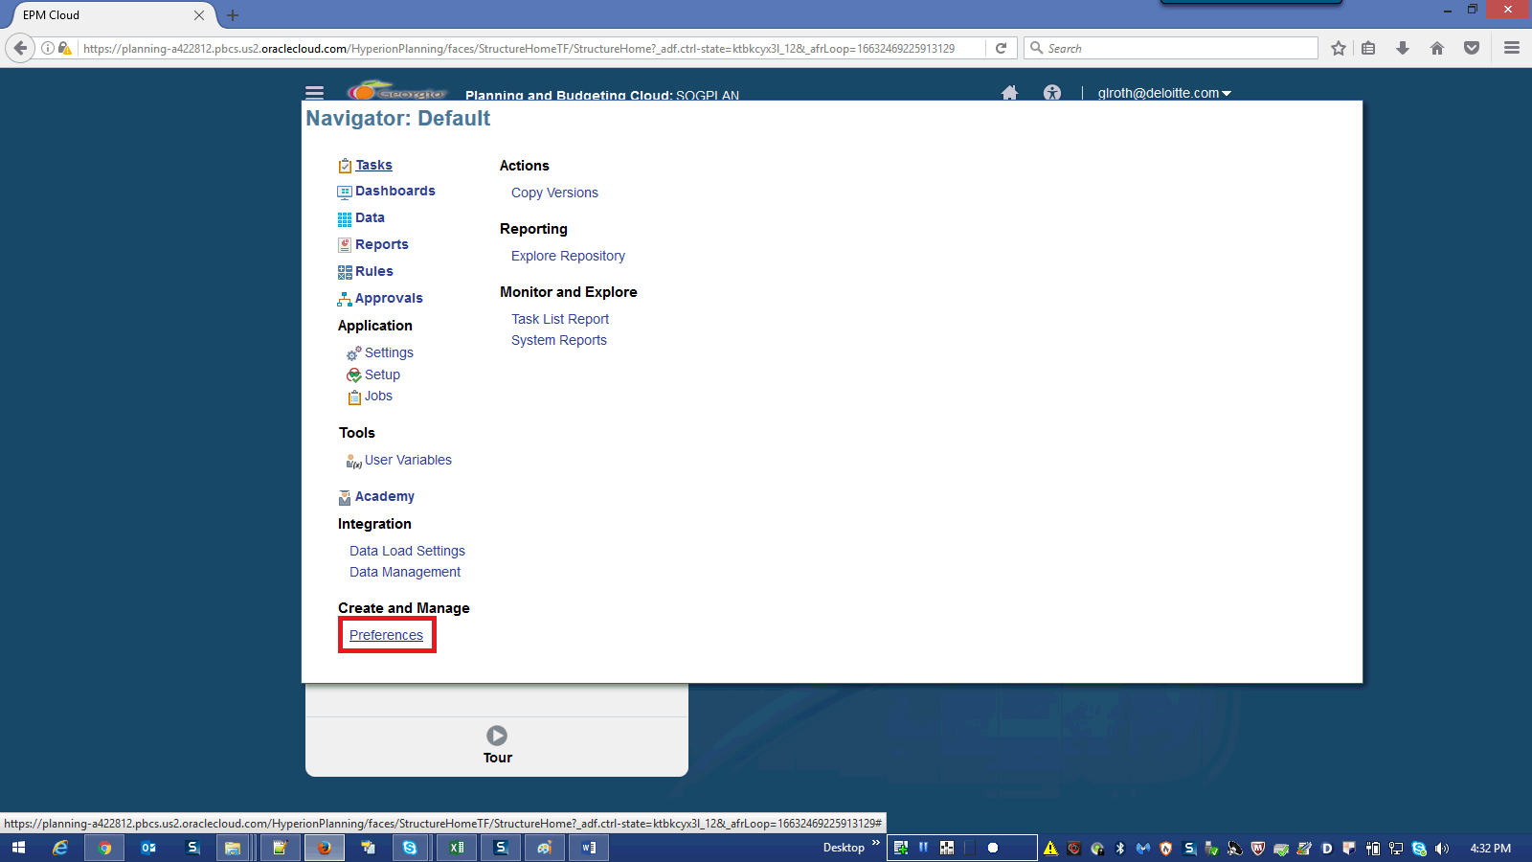

Step | Action | Author Notes
 | Click the Preferences link.
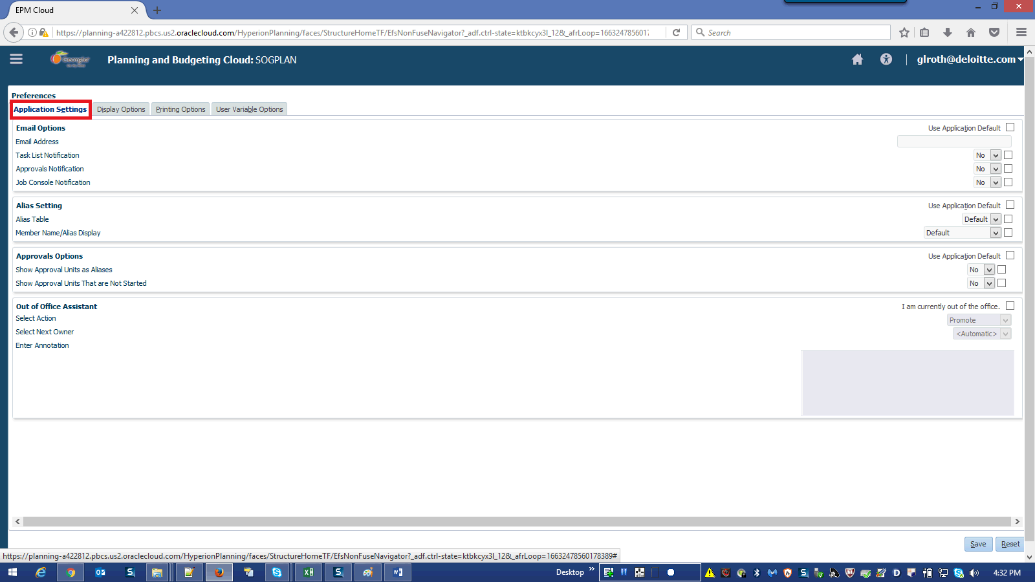

Step | Action | Author Notes
 | Click the Application Settings link.
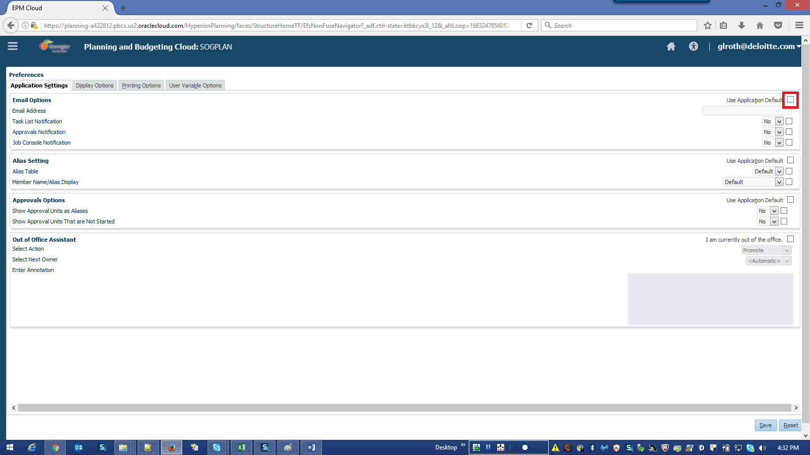

Step | Action | Author Notes
 | Click the Use Application Default option of Email Options.
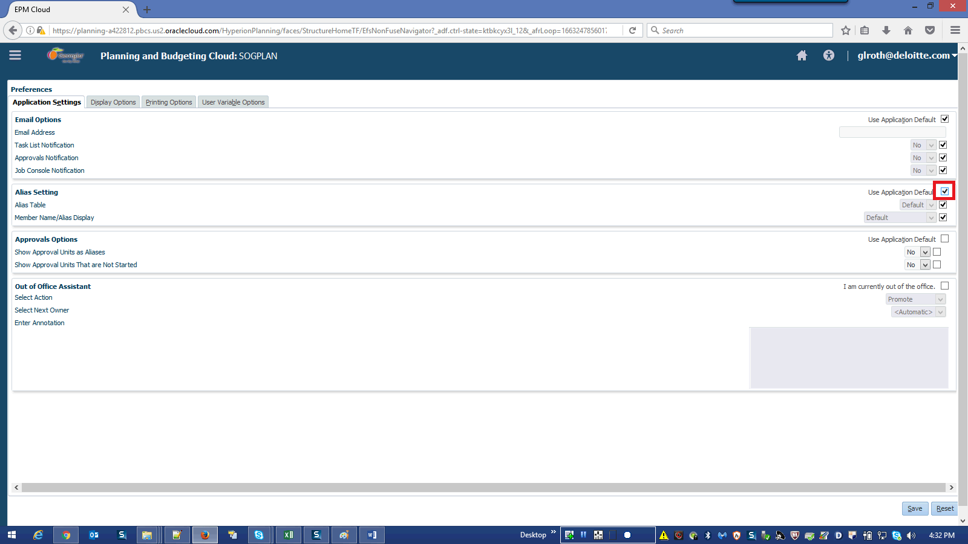

Step | Action | Author Notes
 | Click the Use Application Default option of Alias Setting.
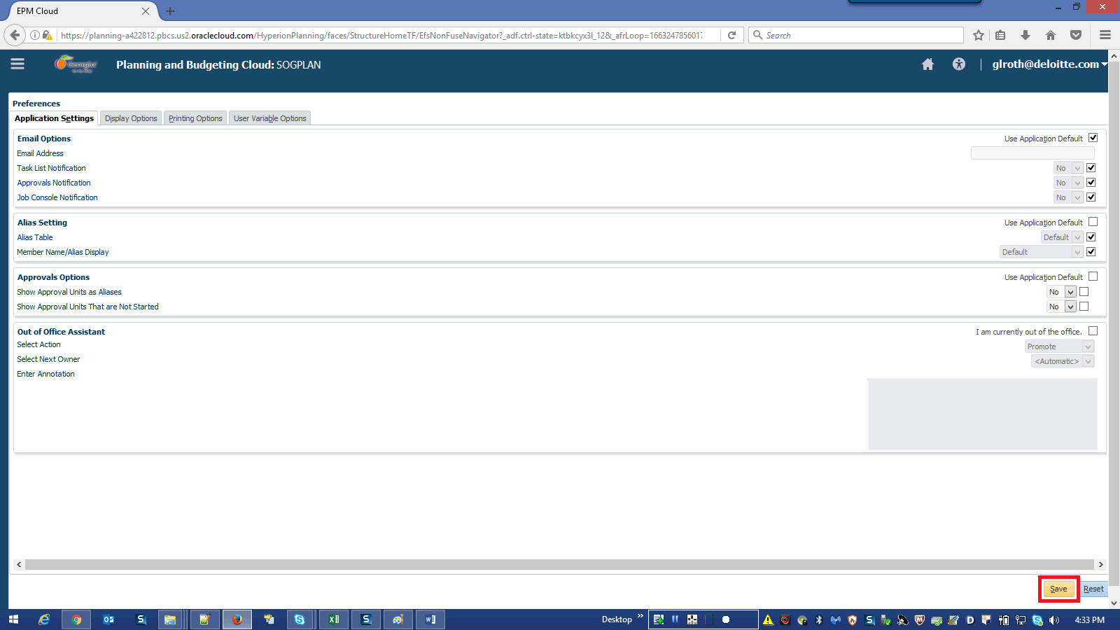

Step | Action | Author Notes
 | Click in the Save field.
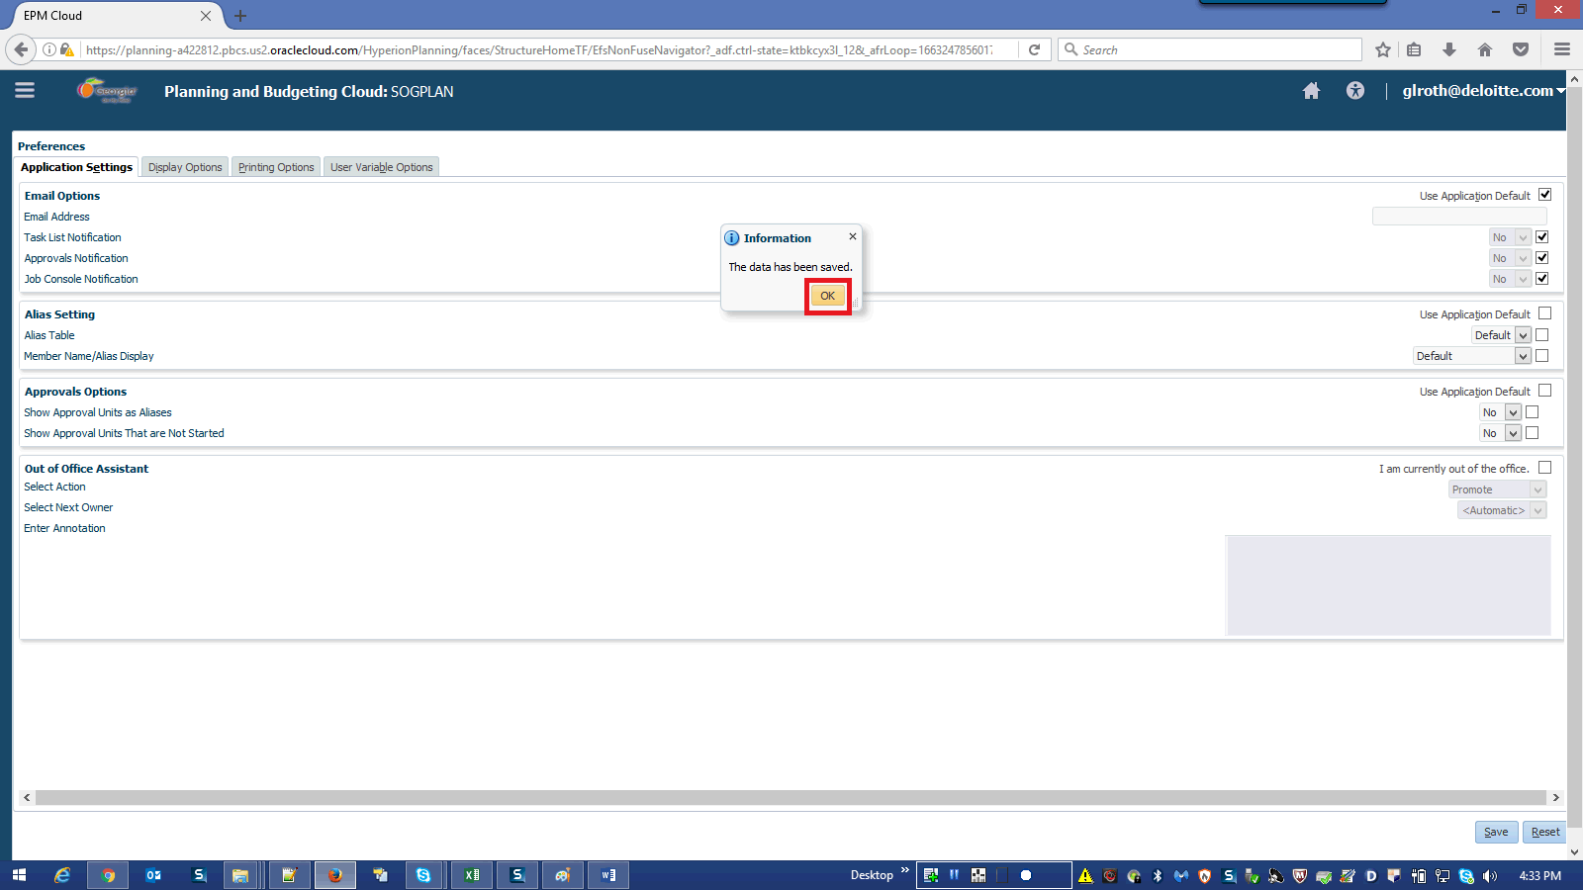

Step | Action | Author Notes
 | Click OK button.
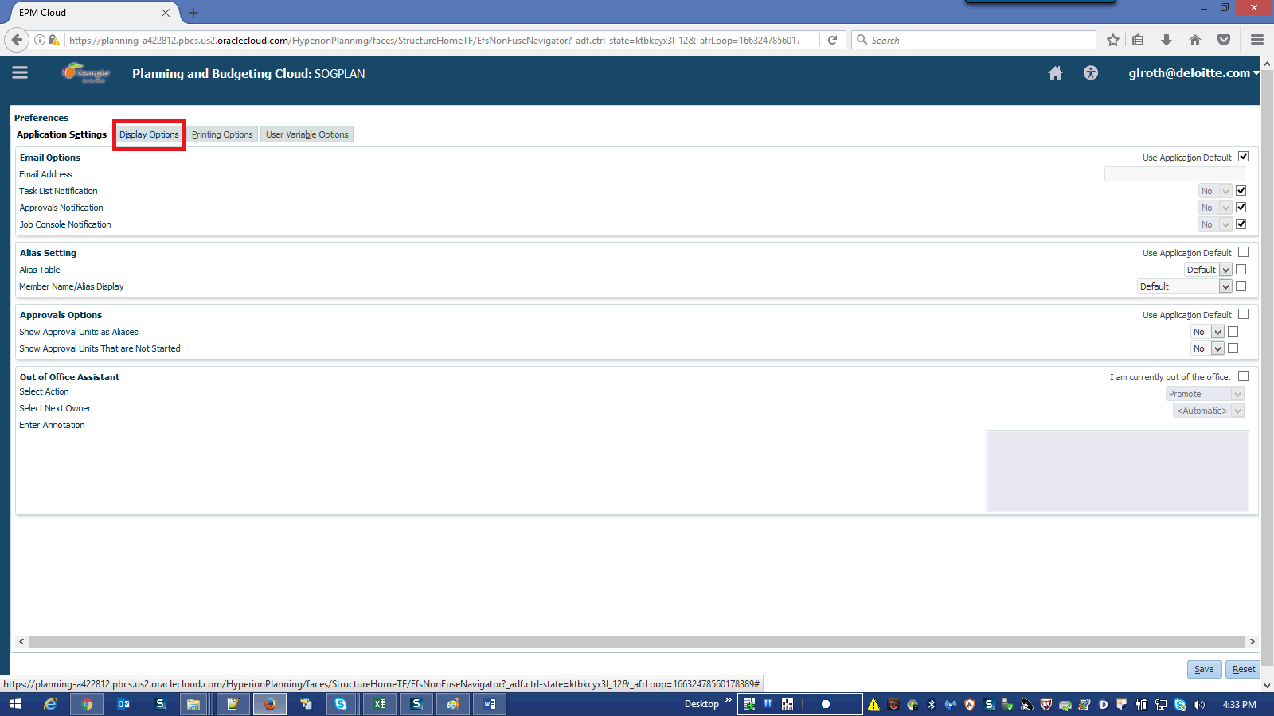

Step | Action | Author Notes
 | Click the Display Options link.
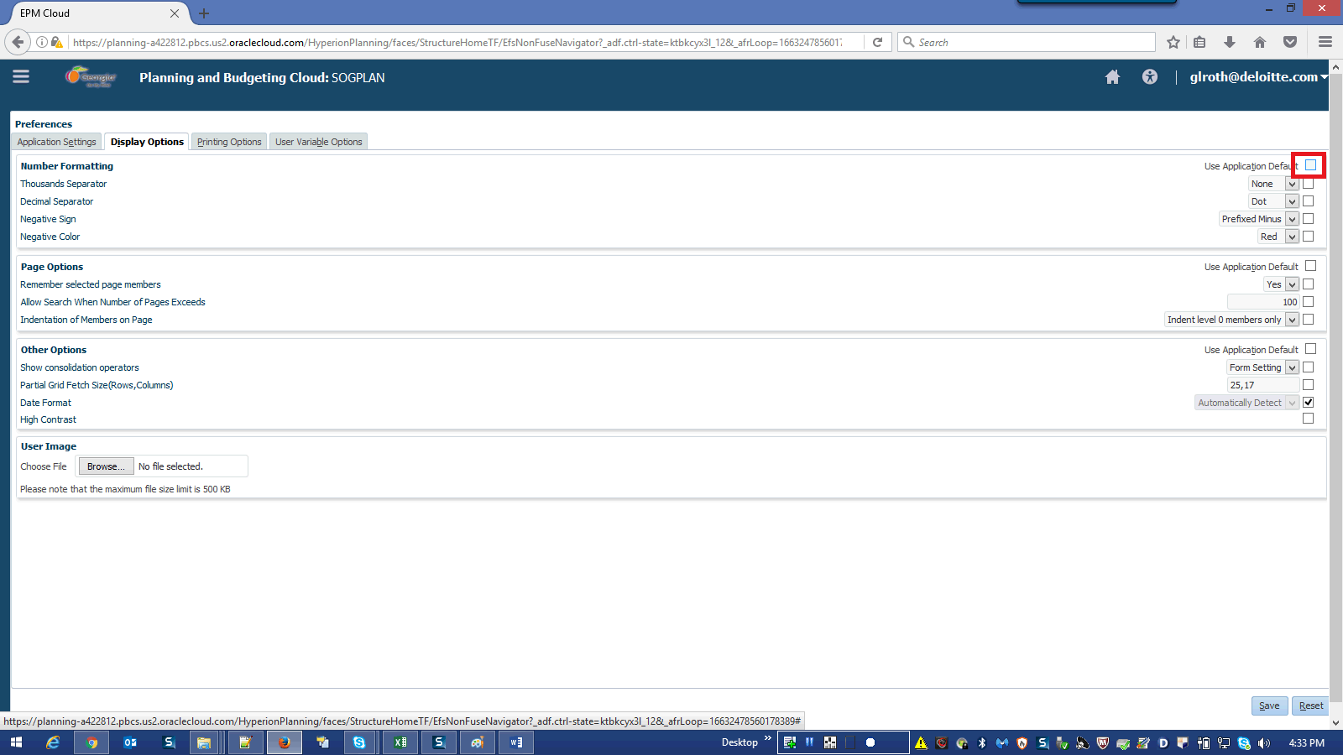

Step | Action | Author Notes
 | Click the Use Application Default option.

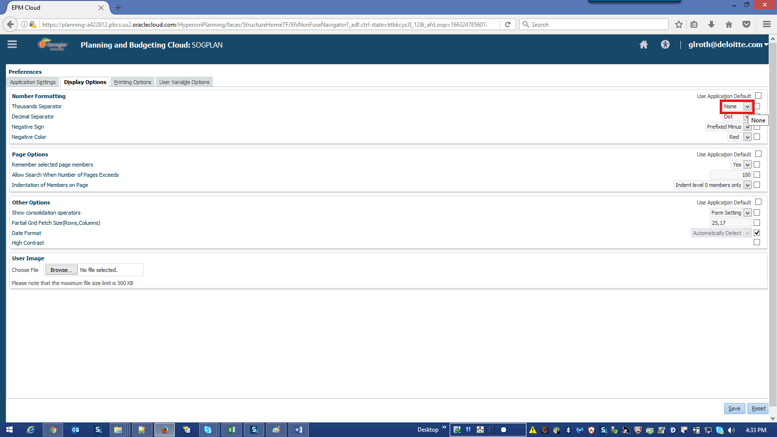

Step | Action | Author Notes
 | Click the Thousands Separator list.
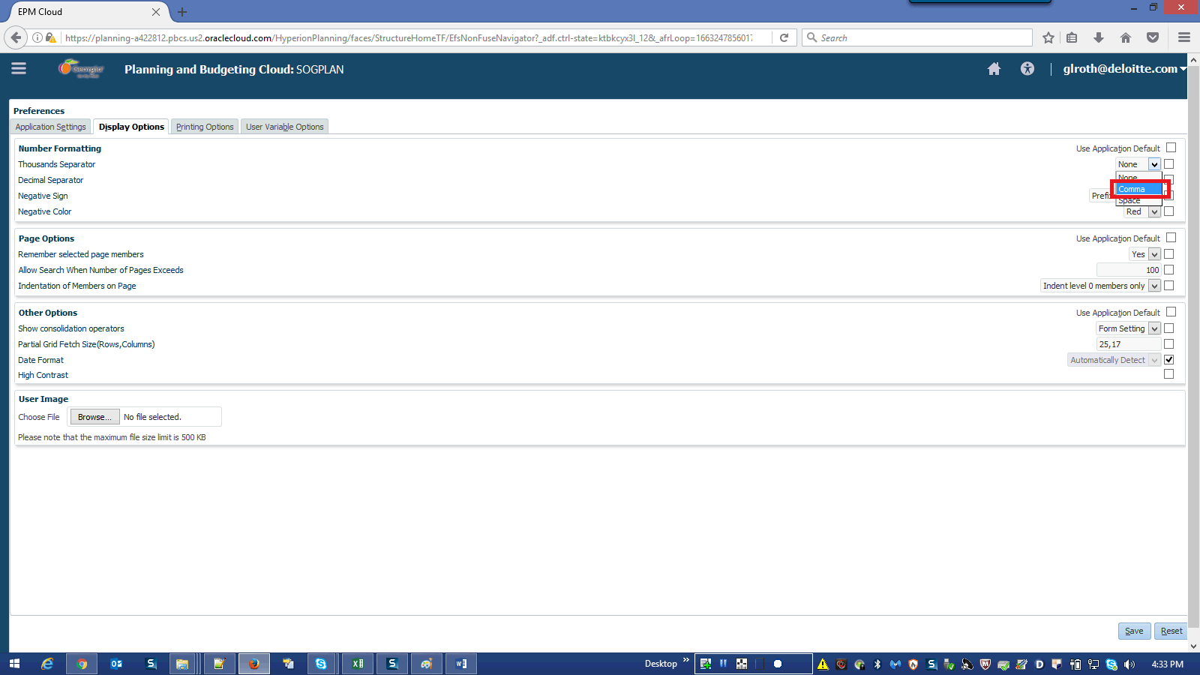

Step | Action | Author Notes
 | Select Comma from the list.
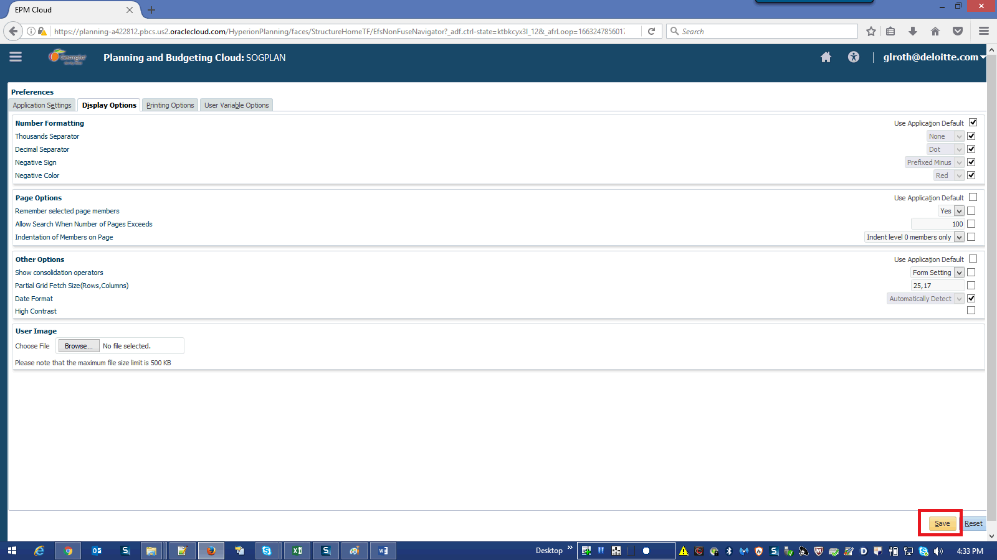

Step | Action | Author Notes
 | Click in the Save field.
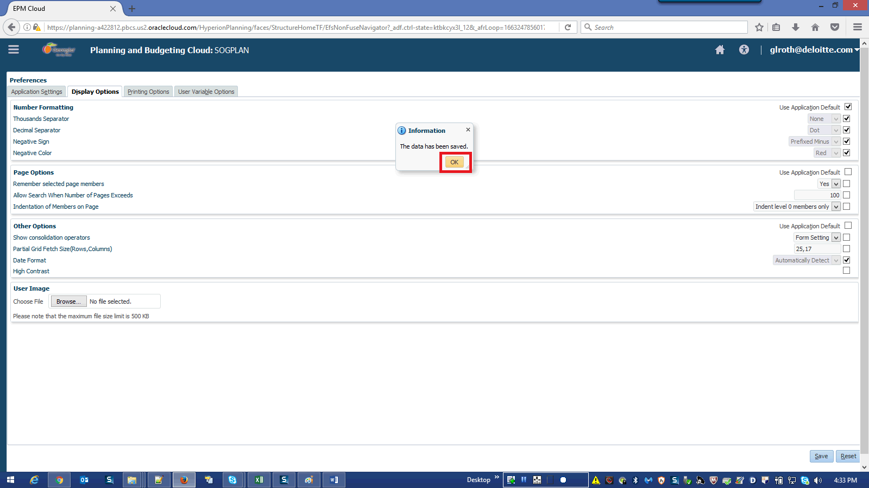

Step | Action | Author Notes
 | Click OK button.
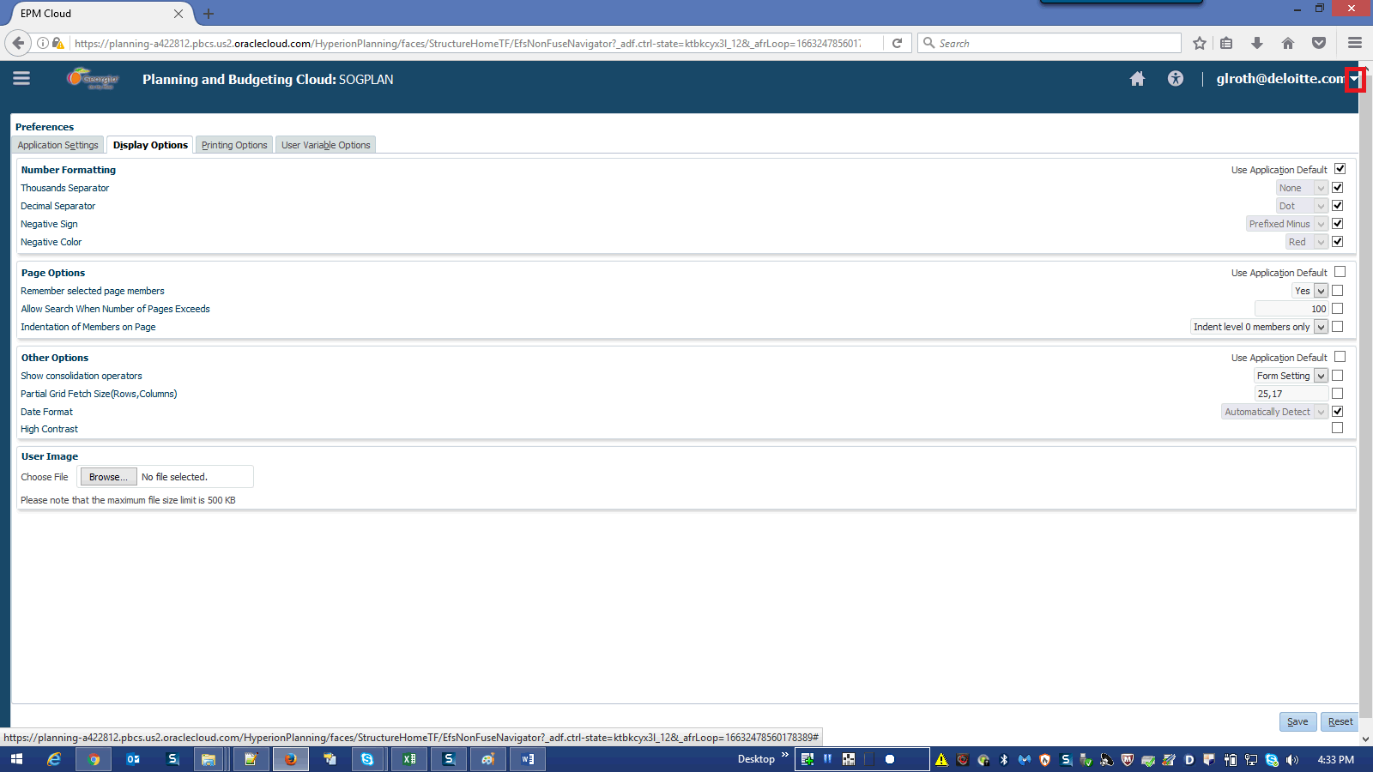

Step | Action | Author Notes
 | Click the glroth@deloitte.com graphic.
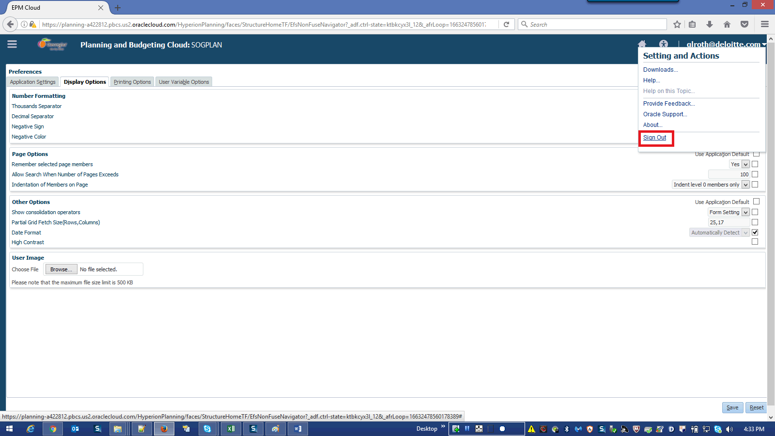

Step | Action | Author Notes
 | Click Sign Out.
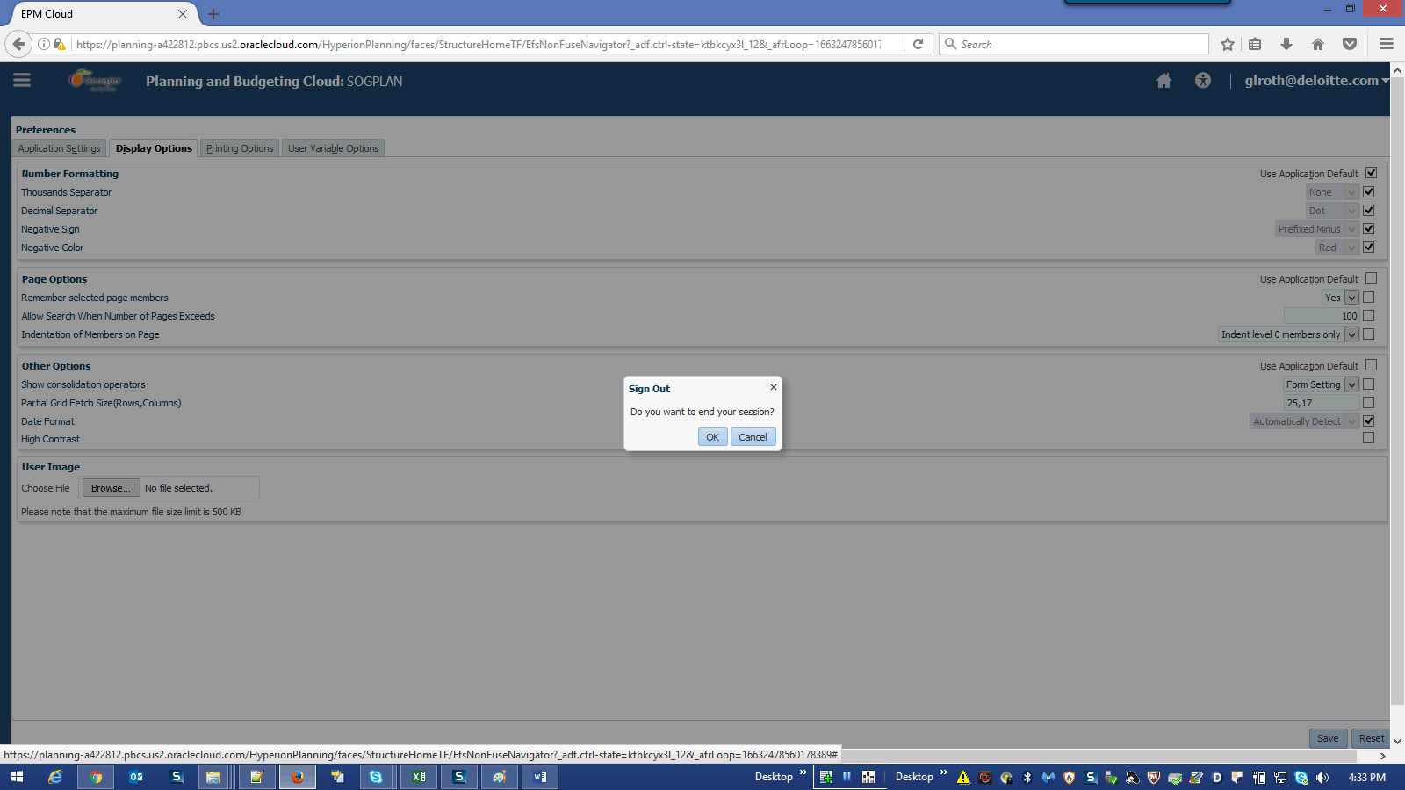

Step | Action | Author Notes
Click OK.

End of Procedure.

