Topic Name | 2.1AOBPlanner: Budget Management-Agency Entry and submittal of AOB
Department
File Name
Date Modified
Last Changed by
Status
Owner

Test Procedure
Step | Action | Author Notes
 | Click New tab tab. (Launch web browser Firefox or Google Chrome)

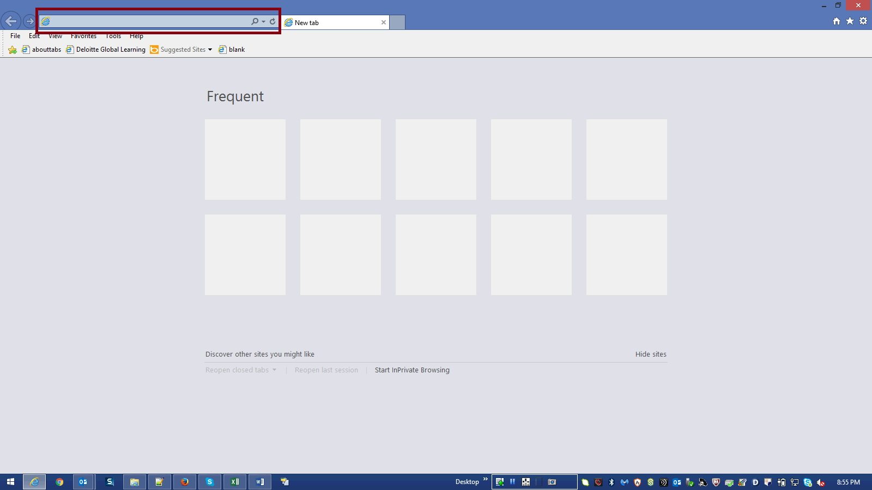

Step | Action | Author Notes
Copy application URL :
https://planning- a419537.pbcs.us2.oraclecloud.com/HyperionPlanning
 | Paste URL in browser and hit enter
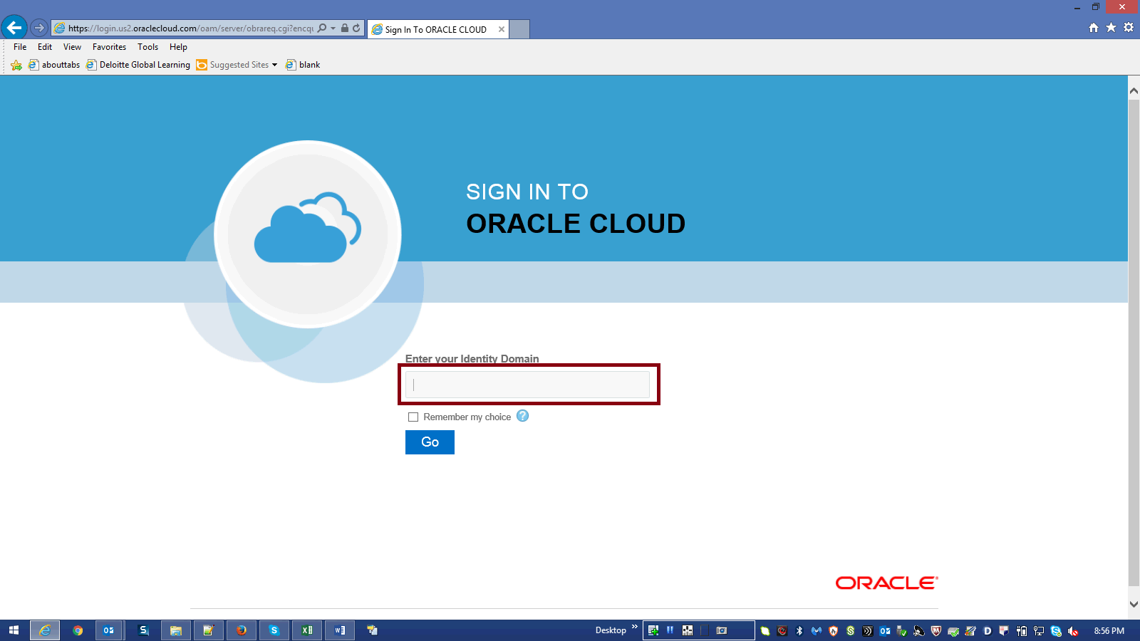

Step | Action | Author Notes
 | Enter your Identity Domain in the highlighted box.
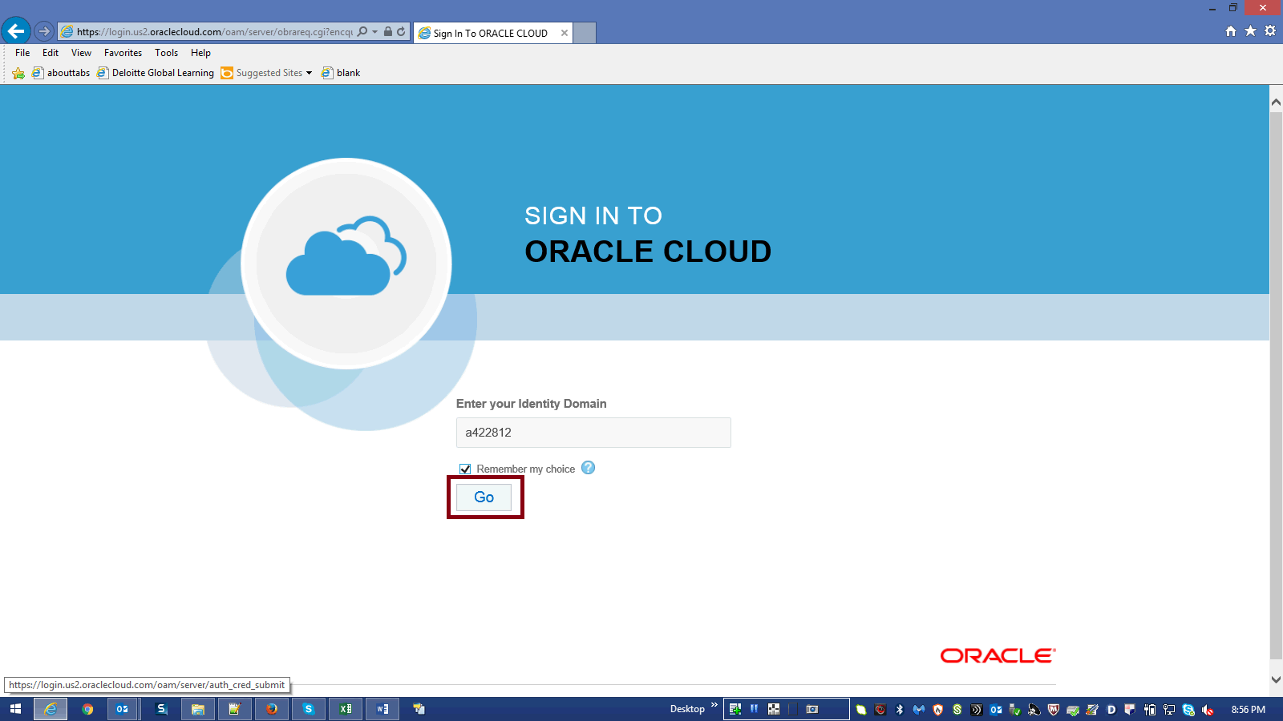

Step | Action | Author Notes
 | Click Go button.
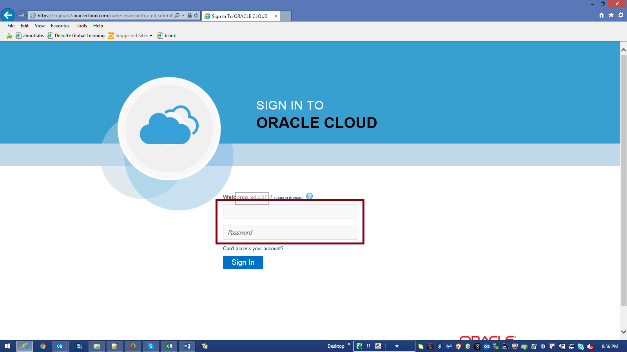

Step | Action | Author Notes
Enter Your UserName and Password.
Enter a valid value
E.g.Username "xxxxx@xxxx.com".
Password : xxxxxx
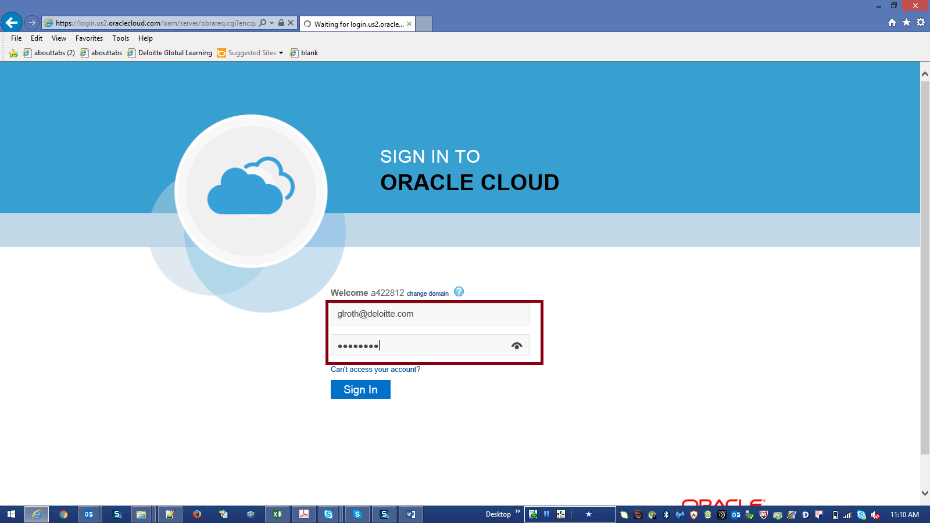

Step | Action | Author Notes
 | Click Sign in.

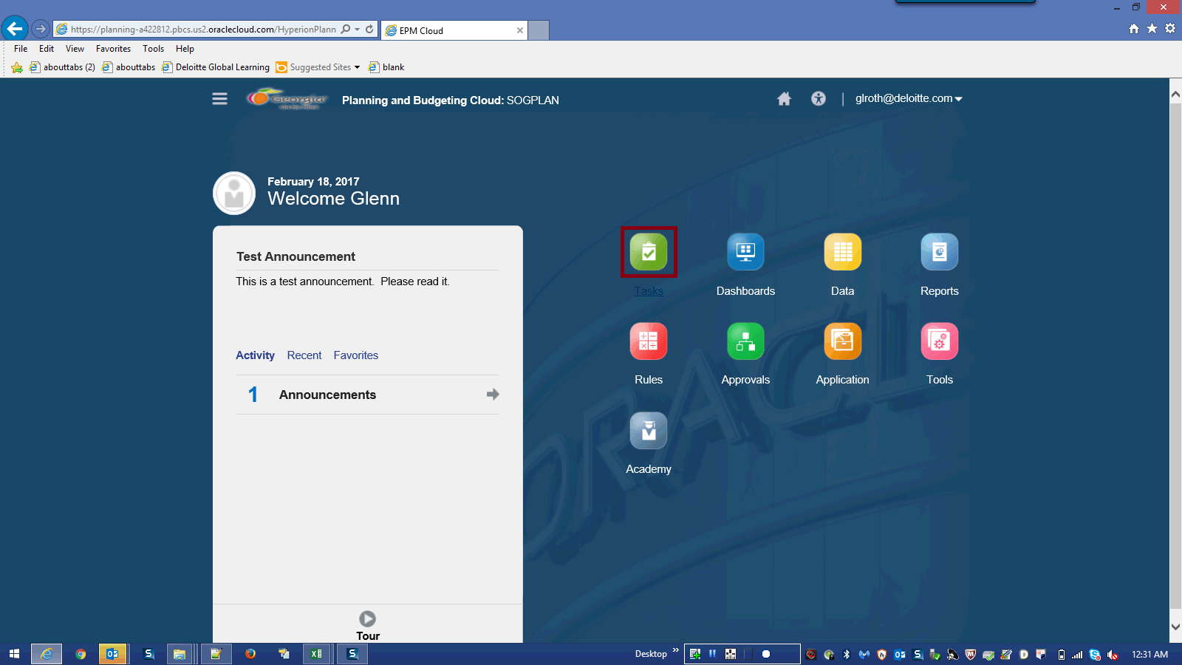

Step | Action | Author Notes
 | Click the Tasks link.
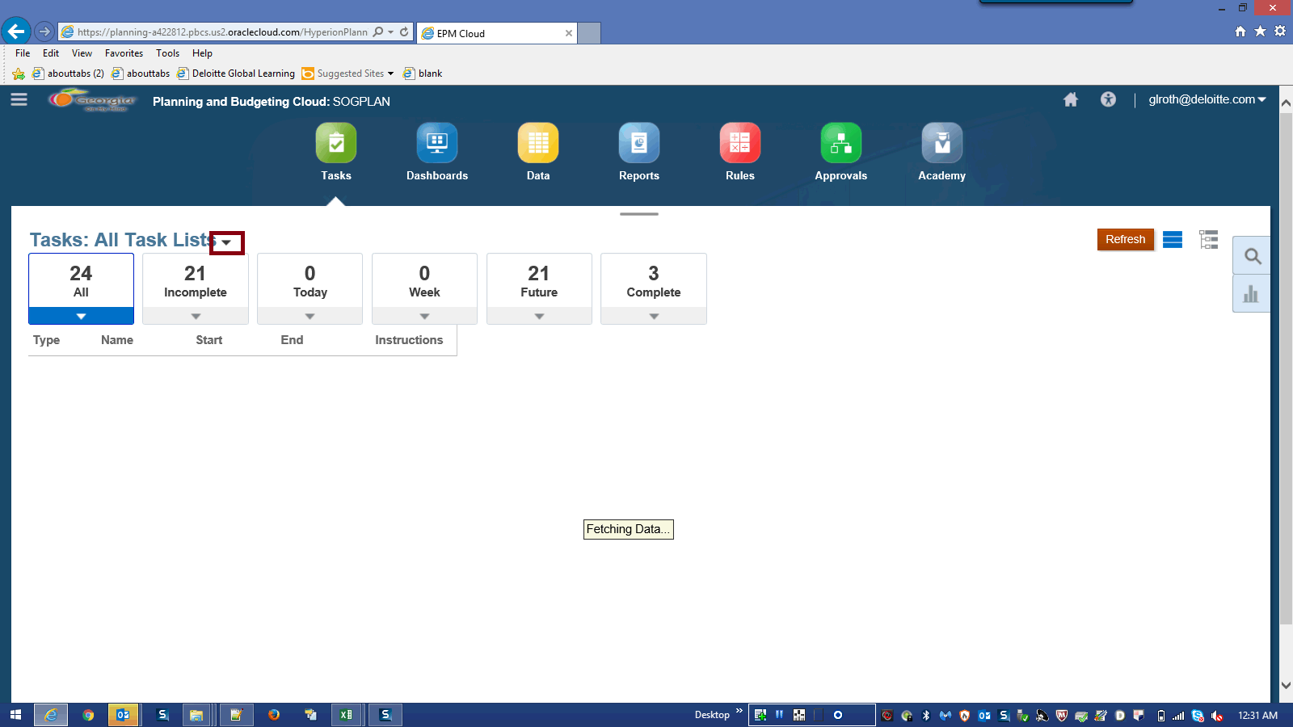

Step | Action | Author Notes
 | Click the Tasks: All Task Lists… list.
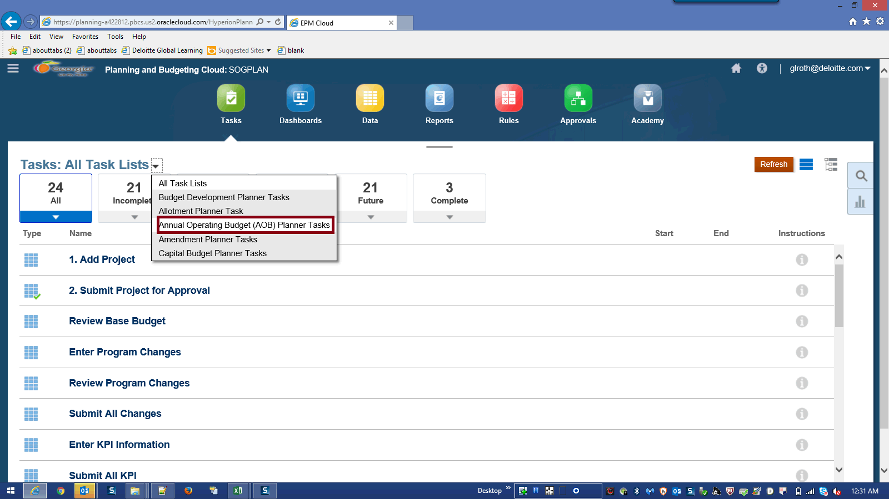

Step | Action | Author Notes
 | Click the Annual Operating Budget (AOB) Planner Tasks list item.
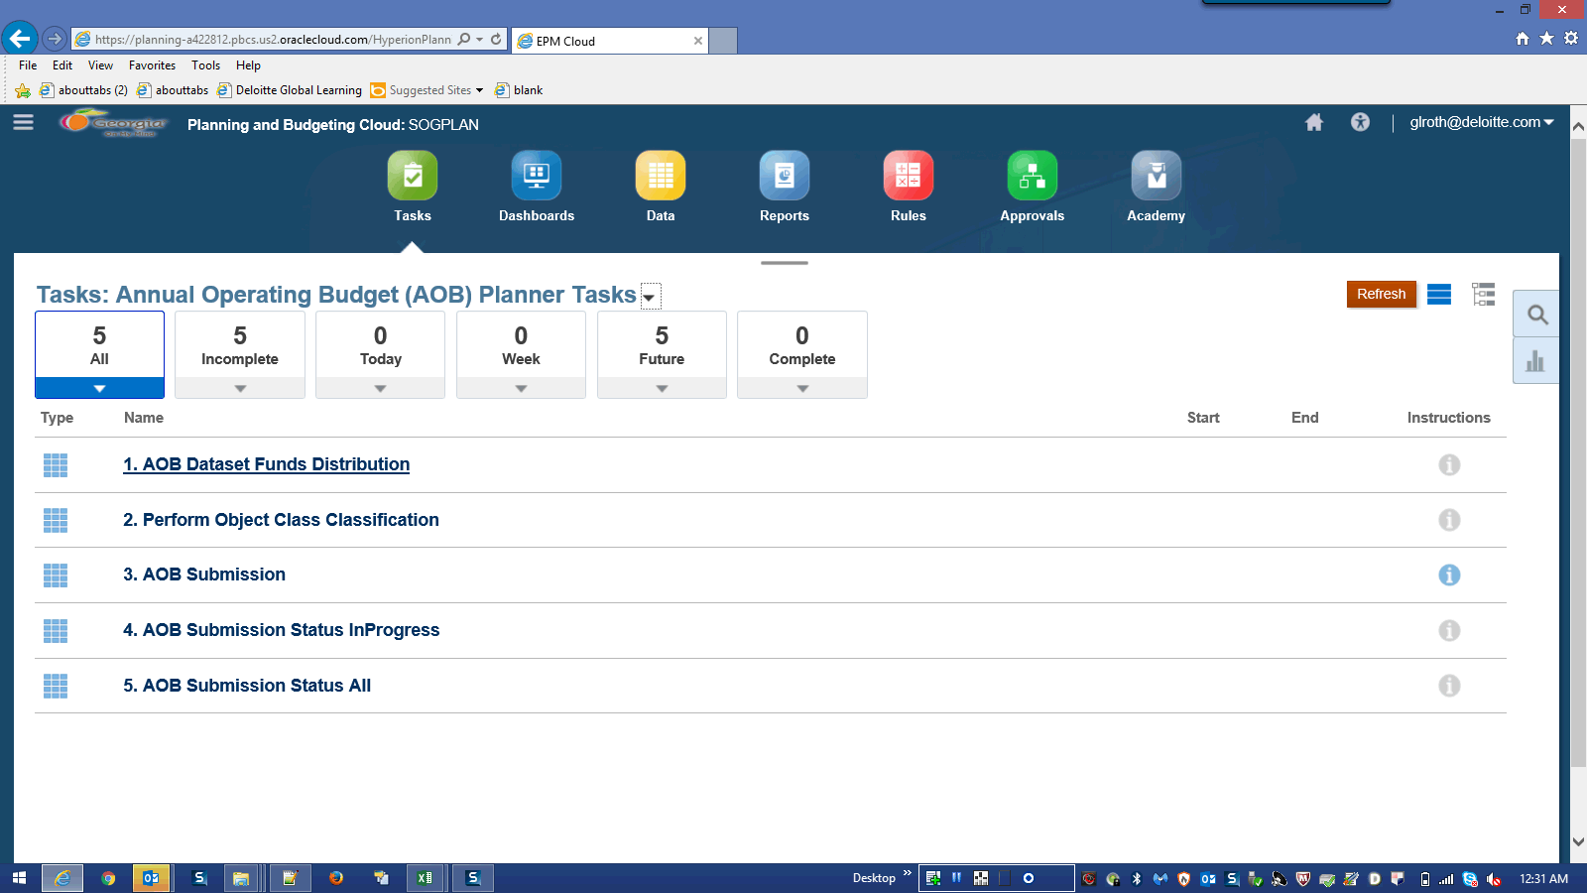

Step | Action | Author Notes
 | Click the 1. AOB Dataset Funds Distribution link.
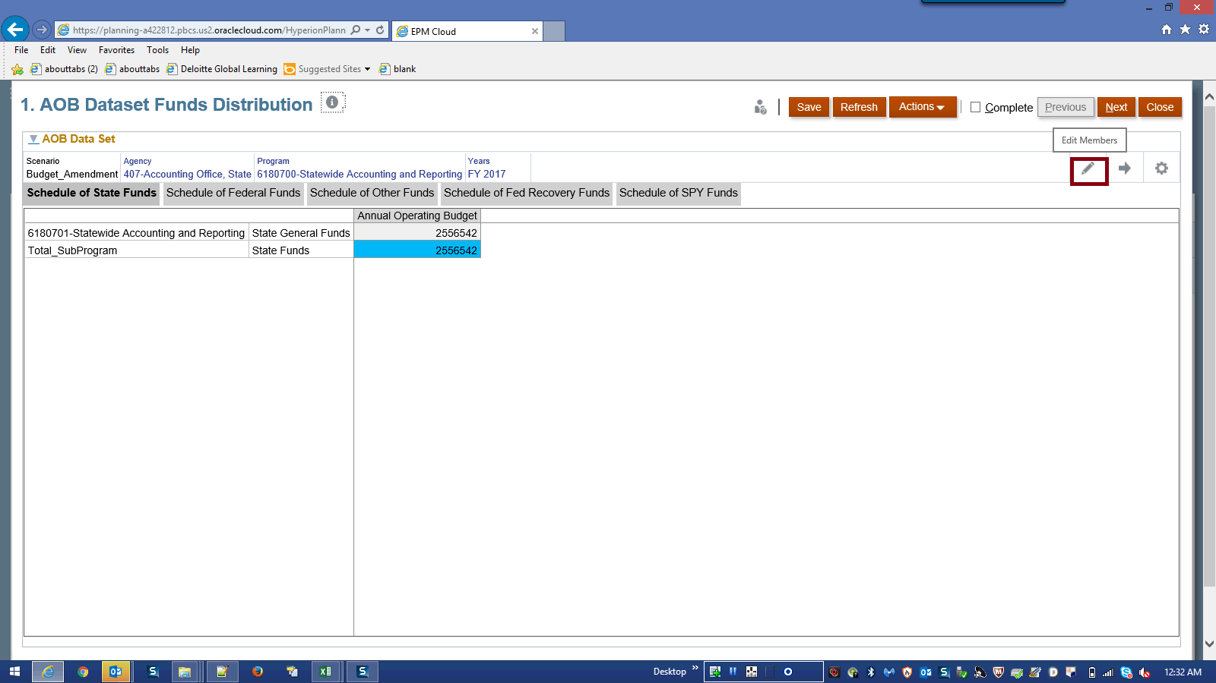

Step | Action | Author Notes
 | Click the Edit Members button.
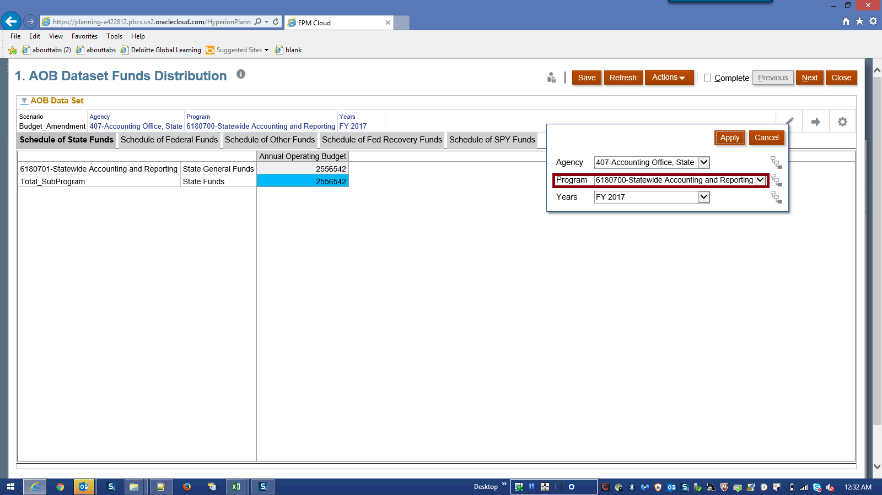

Step | Action | Author Notes
 | Click the Program list.
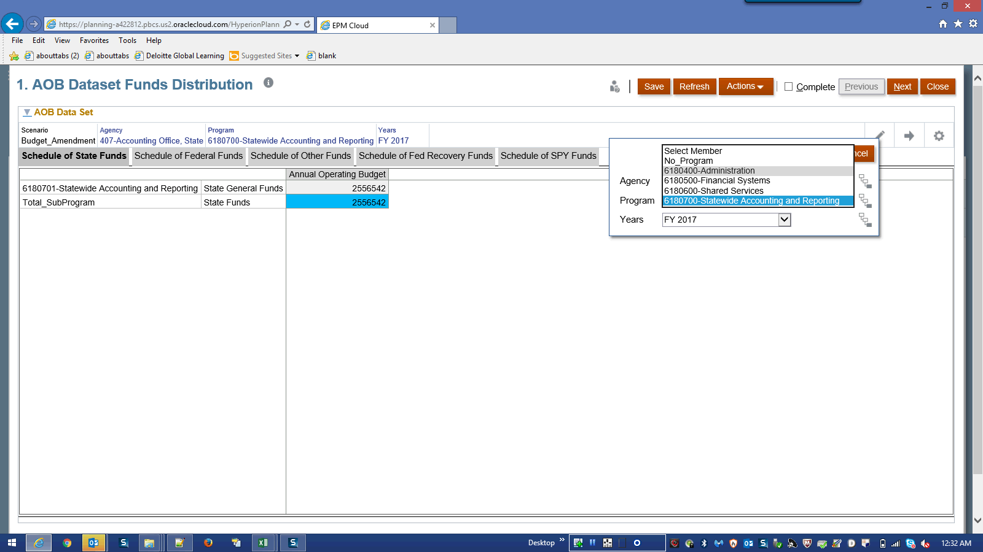

Step | Action | Author Notes
 | Click the program name list item.
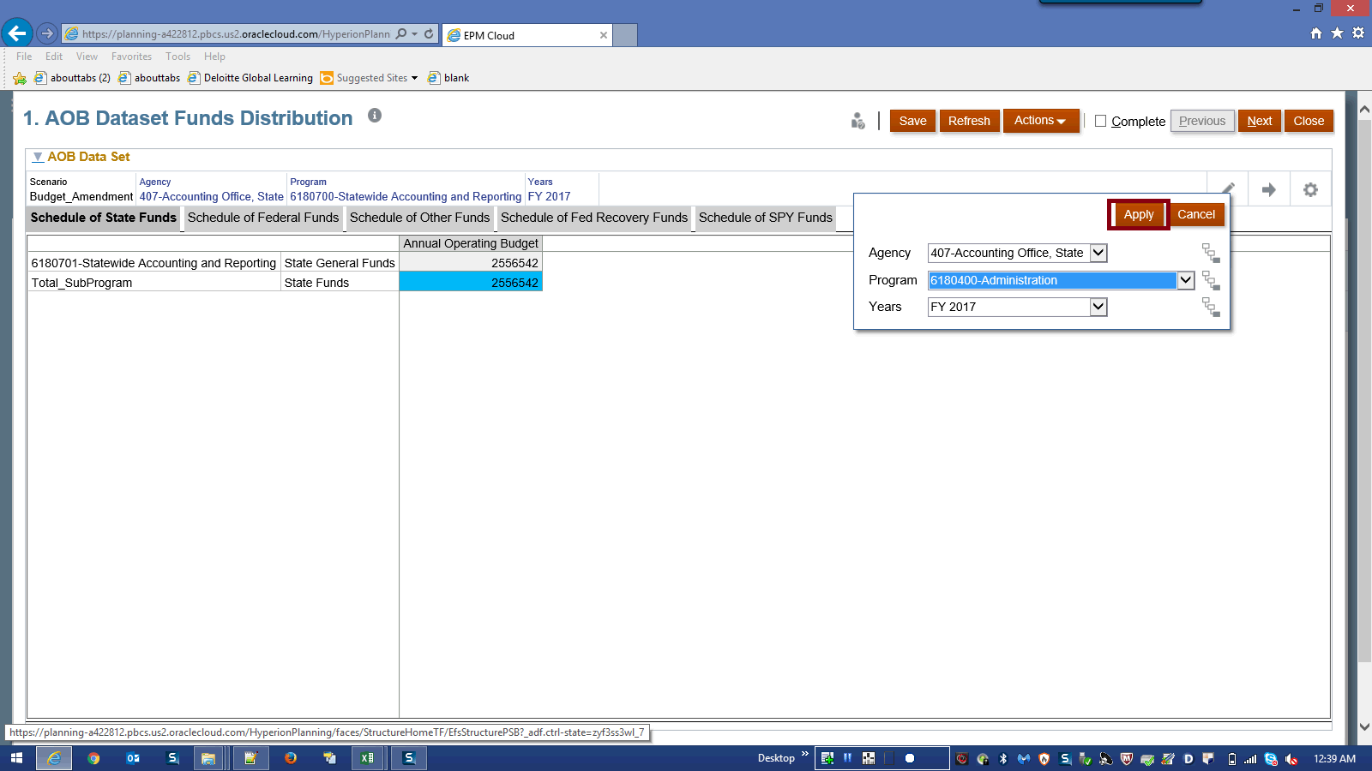

Step | Action | Author Notes
 | Click the Apply object.
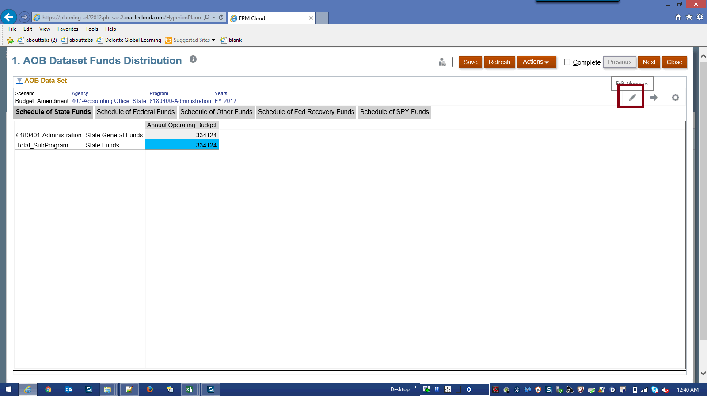

Step | Action | Author Notes
 | Click the Edit Members button.
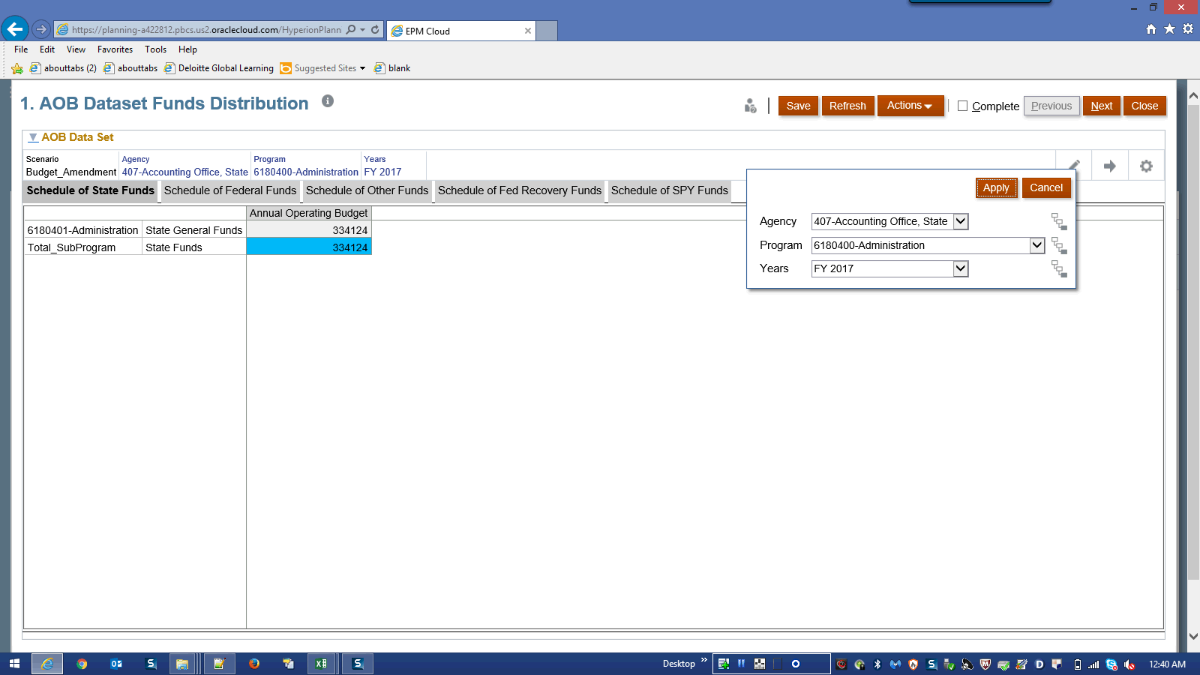

Step | Action | Author Notes
Click the Agency list.
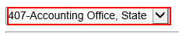
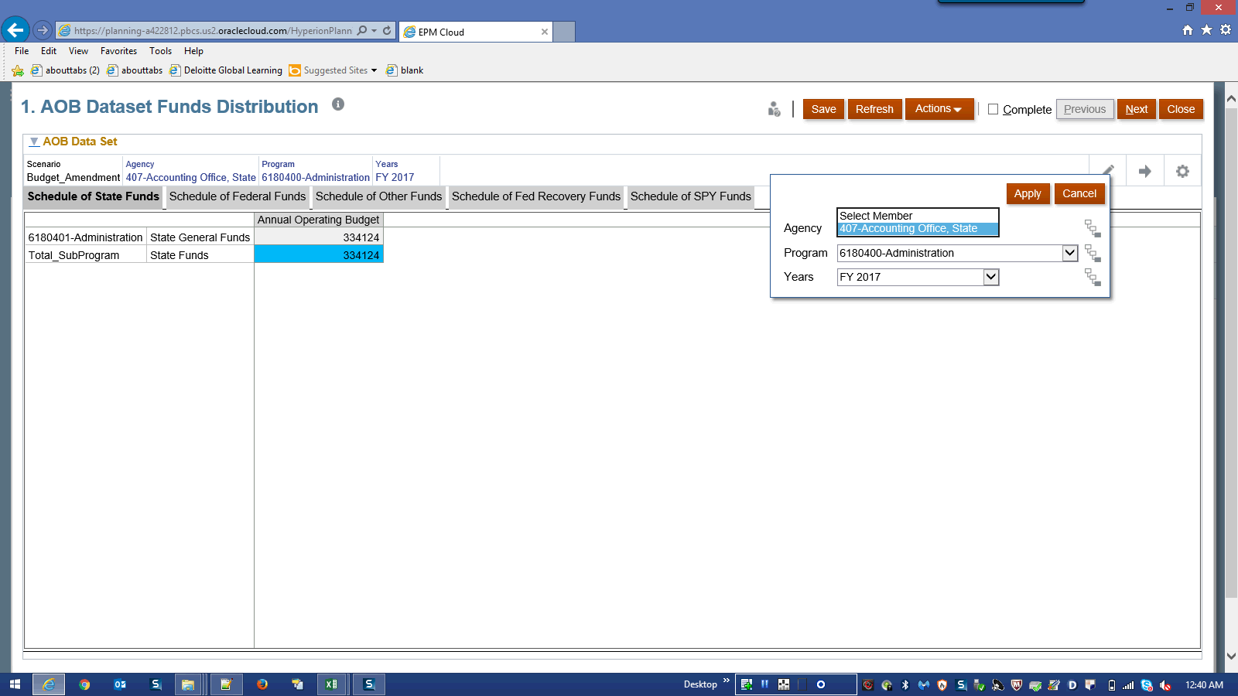

Step | Action | Author Notes
 | Click the 407-Accounting Office, State list item.
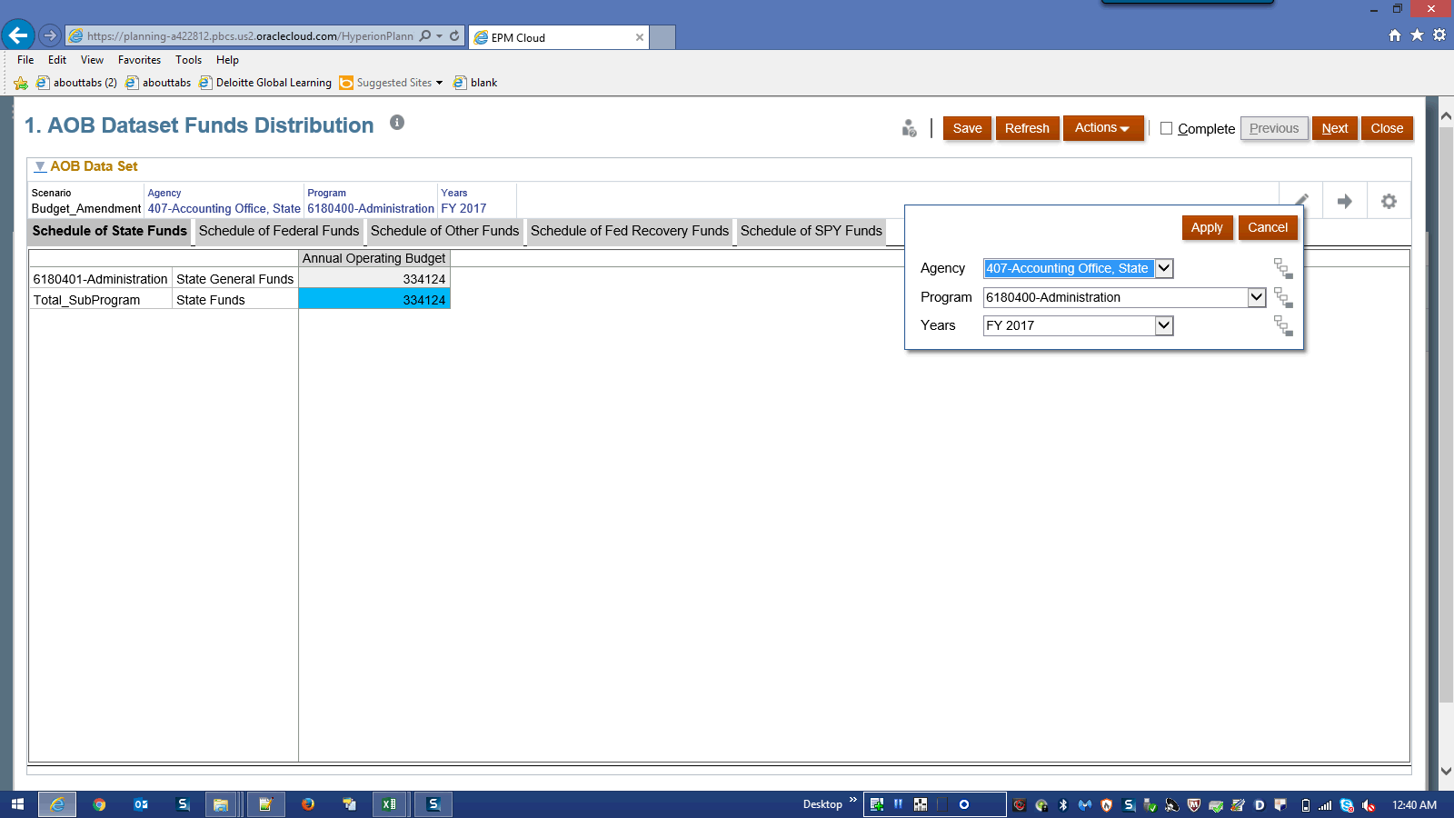

Step | Action | Author Notes
 | Click the Years list.
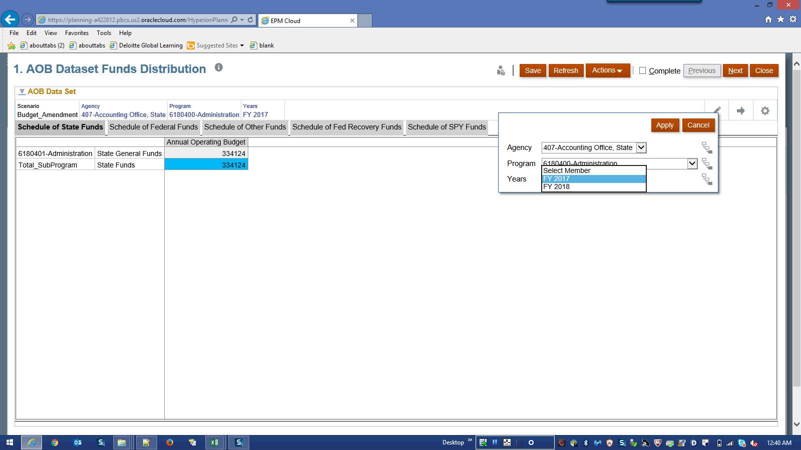

Step | Action | Author Notes
 | Click the FY 2017 list item.
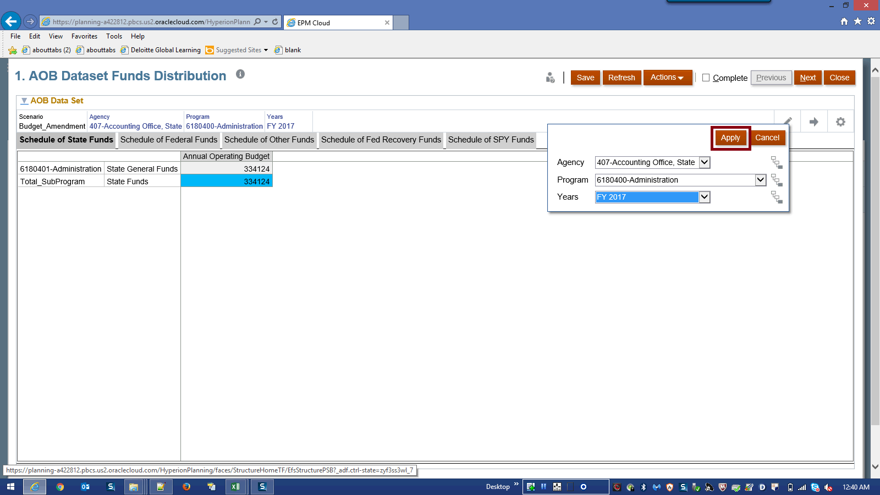

Step | Action | Author Notes
 | Click the Apply button.
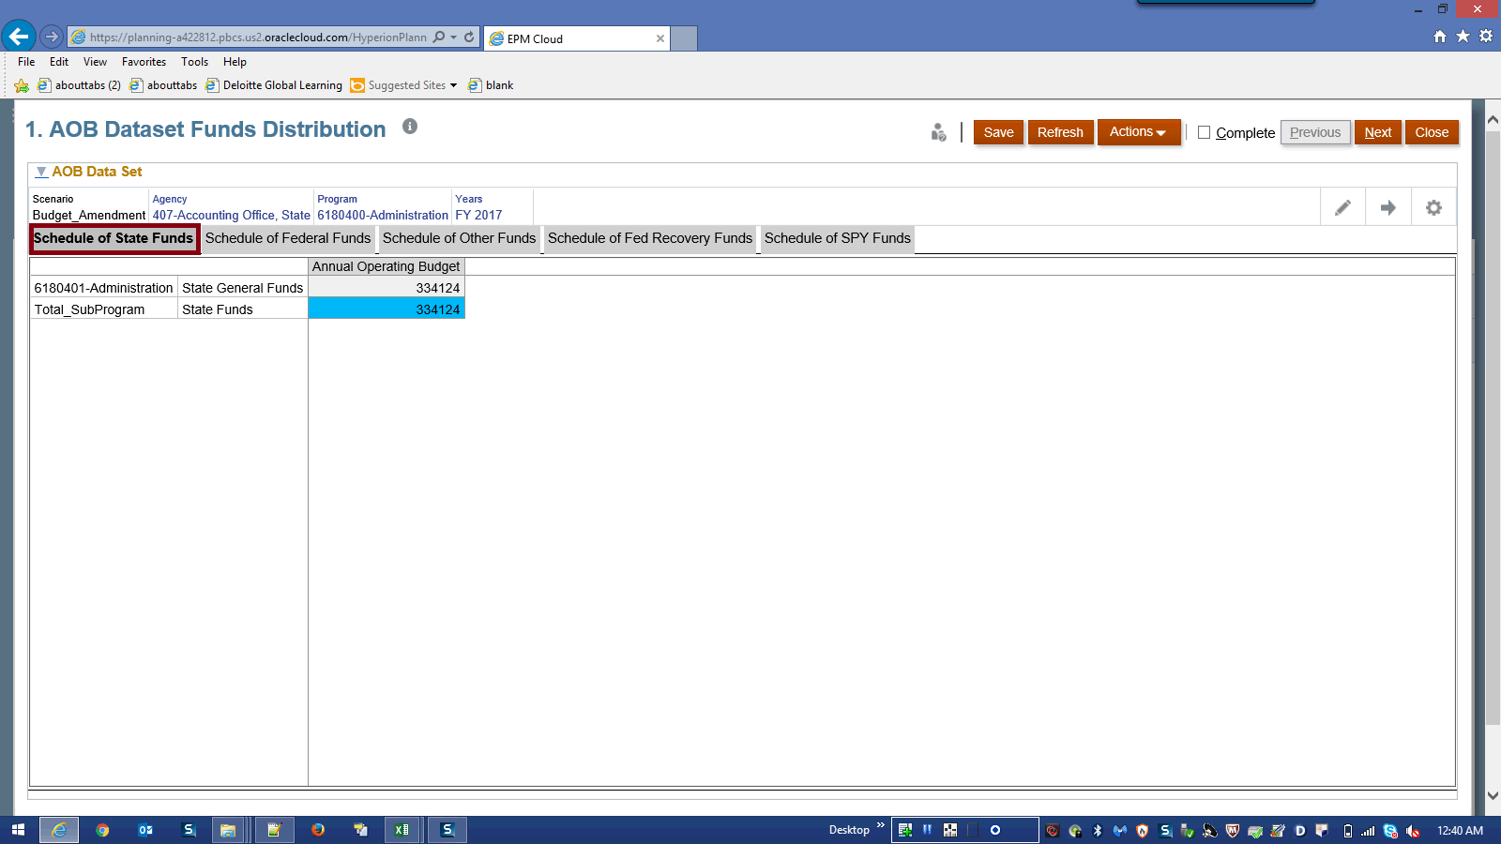

Step | Action | Author Notes
 | Click the Schedule of State Funds link.
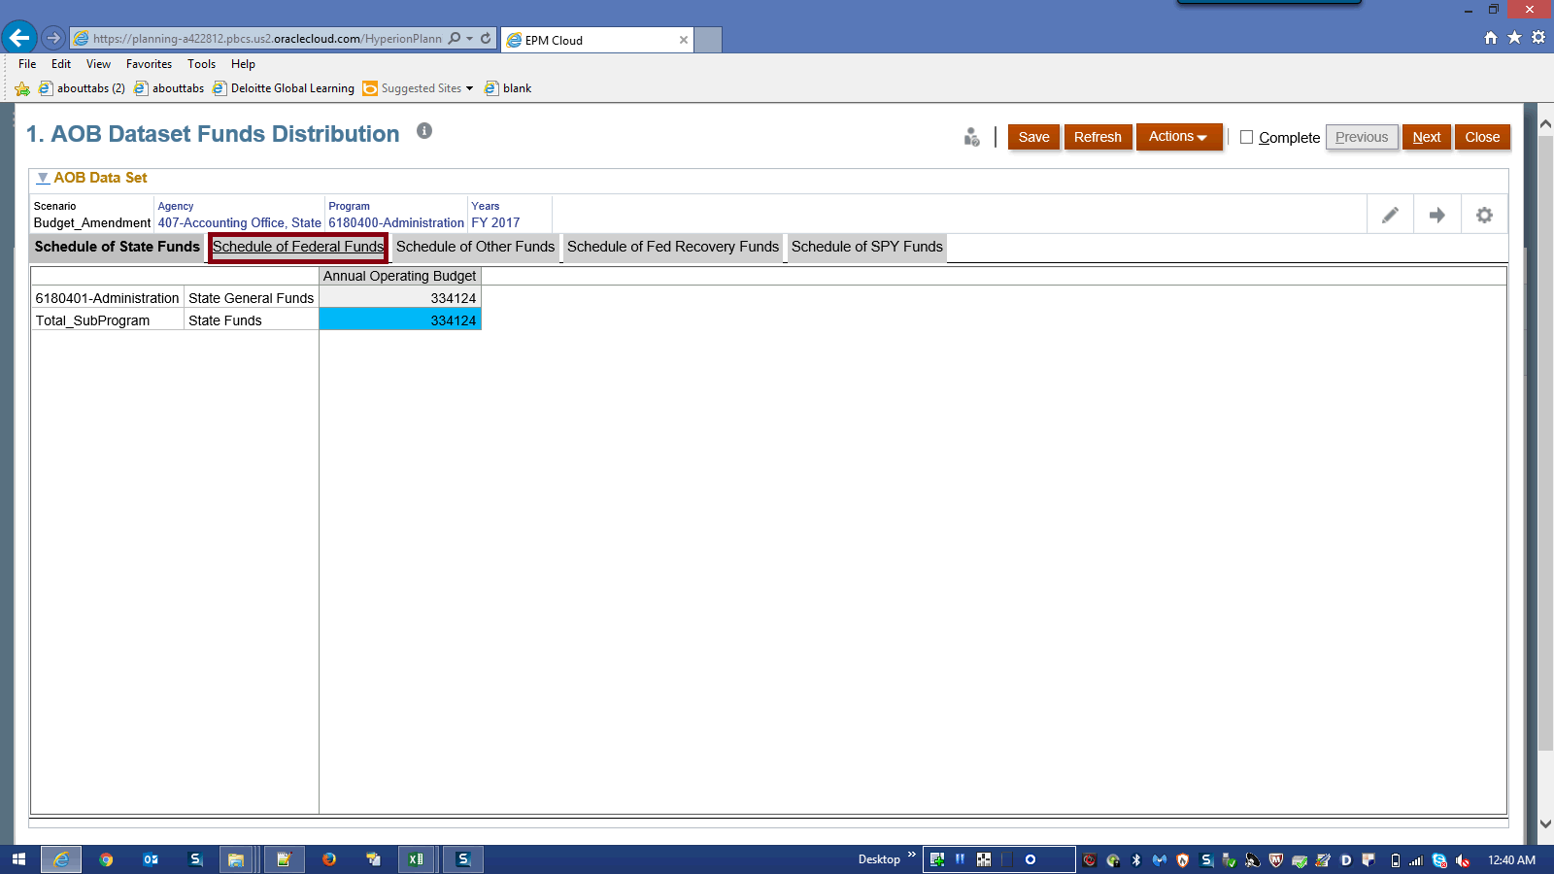

Step | Action | Author Notes
 | Click the Schedule of Federal Funds link.
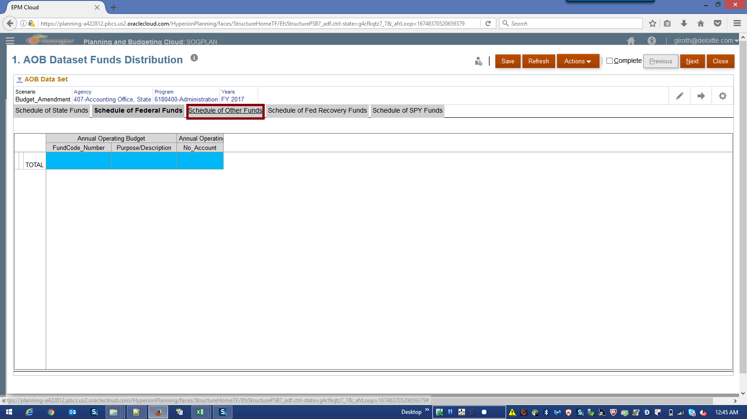

Step | Action | Author Notes
 | Click the Schedule of Other Funds link.
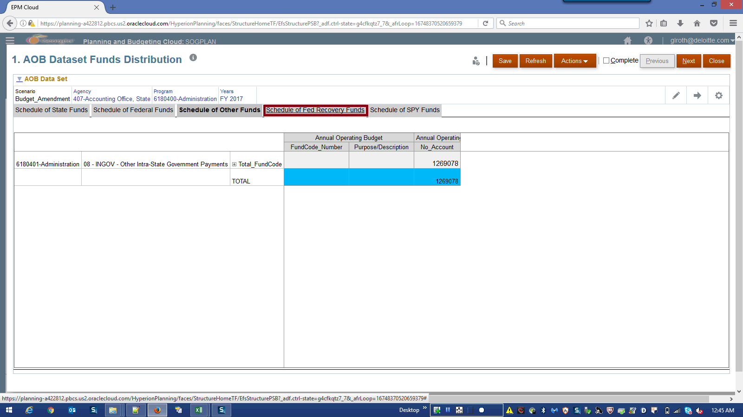

Step | Action | Author Notes
 | Click the Schedule of Fed Recovery Funds link.
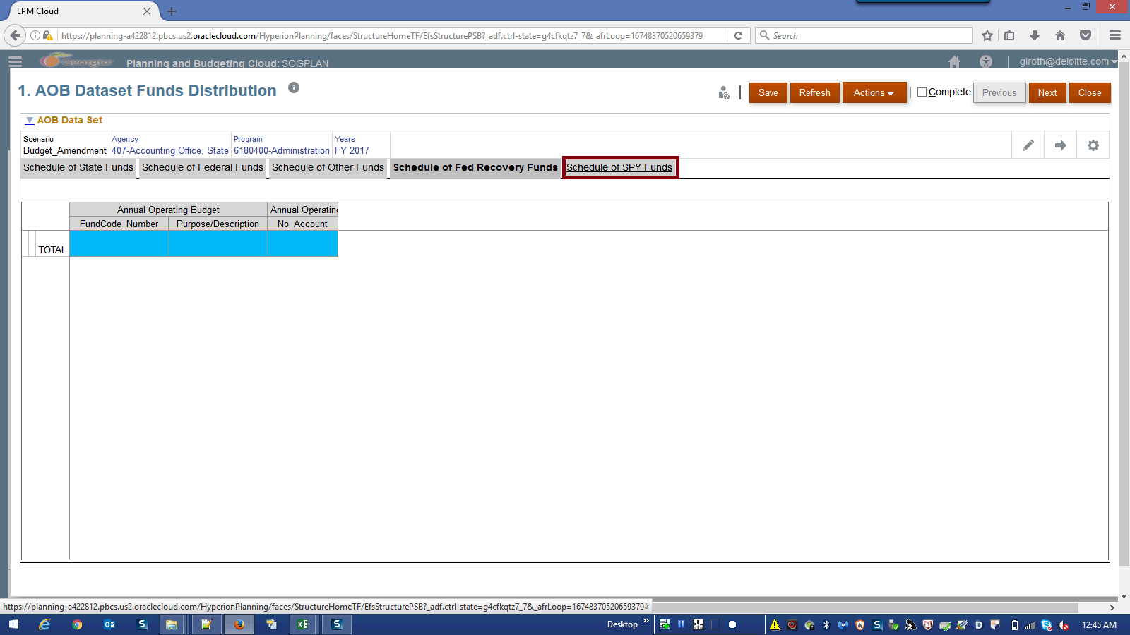

Step | Action | Author Notes
Click the Schedule of SPY Funds link.

NOTE: Repeat Step 12 to Step 26 by selecting program by program and review the AOB data.
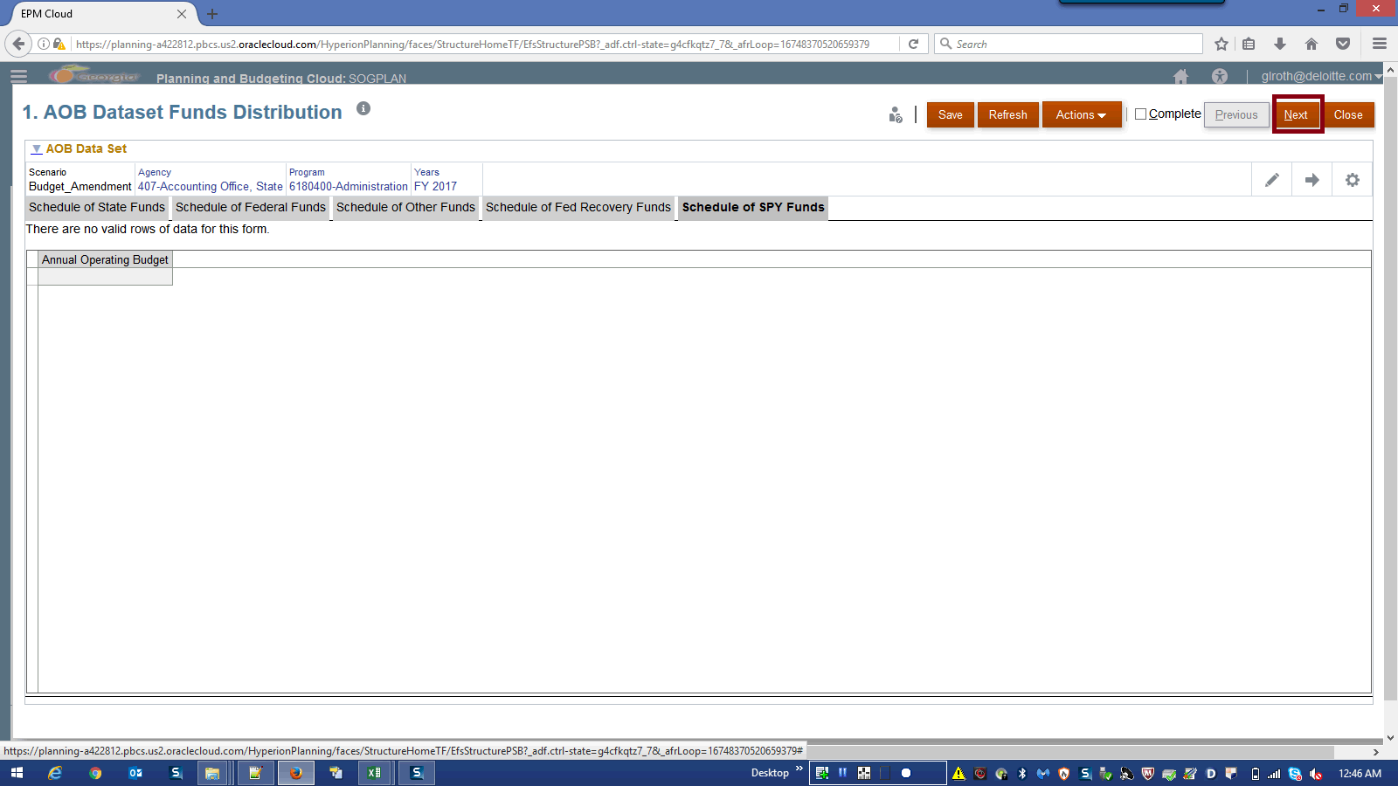

Step | Action | Author Notes
Click in the Next field.
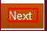
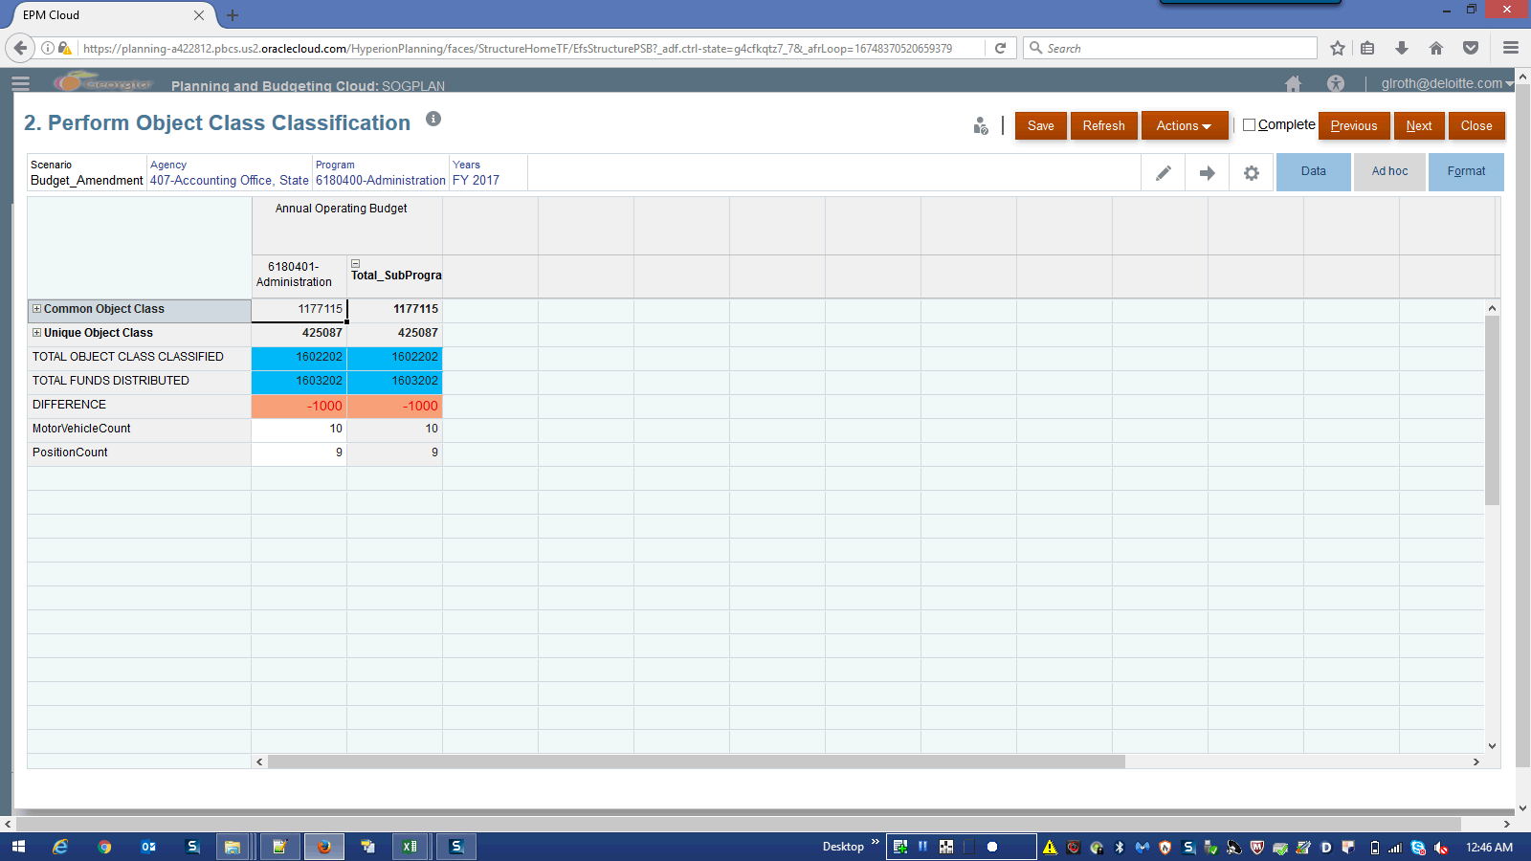

Step | Action | Author Notes
 | Click + icon to expand.
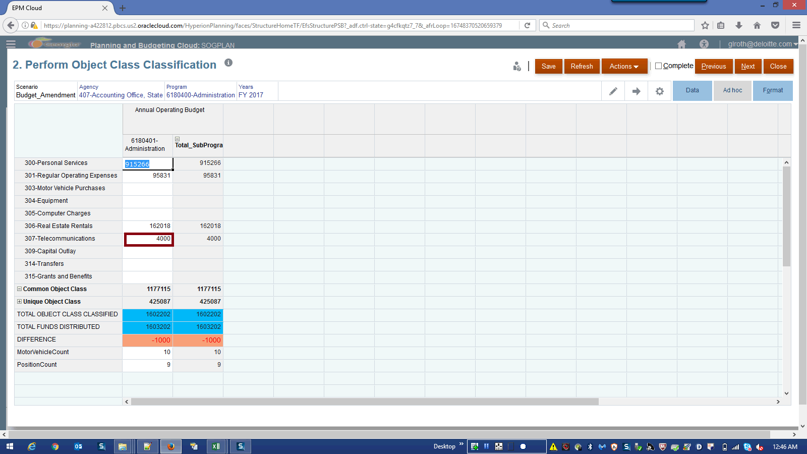

Step | Action | Author Notes
 | Click in the highlighted field.
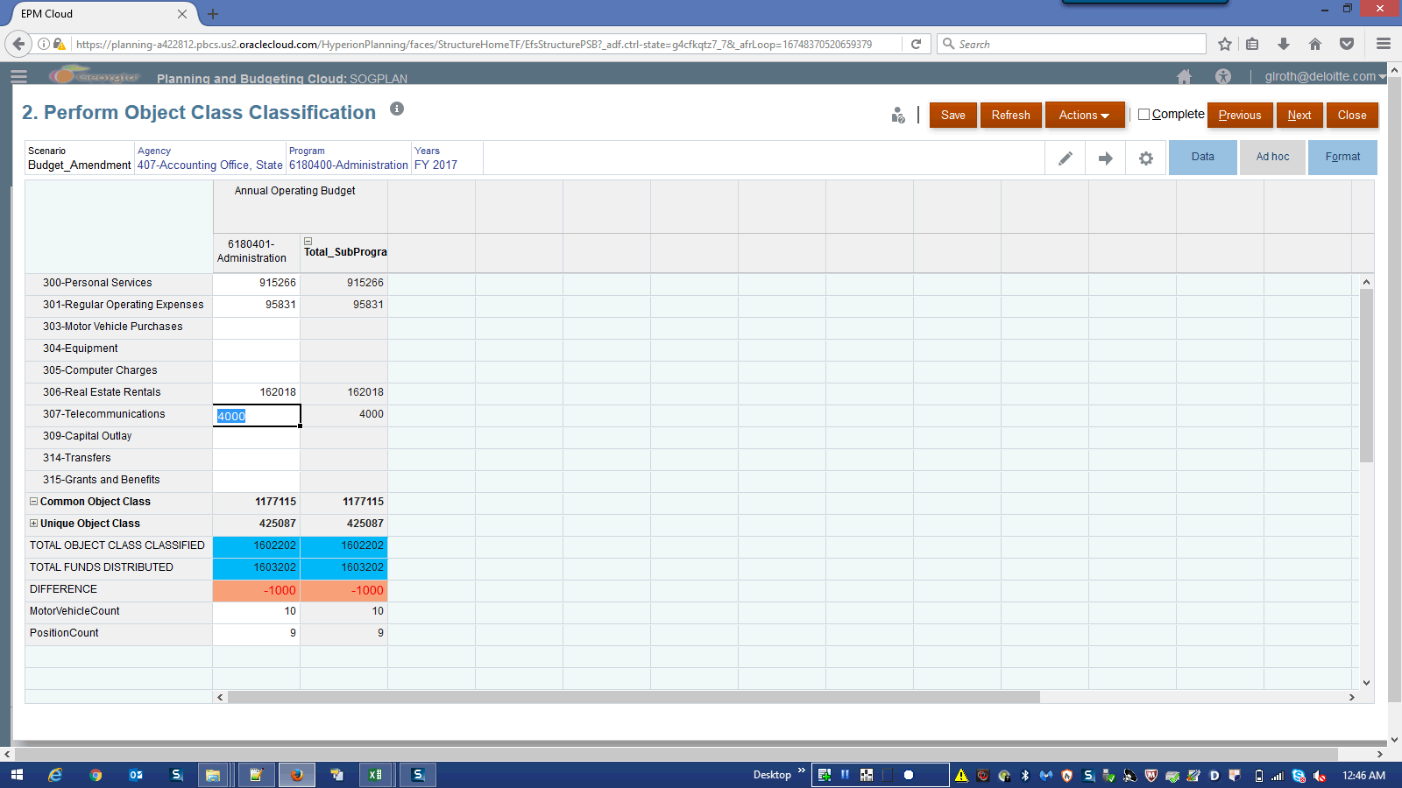

Step | Action | Author Notes
 | Enter the desired information into the field. Enter a valid value e.g. "5000".
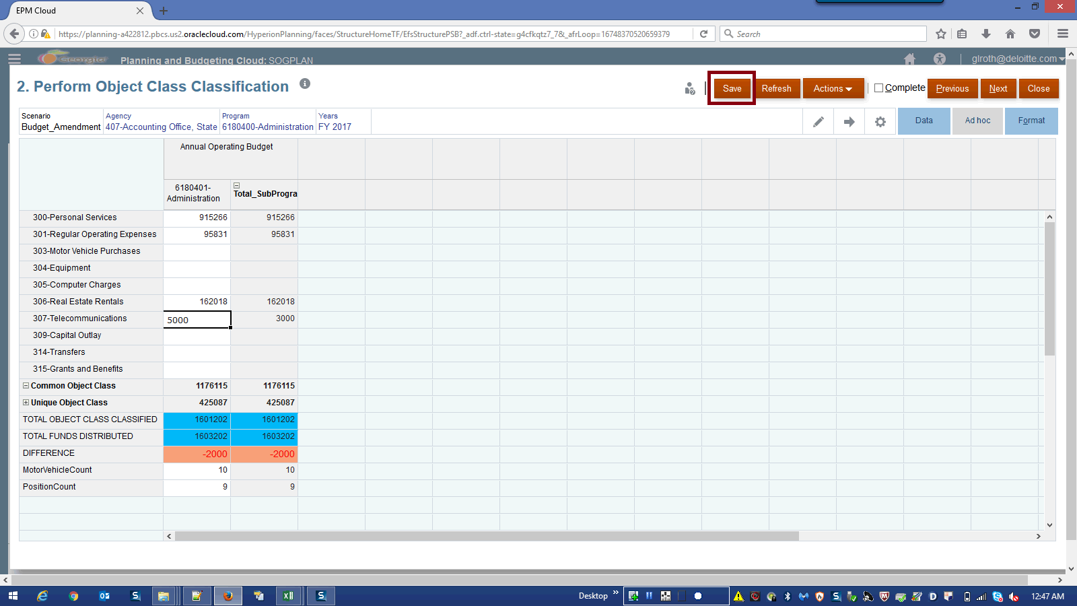

Step | Action | Author Notes
 | Click the Save button.
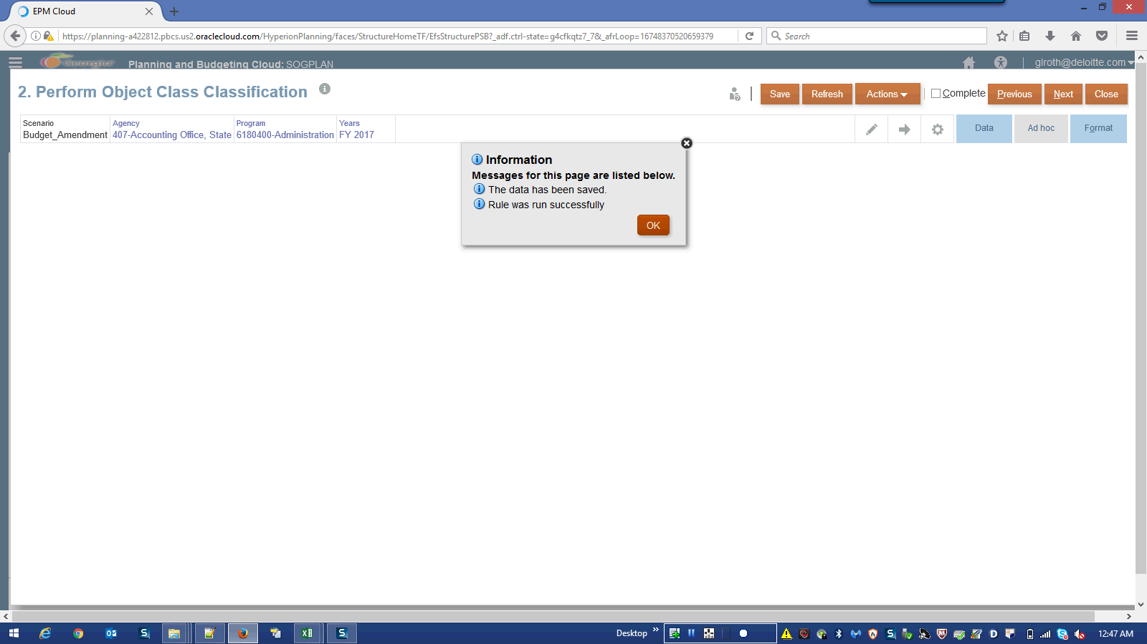

Step | Action | Author Notes
 | Click the OK button.
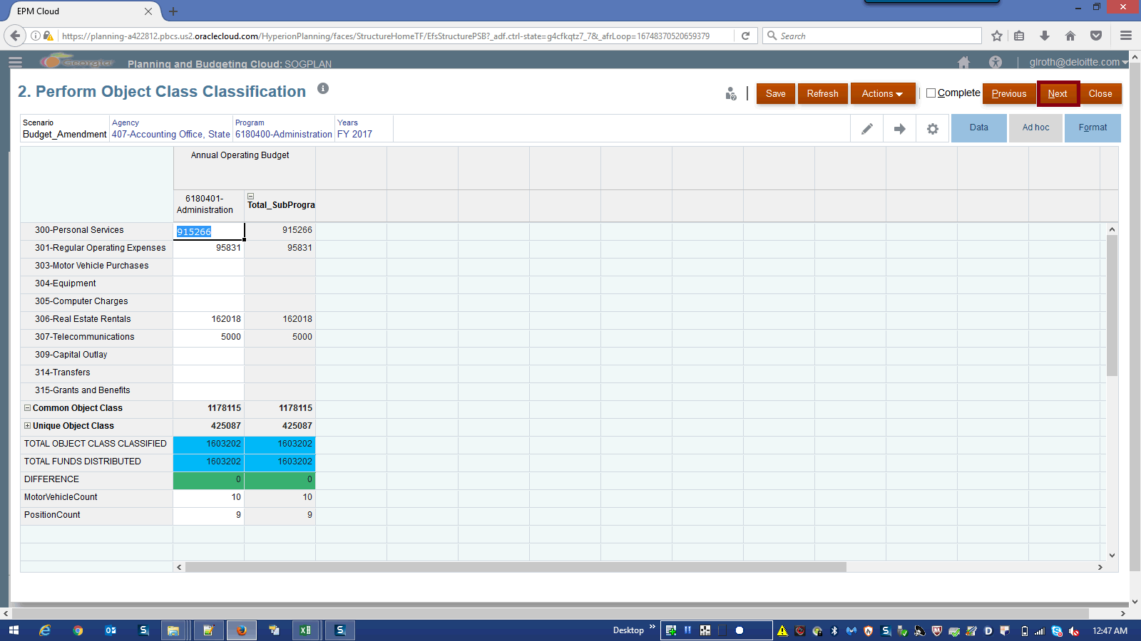

Step | Action | Author Notes
Click the Next button.
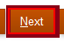
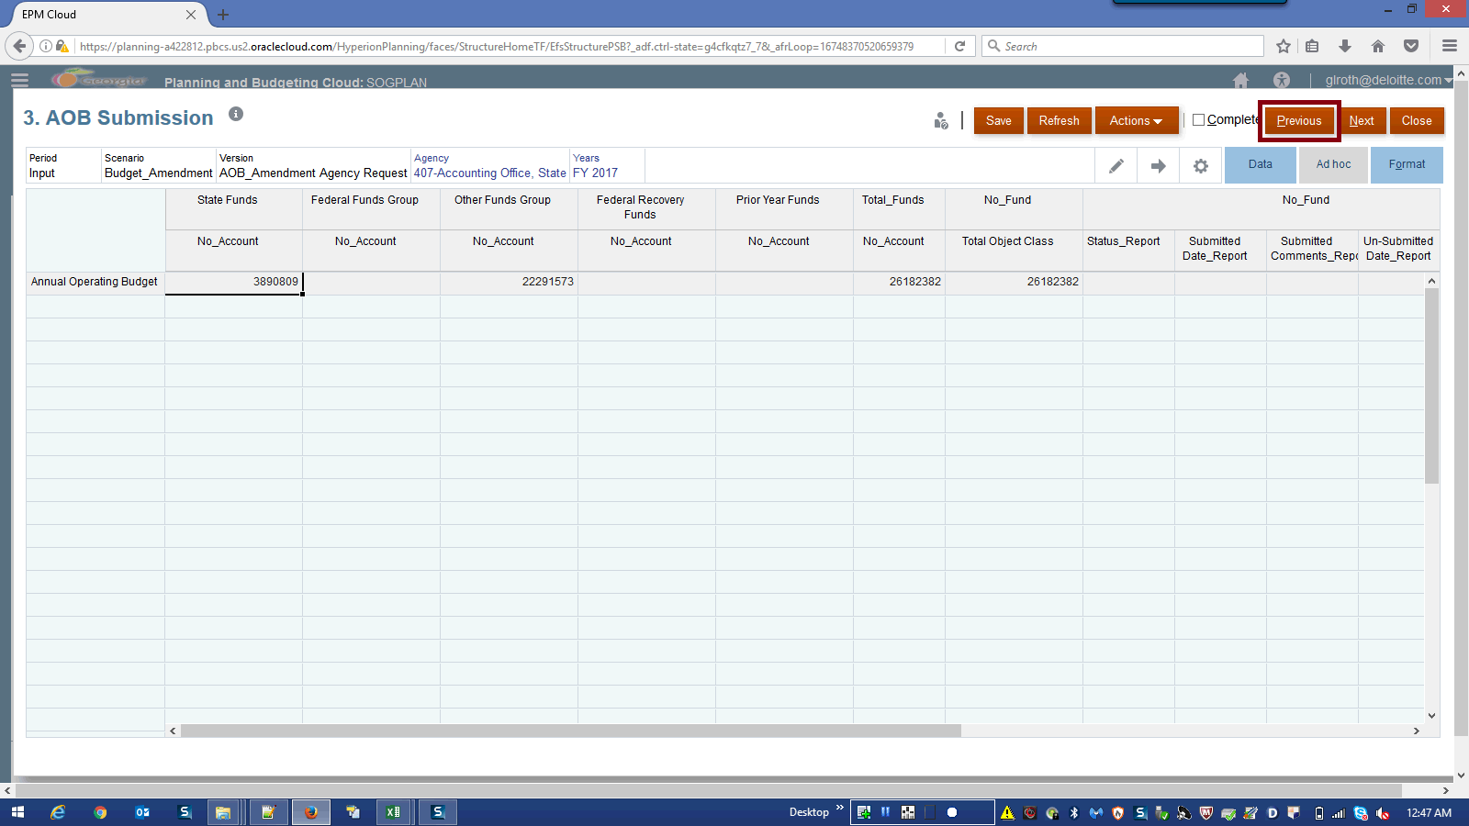

Step | Action | Author Notes
Click in the Previous field.
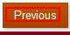
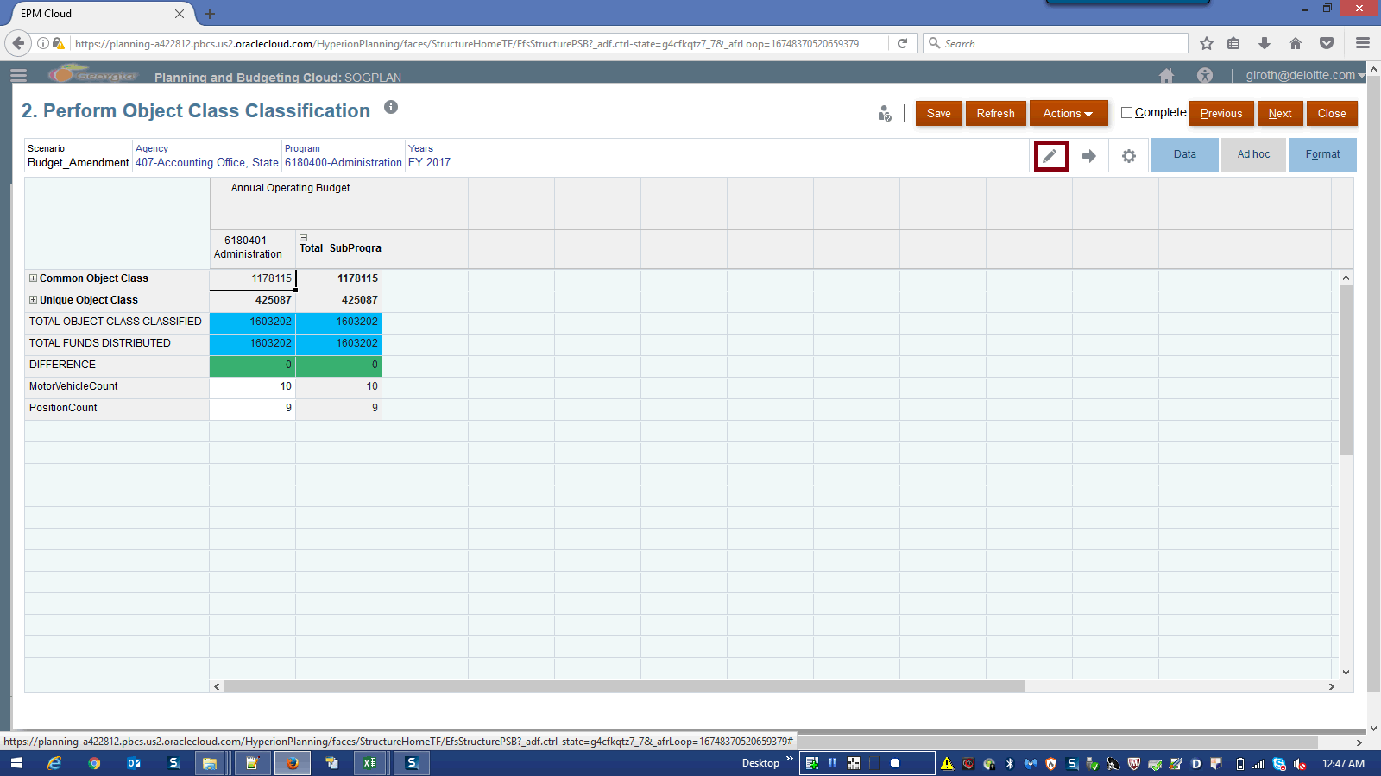

Step | Action | Author Notes
 | Click the Edit Members graphic.
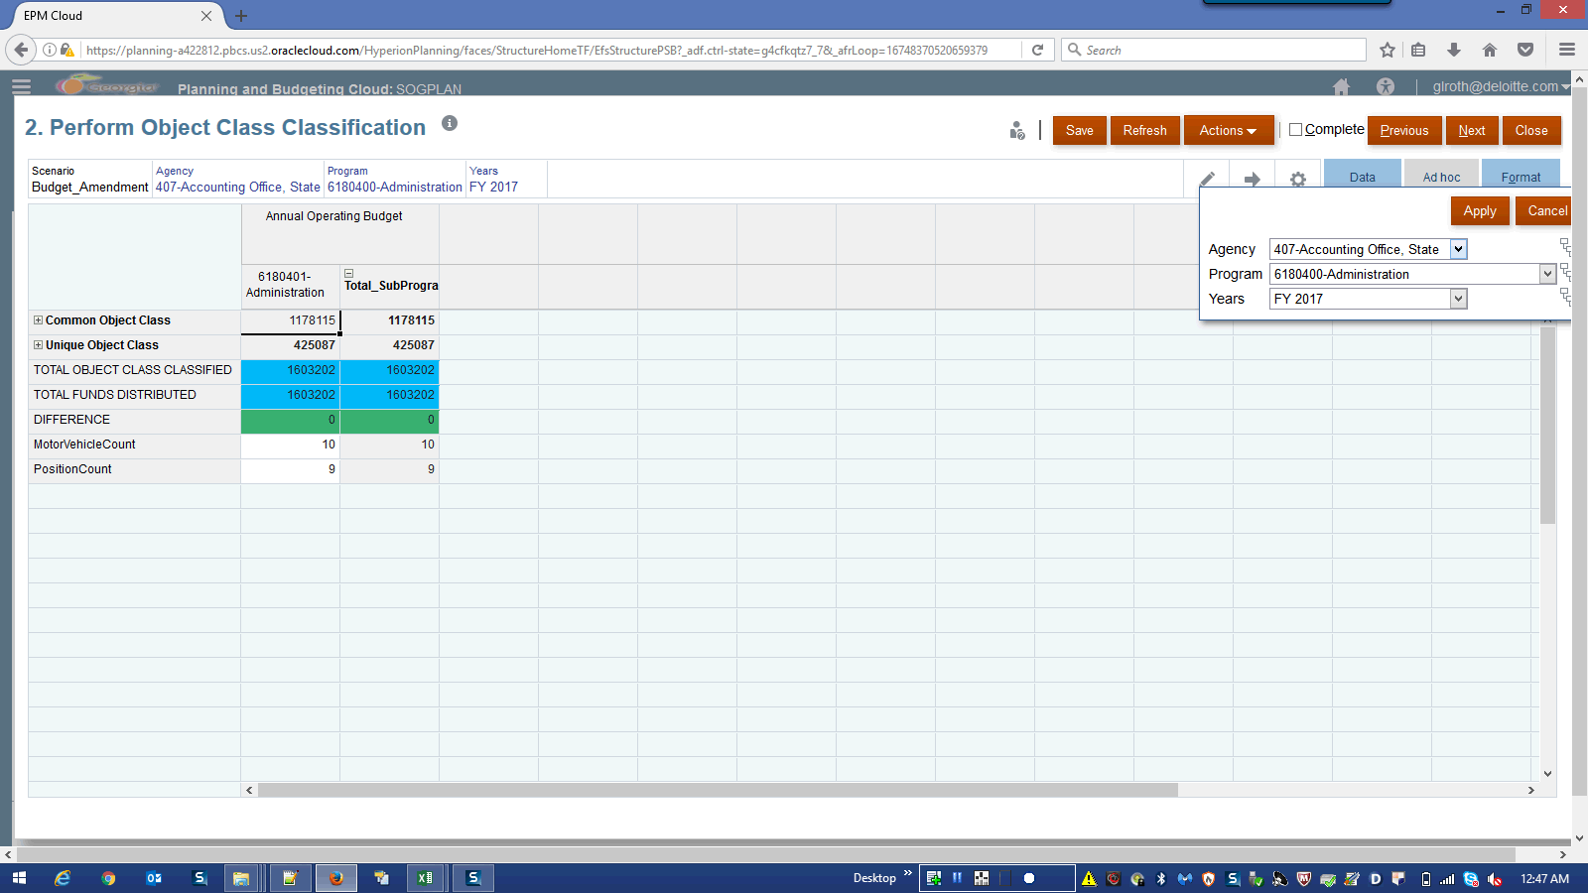

Step | Action | Author Notes
 | Click the Program list.
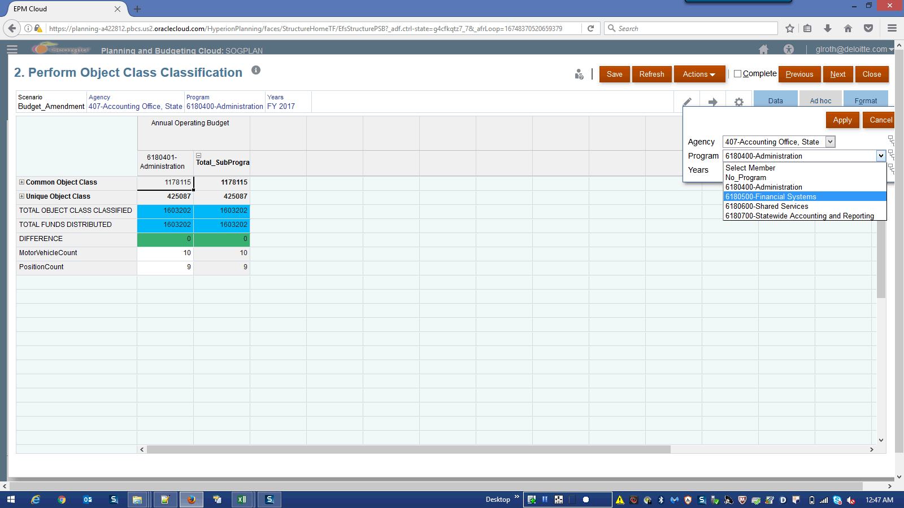

Step | Action | Author Notes
 | Click the 6180500-Financial Systems list item.
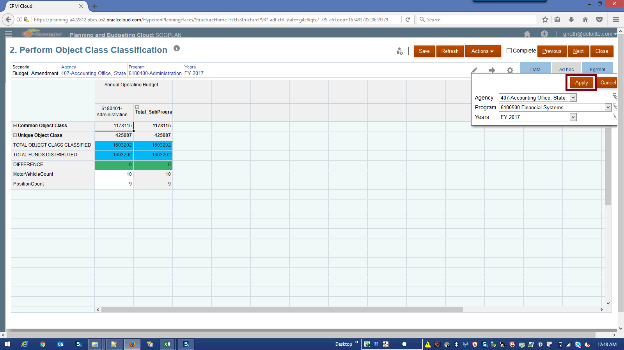

Step | Action | Author Notes
Click the Apply button.

NOTE:
For each Program, DIFFERENCE of TOTAL OBJECT CLASS CLASSIFIED and TOTAL FUNDS DISTRIBUTED should be zero. DIFFERENCE row should show as Green.
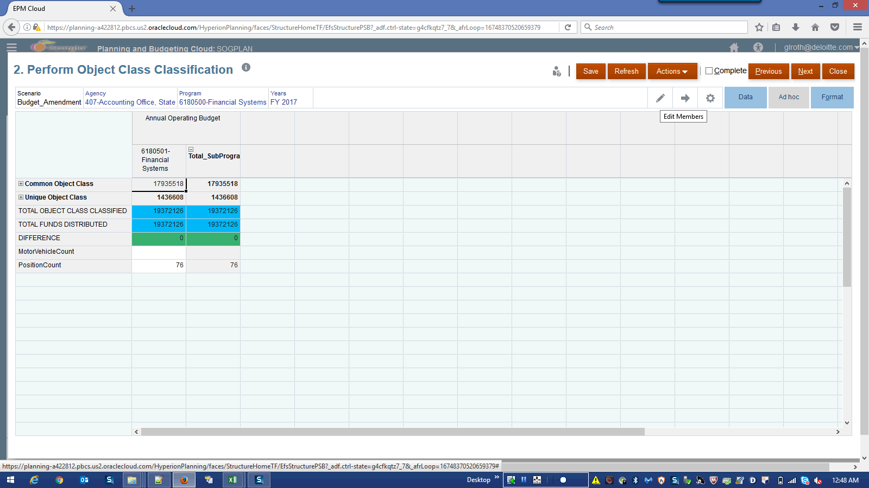

Step | Action | Author Notes
 | Click the Edit Members graphic.
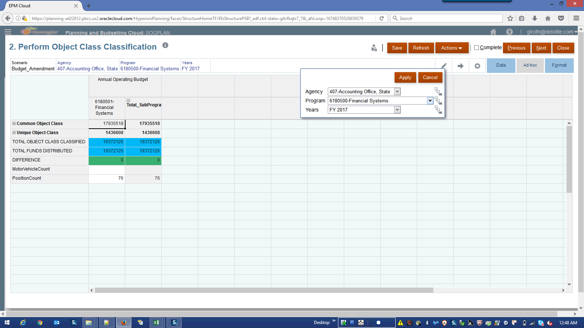

Step | Action | Author Notes
 | Click the Program list.
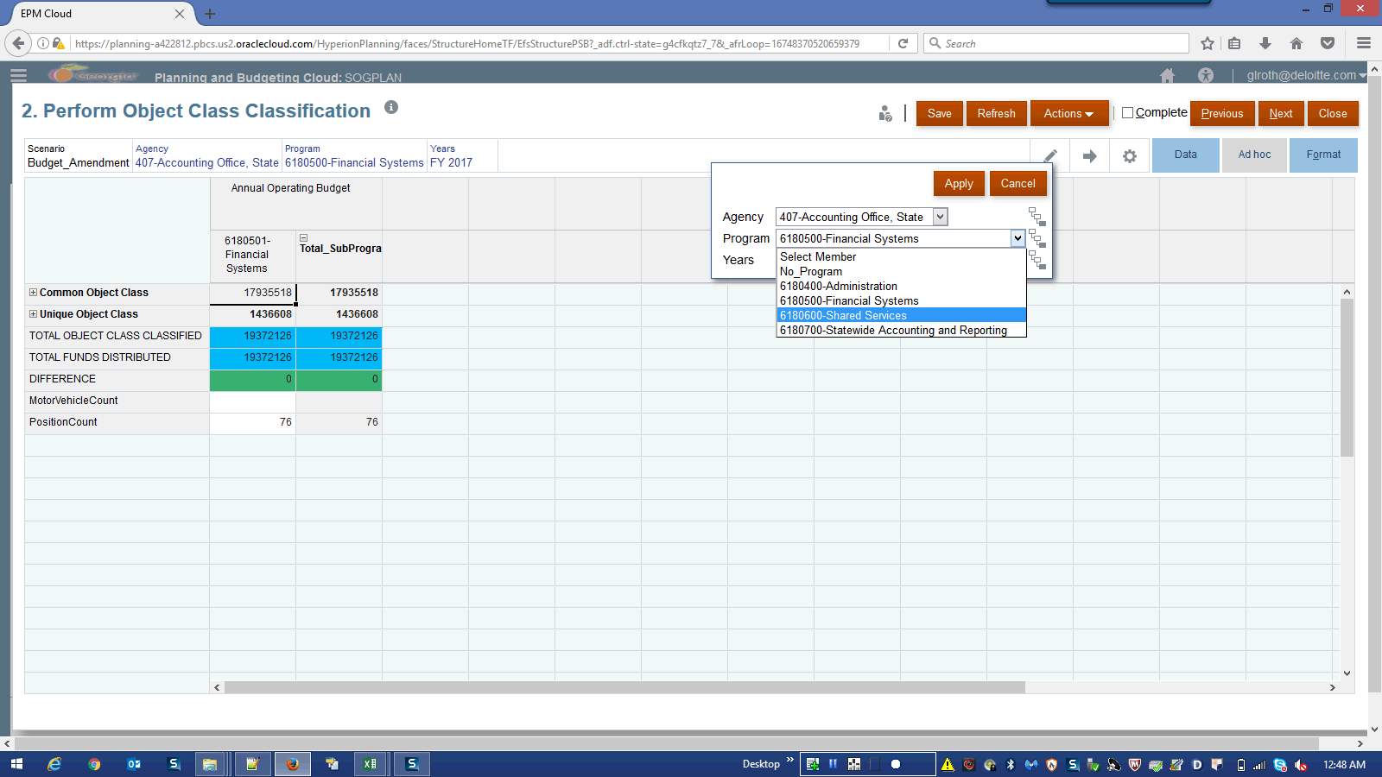

Step | Action | Author Notes
 | Click the 6180600-Shared Services list item.
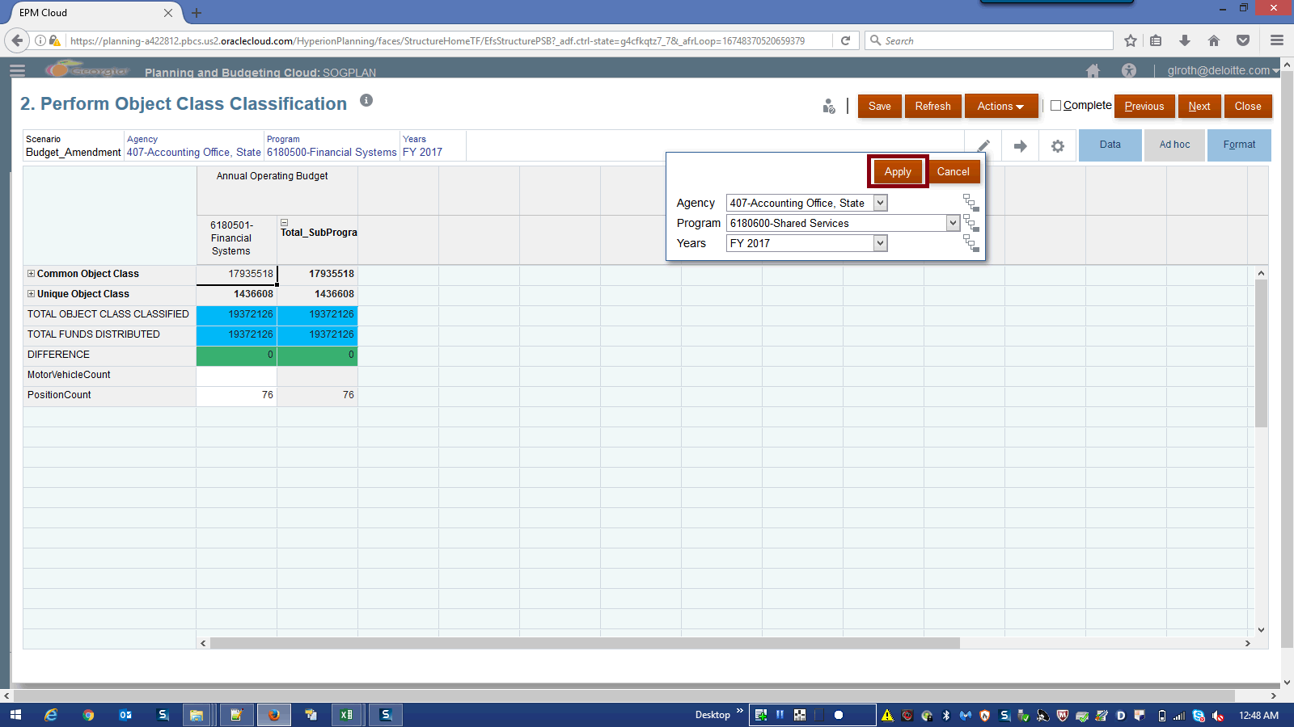

Step | Action | Author Notes
 | Click the Apply button.
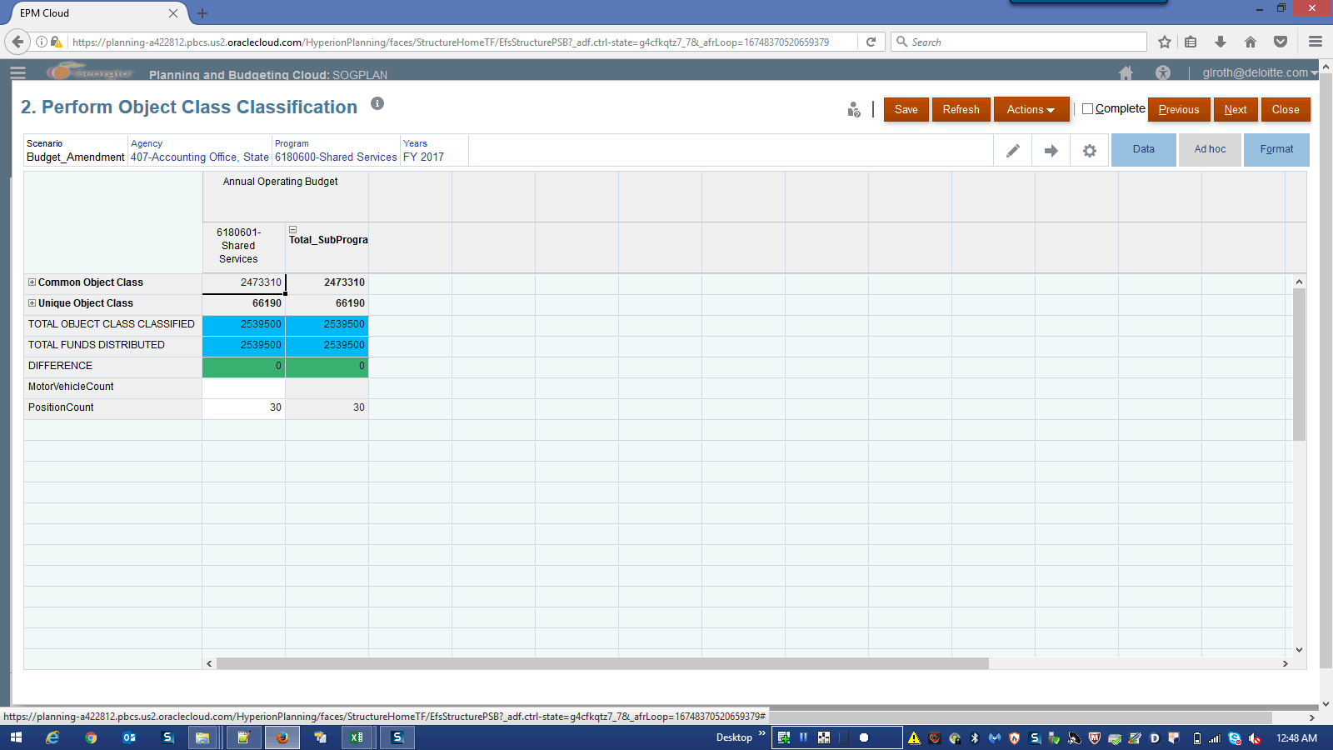

Step | Action | Author Notes
 | Click the Edit Members graphic.
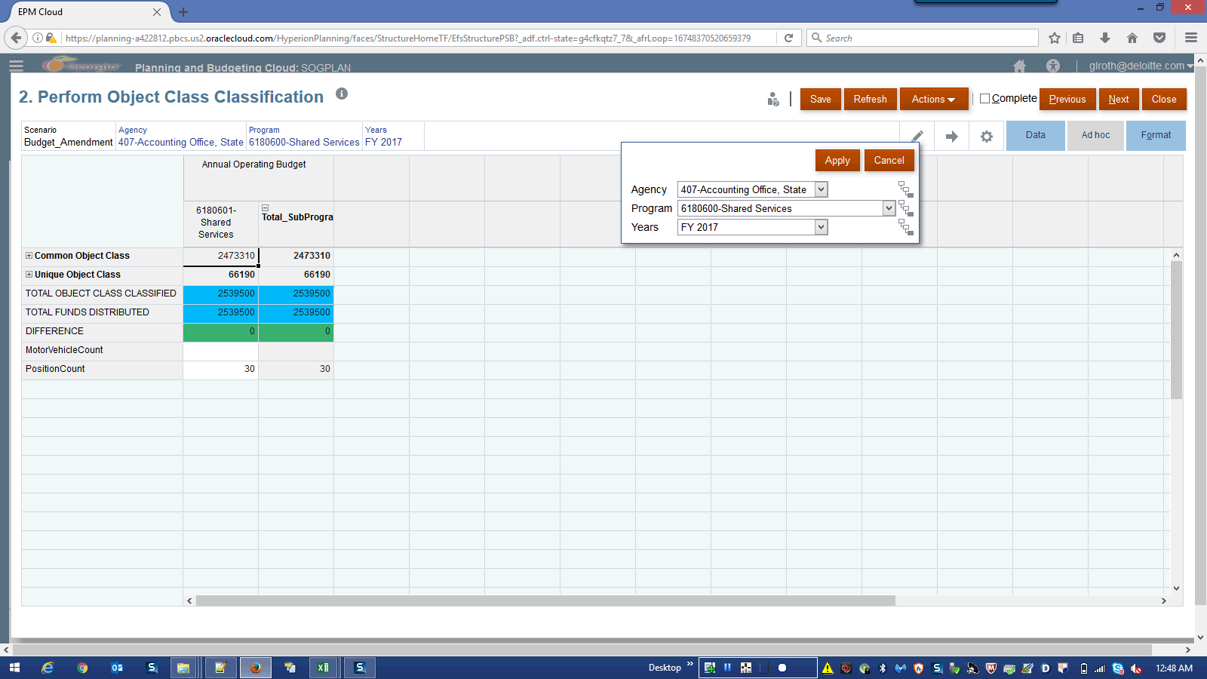

Step | Action | Author Notes
 | Click the Program list.
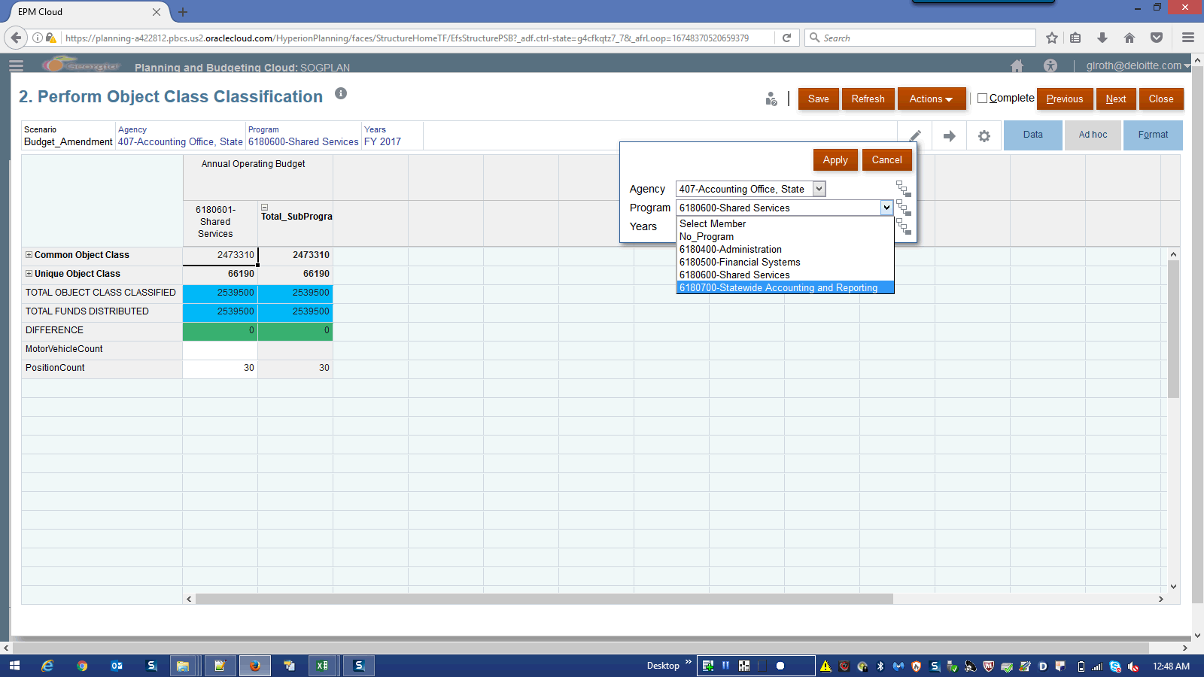

Step | Action | Author Notes
 | Click the 6180700-Statewide Accounting and Reporting list item.
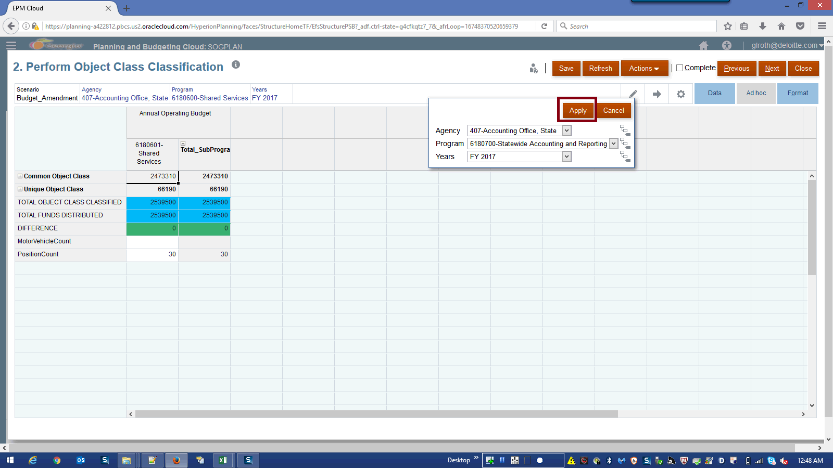

Step | Action | Author Notes
 | Click the Apply button.
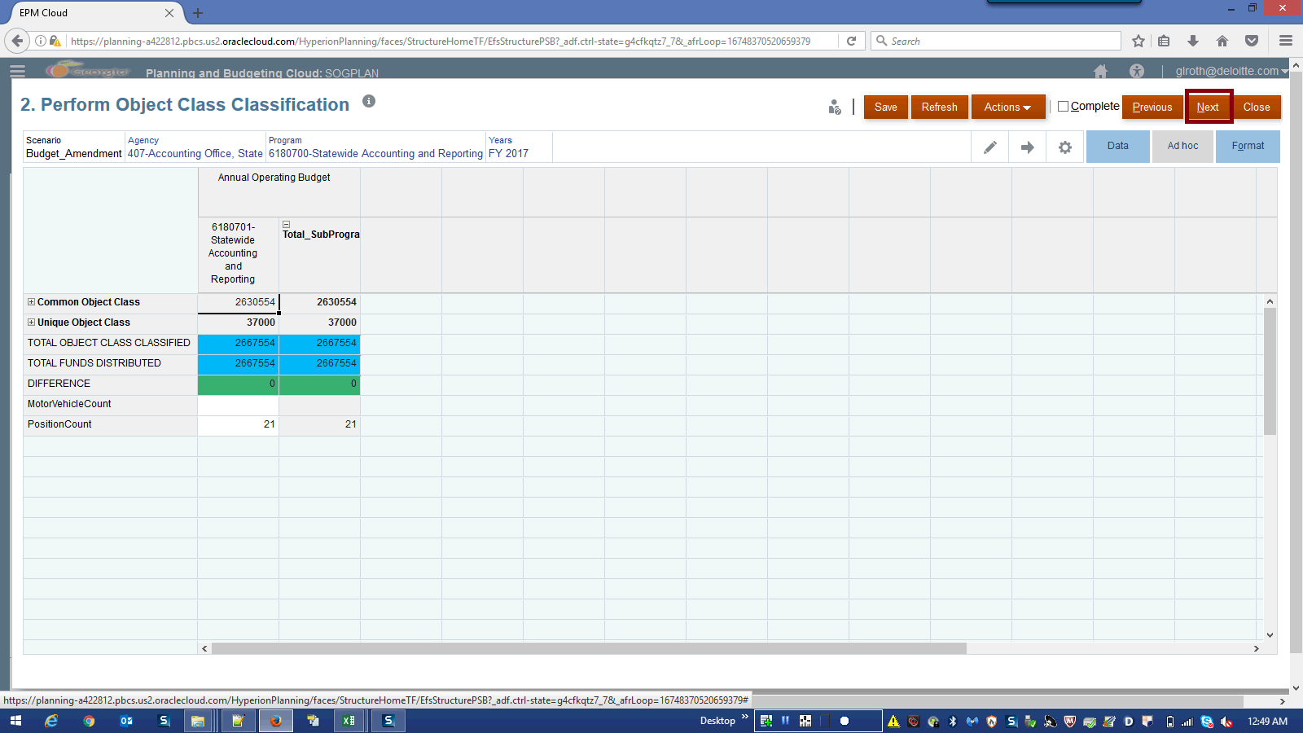

Step | Action | Author Notes
Click in the Next field.
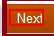
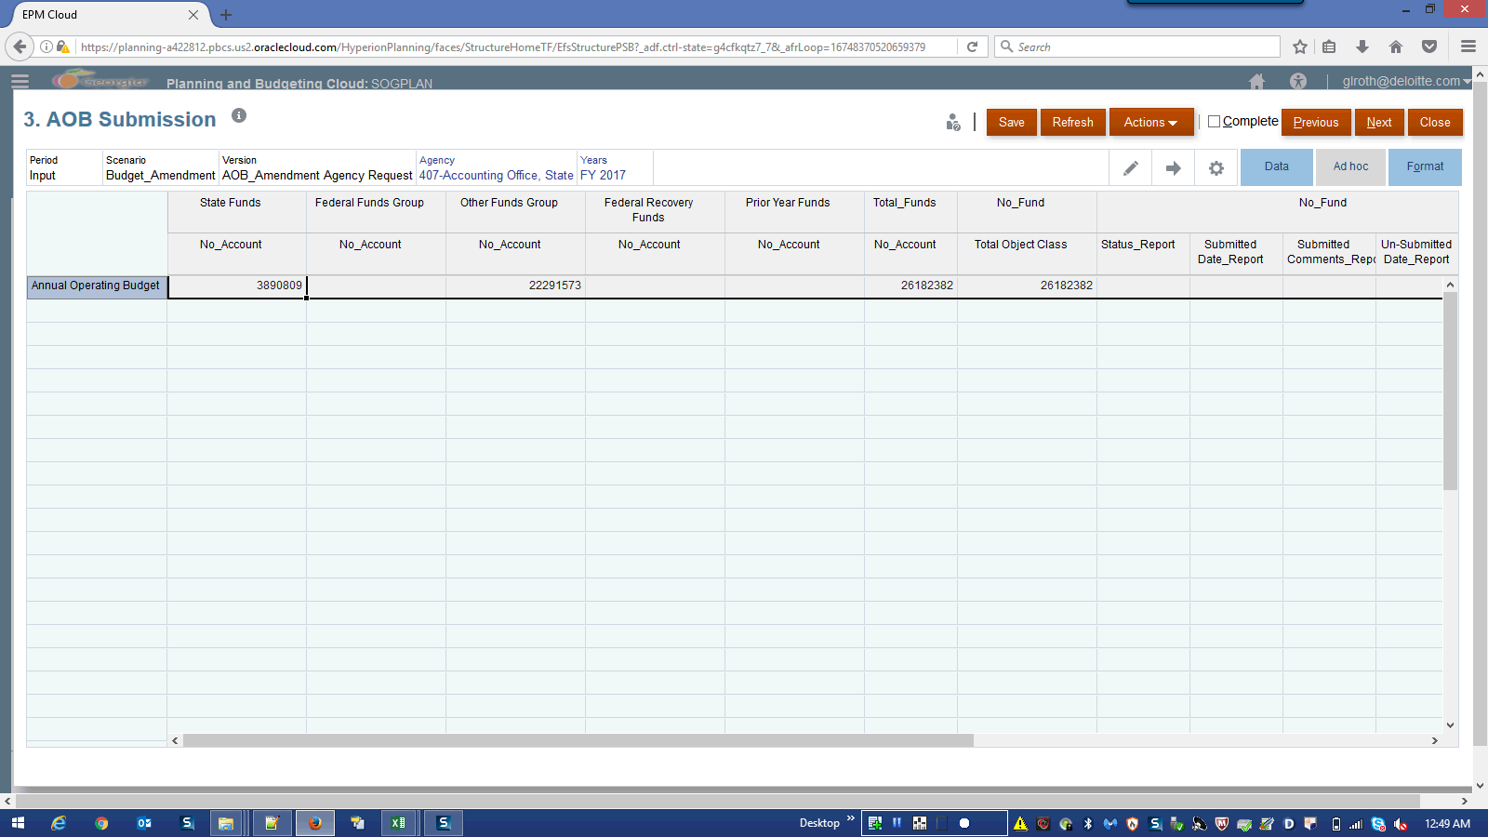

Step | Action | Author Notes
Right-click in the Annual Operating Budget field.
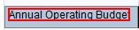
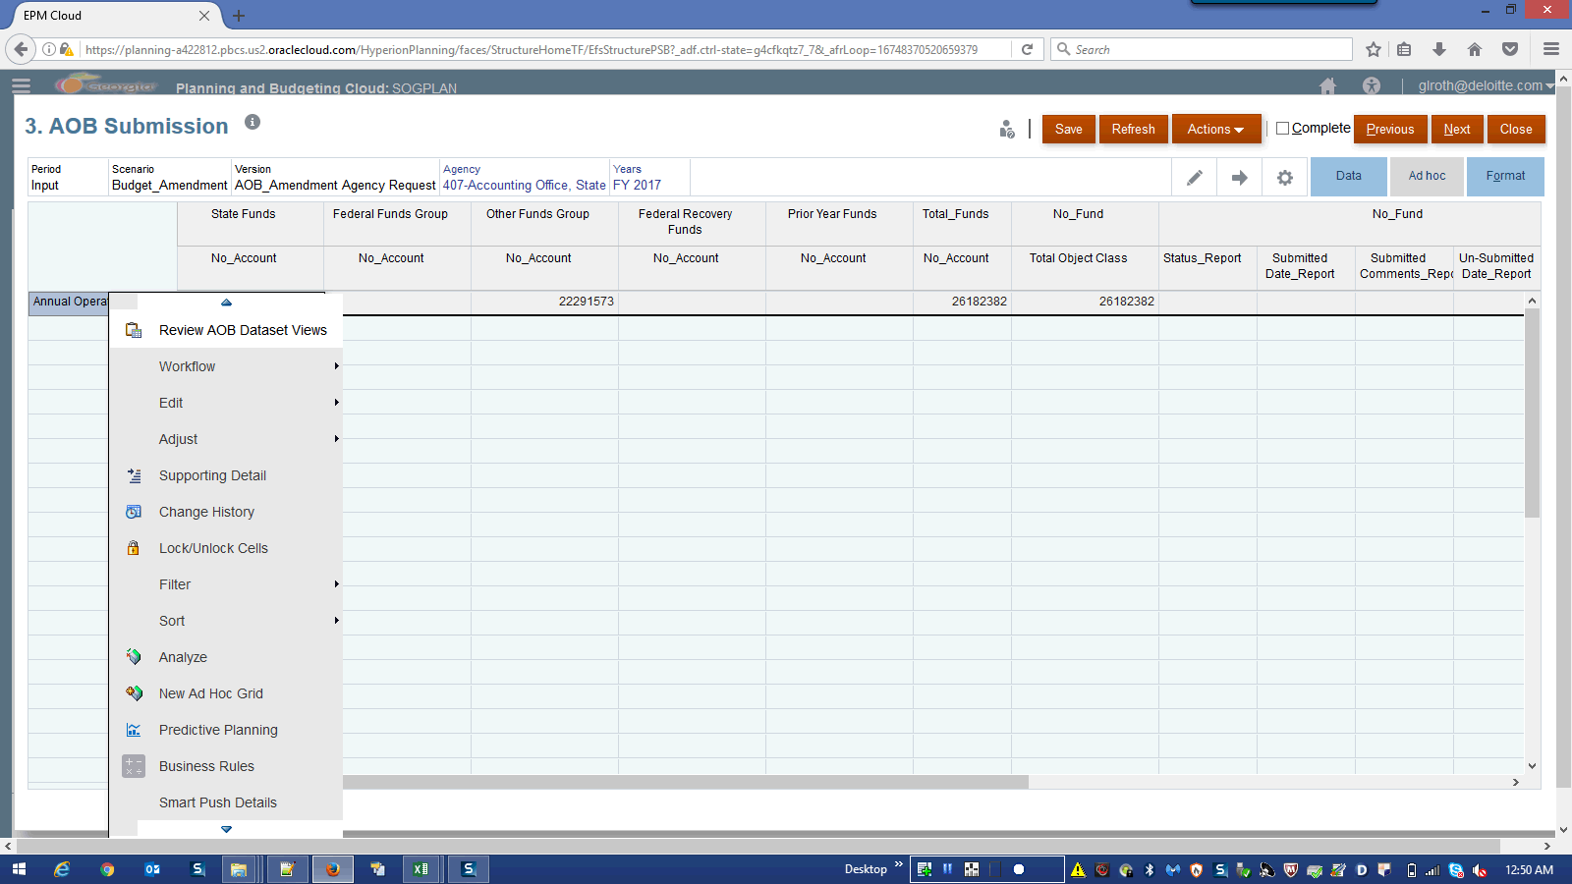

Step | Action | Author Notes
Click in the Review AOB Dataset Views field.
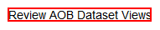
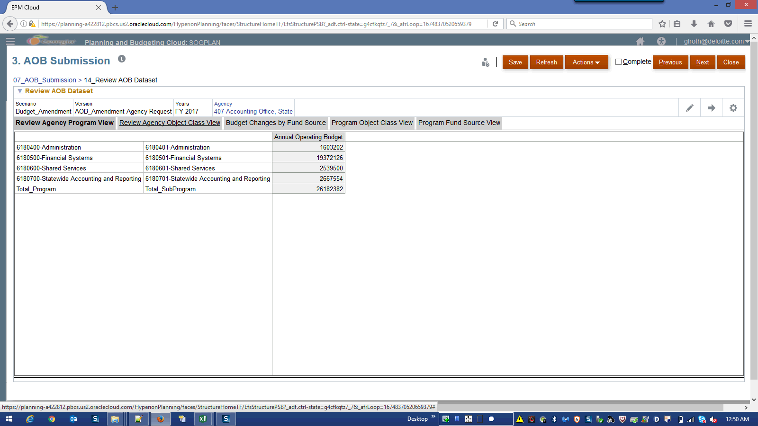

Step | Action | Author Notes
Click the Review Agency Program View link.
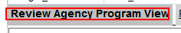

Step | Action | Author Notes
Click the Review Agency Object Class View link.
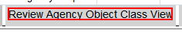
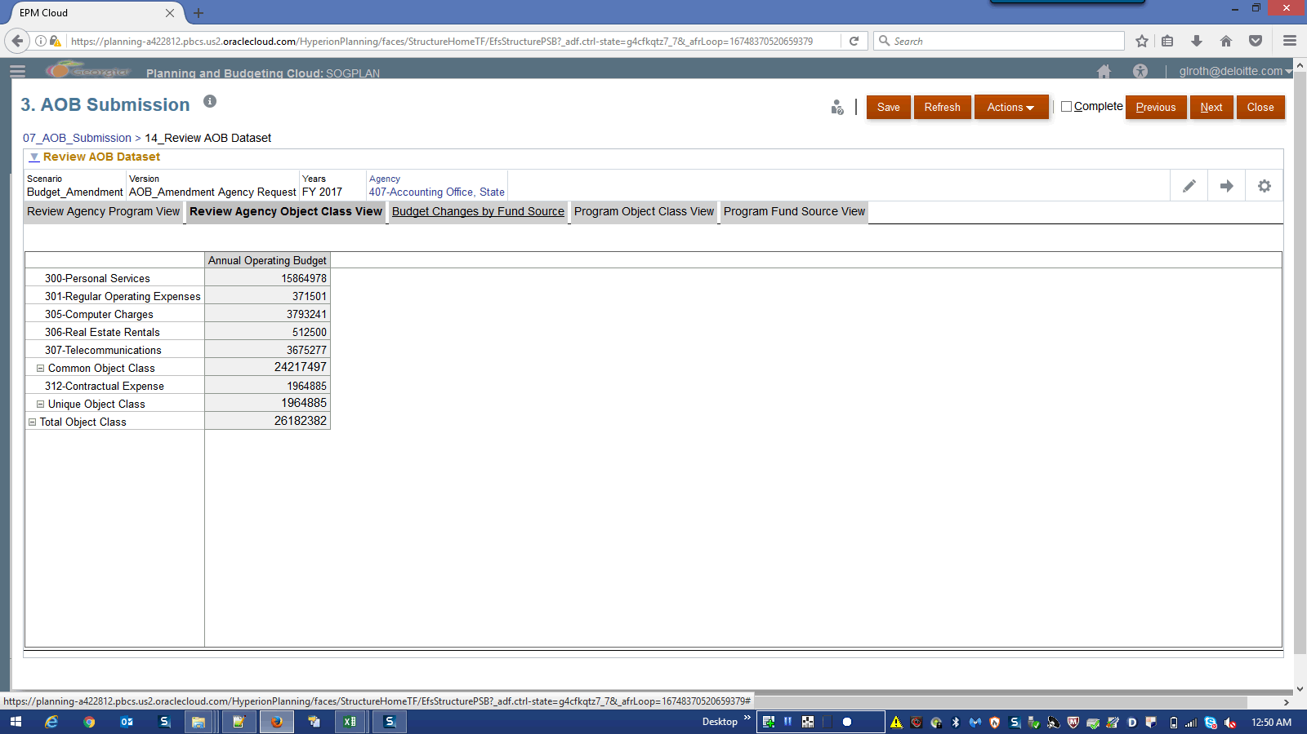

Step | Action | Author Notes
Click the Budget Changes by Fund Source link.
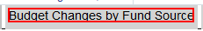
NOTE: Select own Program by Program to review the data using pencil dropdown.
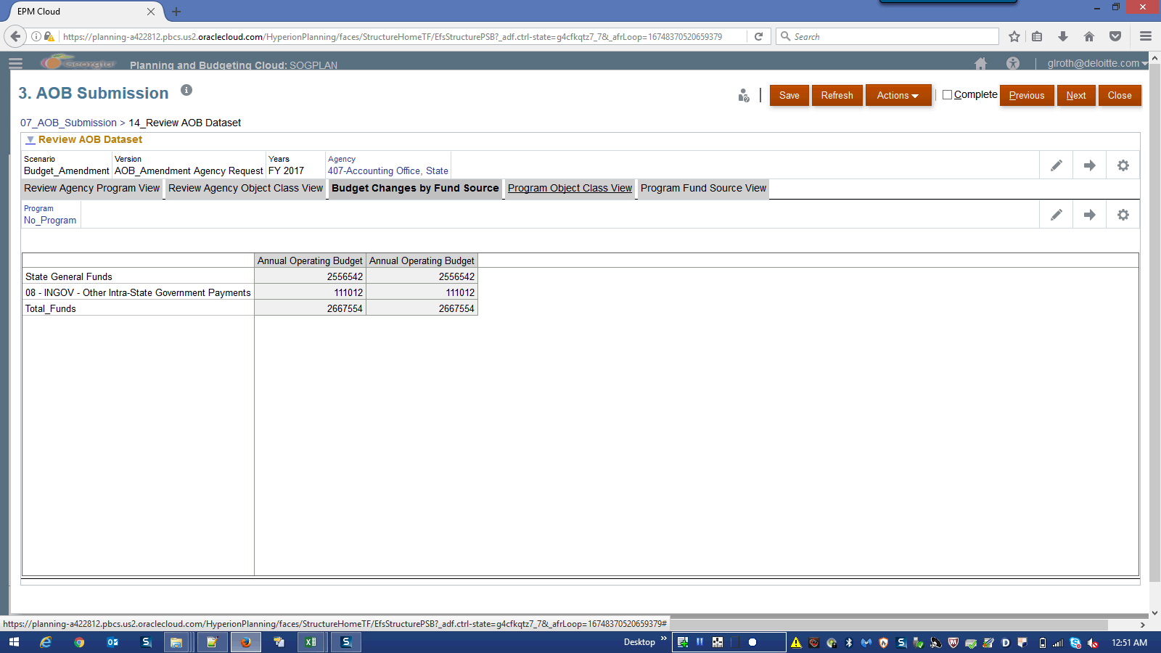

Step | Action | Author Notes
Click the Program Object Class View link.
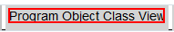
NOTE: Select own Program by Program to review the data using pencil dropdown.
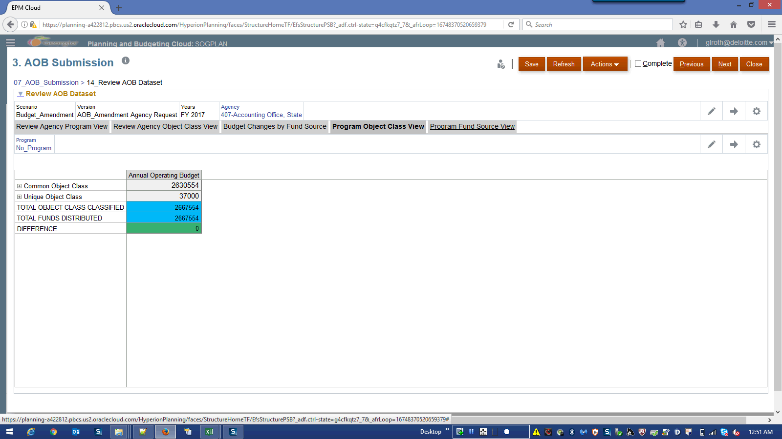

Step | Action | Author Notes
Click the Program Fund Source View link.
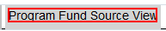
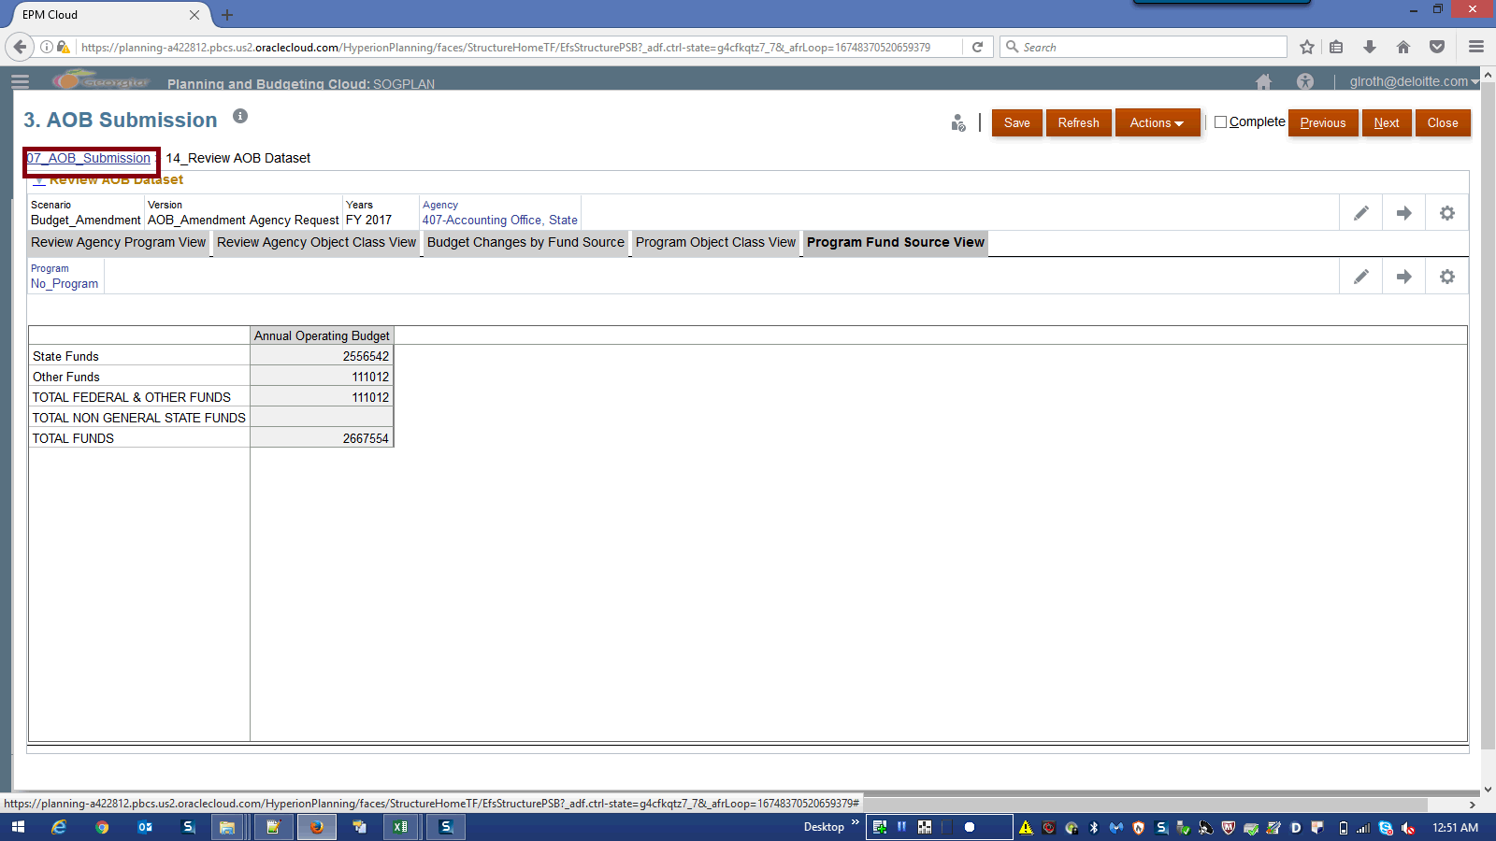

Step | Action | Author Notes
Click the 07_AOB_Submission link.
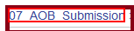
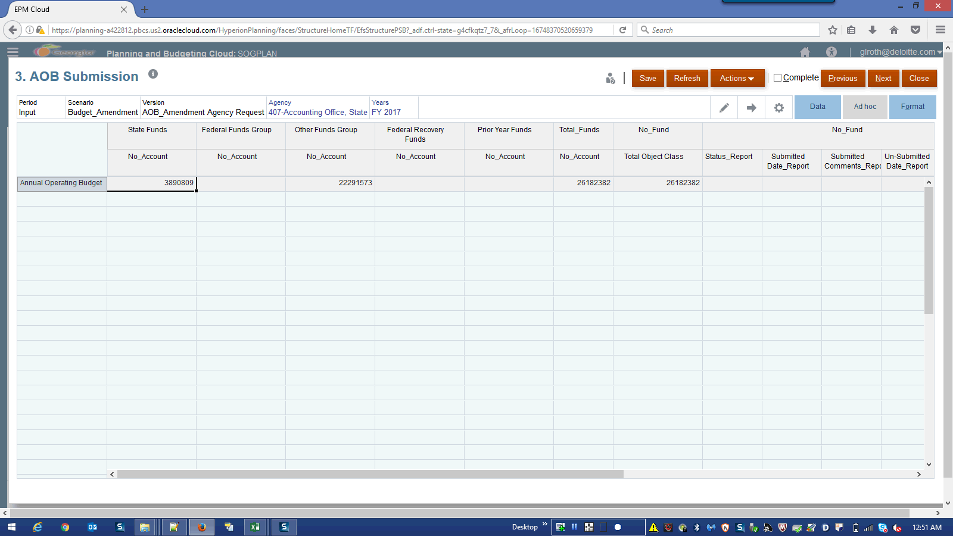

Step | Action | Author Notes
Right-click in the Annual Operating Budget field.
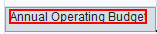
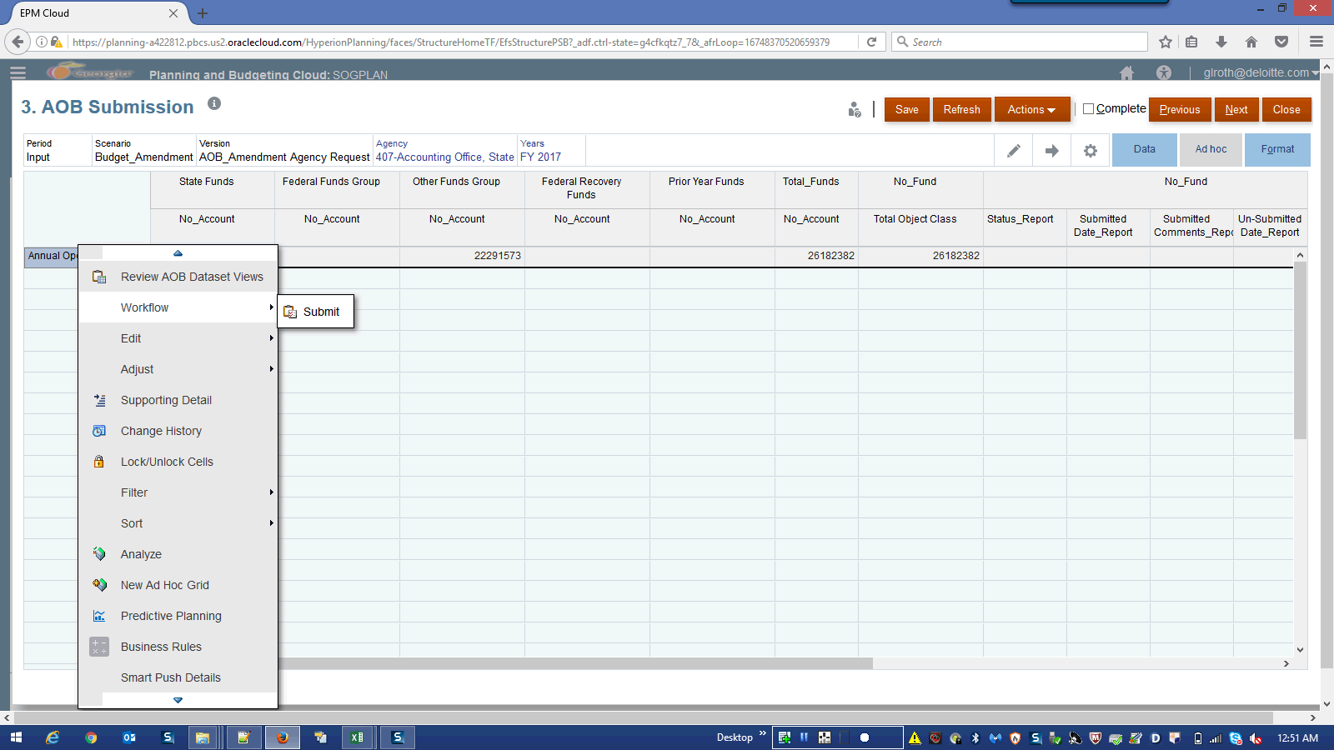

Step | Action | Author Notes
Click the Workflow graphic.
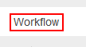
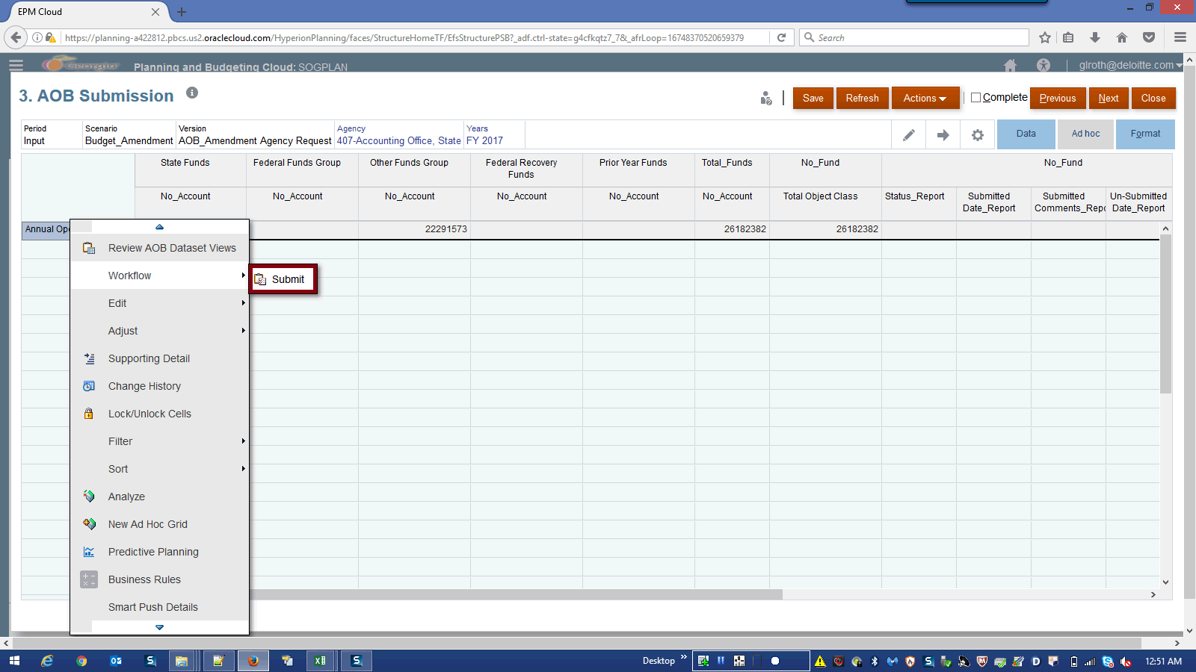

Step | Action | Author Notes
 | Click the Submit graphic.
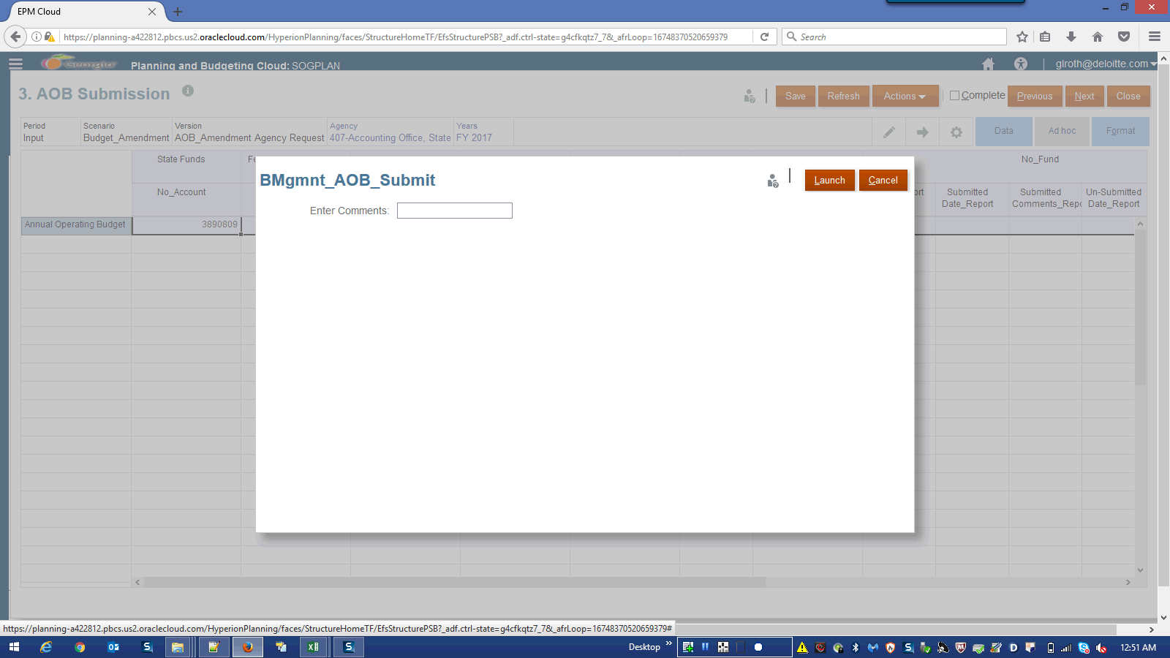

Step | Action | Author Notes
 | Click in the Enter Comments: field.
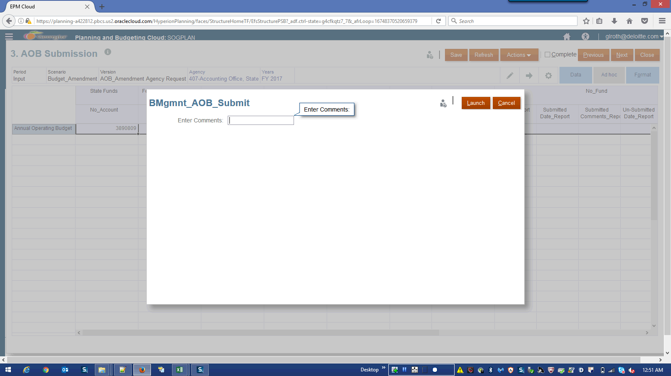

Step | Action | Author Notes
 | Enter the desired information into the Enter Comments: field. Enter a valid value e.g. "AOB_Submitted".
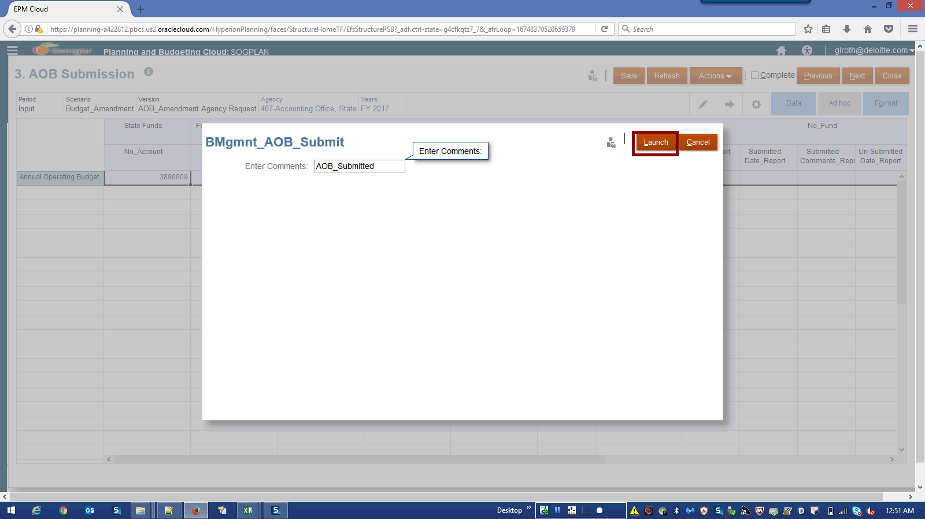

Step | Action | Author Notes
Click in the Launch field.
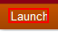
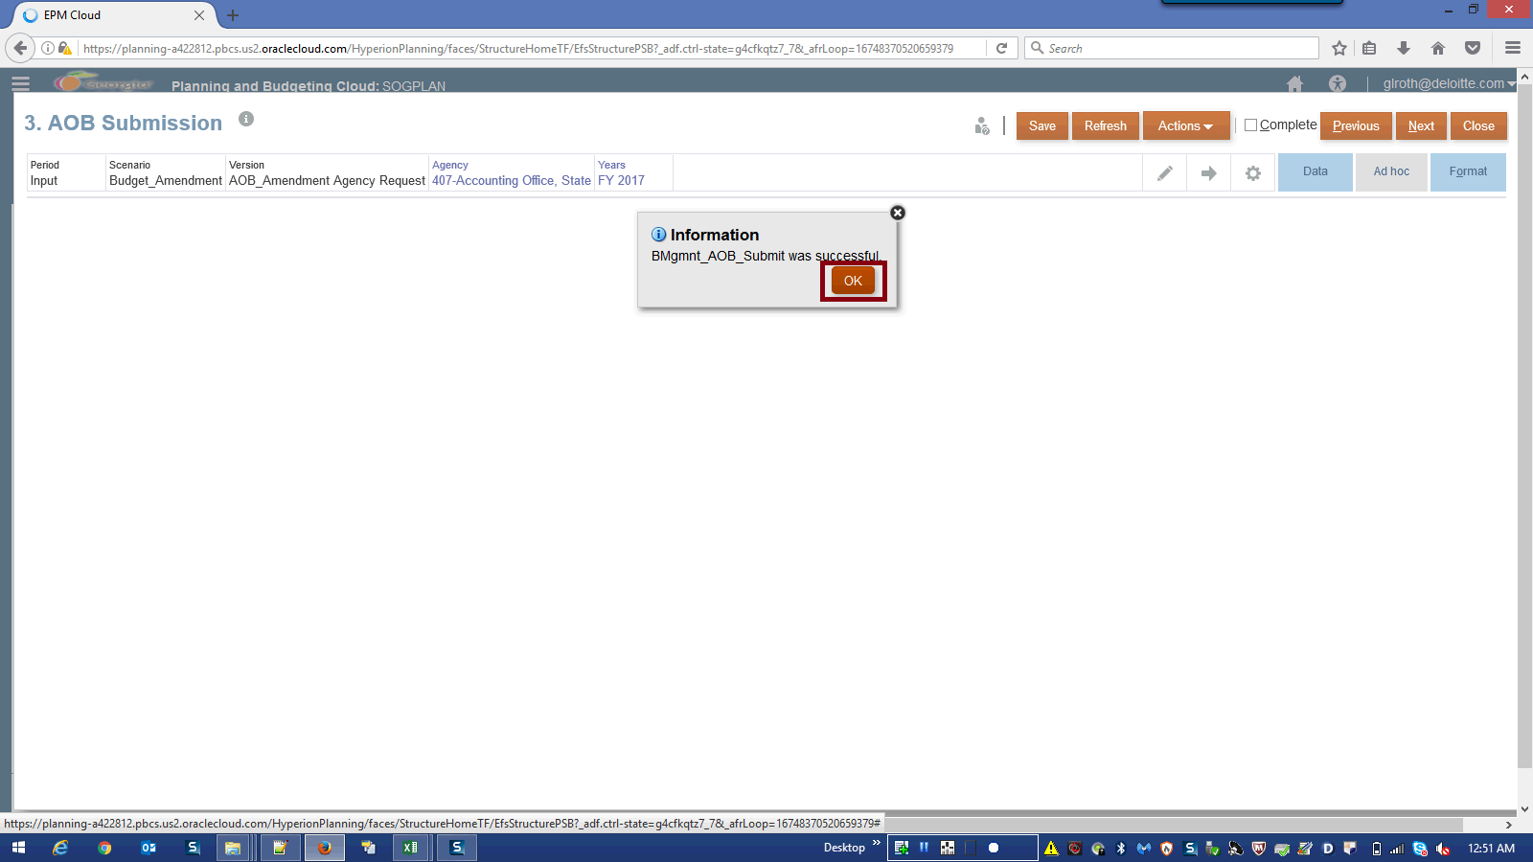

Step | Action | Author Notes
Click the OK button.
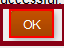
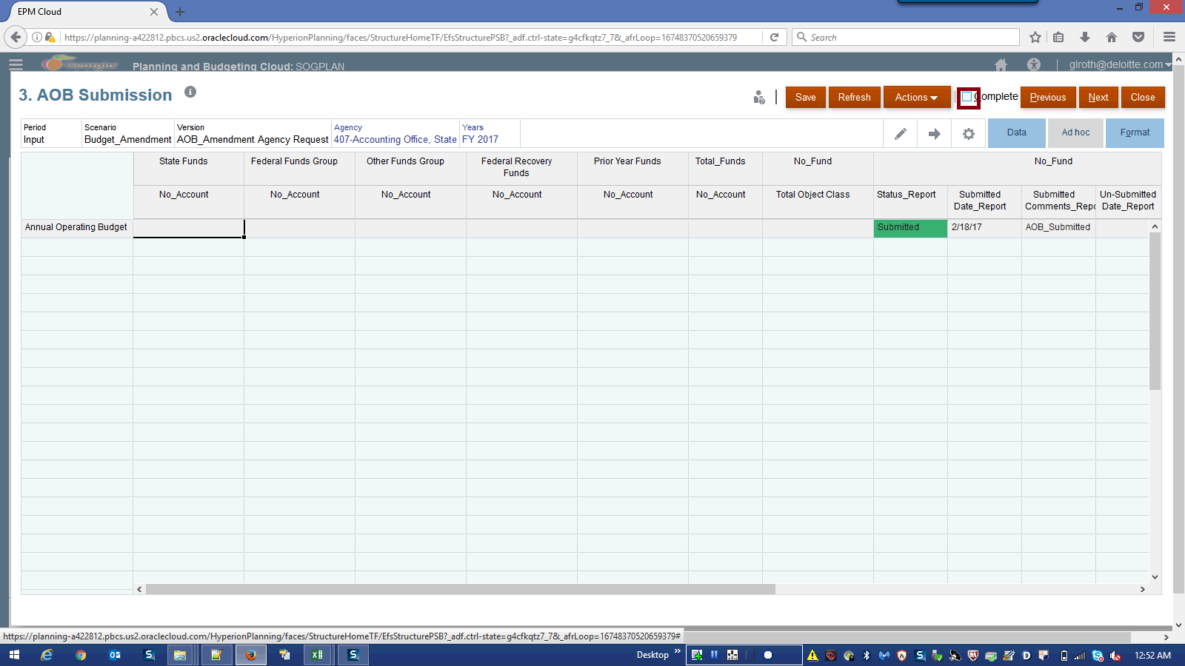

Step | Action | Author Notes
 | Click the Complete option.
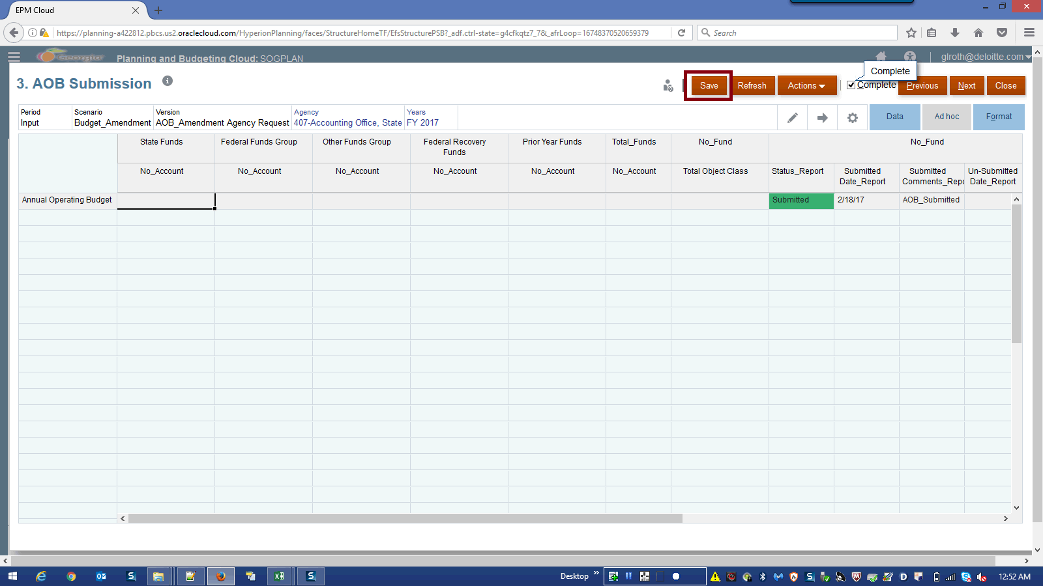

Step | Action | Author Notes
 | Click the Save button.
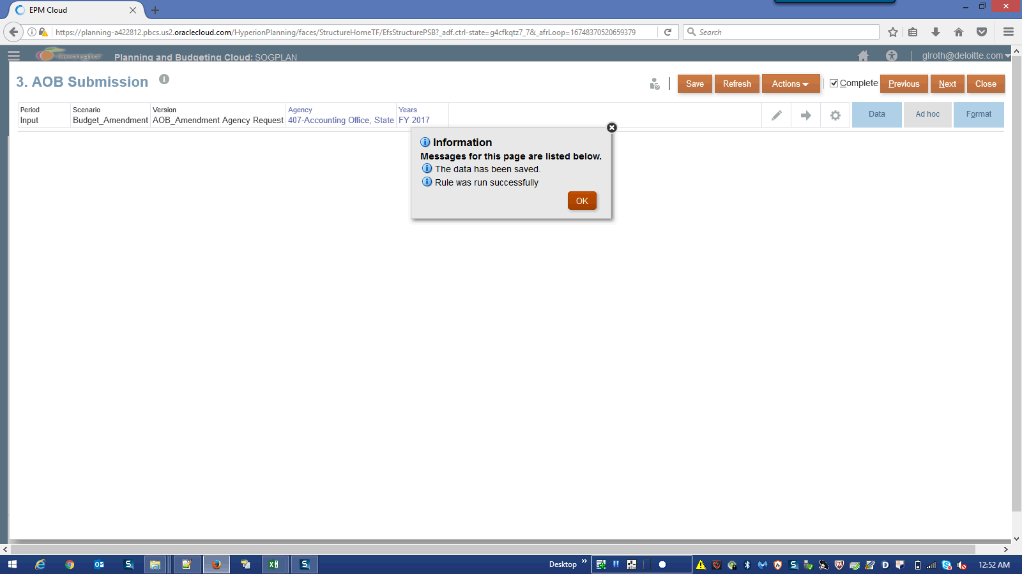

Step | Action | Author Notes
Click the OK button.
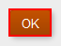
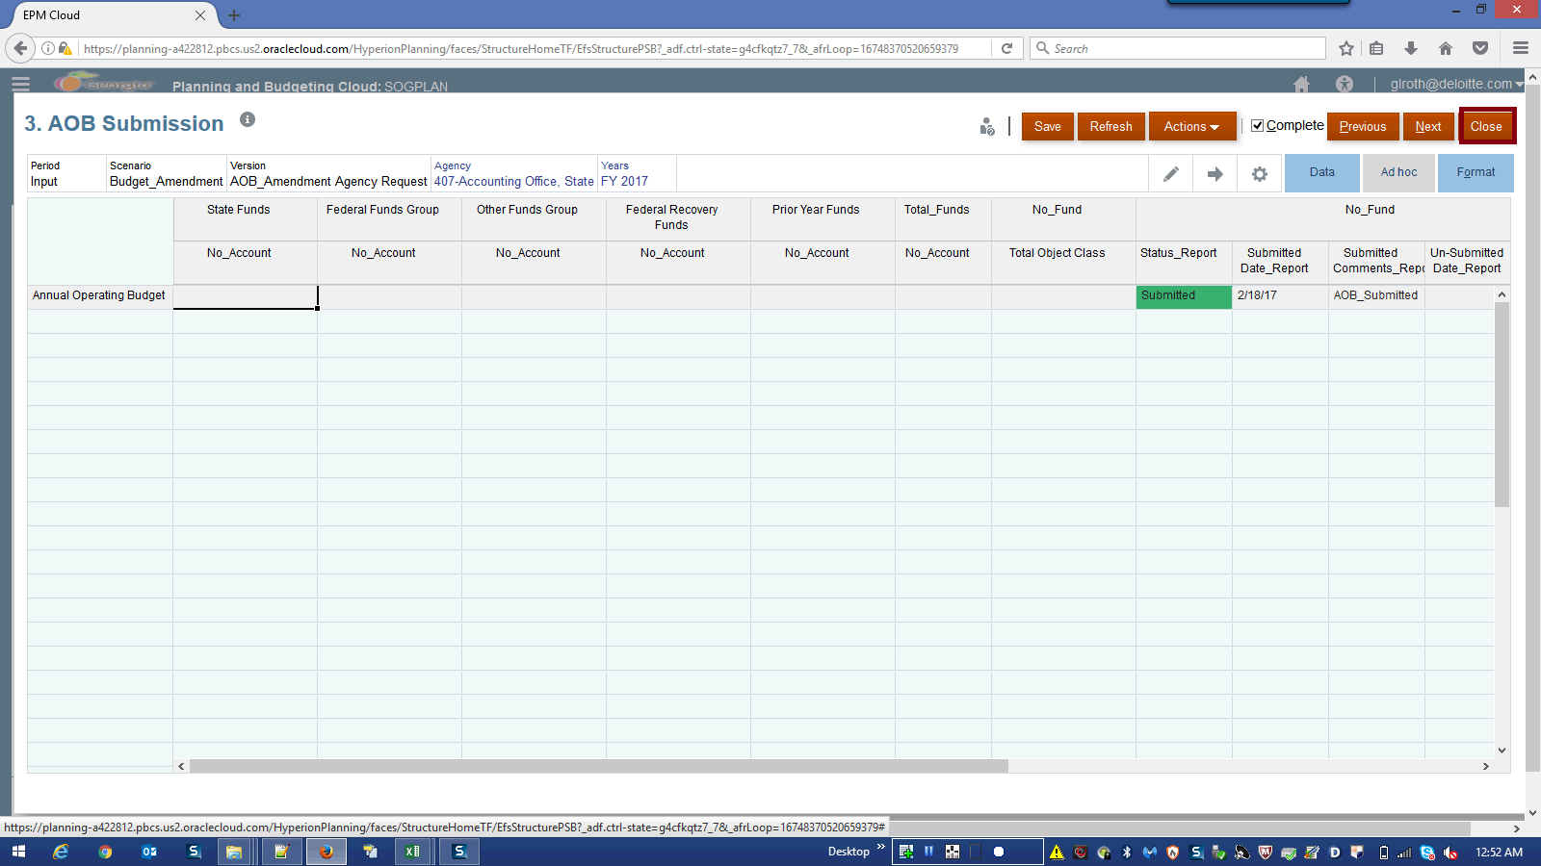

Step | Action | Author Notes
Click the Close button.
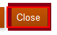
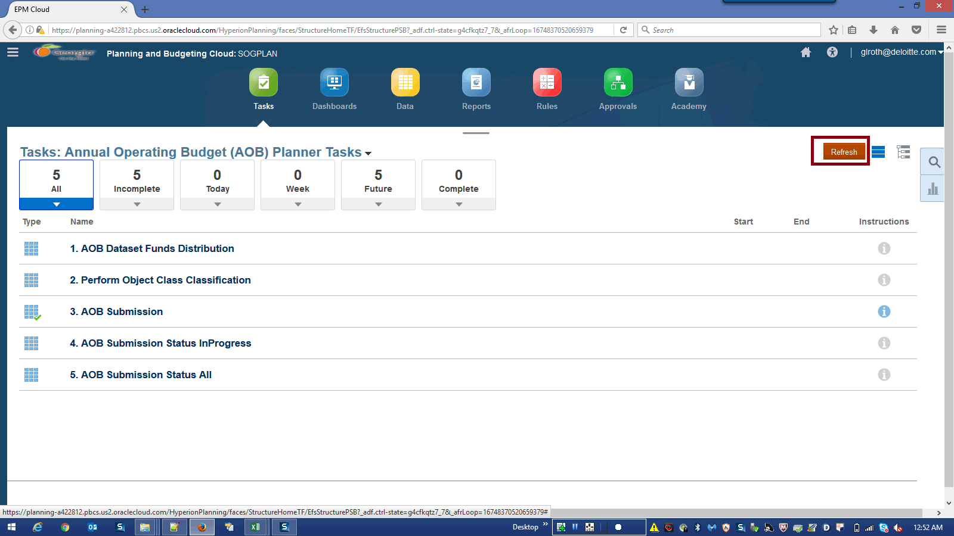

Step | Action | Author Notes
 | Click the Refresh button.
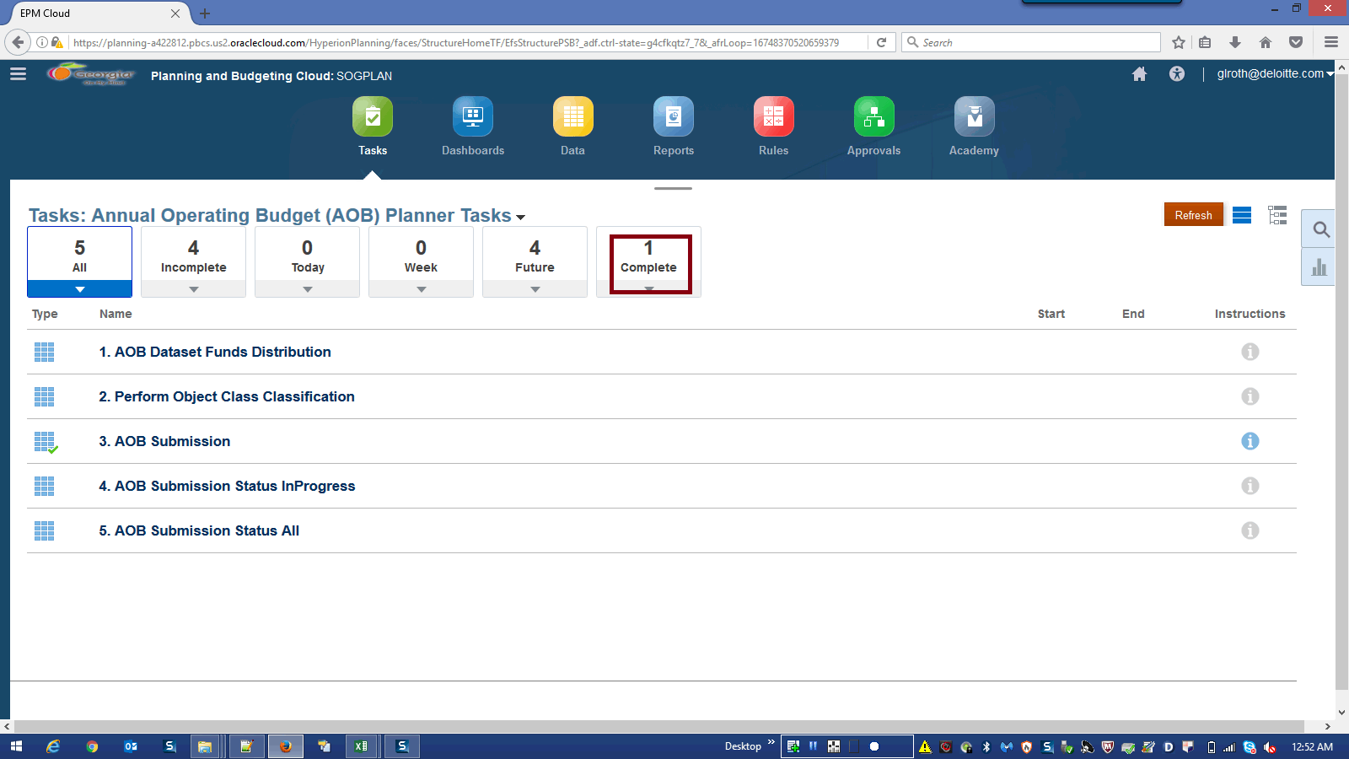

Step | Action | Author Notes
Click in the Complete field.
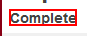
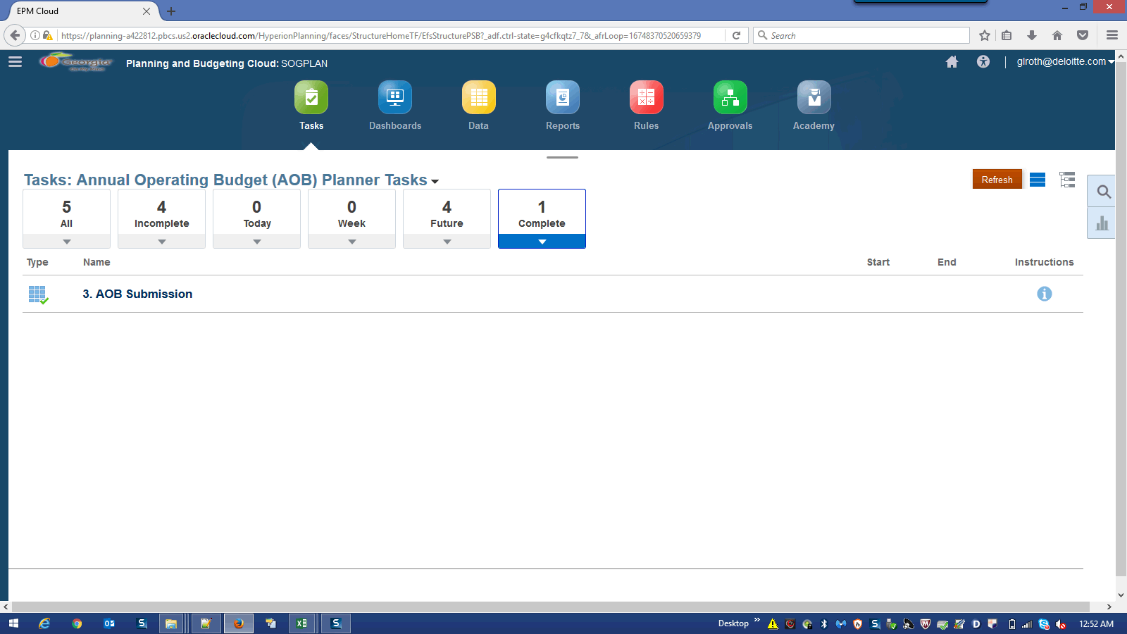

Step | Action | Author Notes
 | End of Procedure.

